

**Assumption College**

Content Group: Foreign Languages

Subject Code: EN30230

Subject: Academic English

Transition Year: Secondary 6/1-8

Semester: 2

Academic Year: 2025

Teacher (s) Ms. Lapassanun Juntarote

Head of Content Group: Ms. Lapassanun Juntarote

|  |  |  |  |  |  |  |  |  |  |  |  |  |  |
| --- | --- | --- | --- | --- | --- | --- | --- | --- | --- | --- | --- | --- | --- |
| Miss Lapassanun Juntarote Class M. 6/1-9 1 Period: Week | | | | | | | | | | | | | |
| Learning Management Plan Analysis | | | | | | | | | | | | | |
| Plan | Learning Outcomes | | | | | | | | | | Proc | Desi | Note |
| Period | 1 | 2 | 3 | 4 | 5 | 6 | 7 | 8 | 9 | 10 |  |
| 1 |  |  | P |  |  |  |  |  |  |  | 5E | Avidity for learning |  |
| 2 |  | P |  |  |  |  |  |  |  |  | Explicit | Self-discipline |  |
| 3 |  |  |  |  |  |  |  | P |  |  | KWL-Plus | Cherishing Thai-ness |  |
| 4 |  |  |  |  |  |  |  |  |  | P | PPP&CIRC | Honesty and integrity |  |
| 5 | P |  |  |  |  |  |  |  |  |  | CIRC and Cooperative Learning | Observance of principles of Sufficiency Economy Philosophy in one’s way of life |  |
| 6 |  |  |  | P |  |  |  |  |  |  | (SIOP + Cooperative Learning + STAD) | Gentlemen of Assumption College |  |
| 7 |  |  |  |  |  |  |  | P |  |  | CALLA | Public-mindedness |  |
| 8 |  |  |  |  |  |  |  |  |  |  |  |  | Exam |
| 9 |  |  |  |  |  |  |  |  |  |  |  |  | Exam |
| 10 |  |  |  |  |  |  |  |  |  |  |  |  | Holidays |
| 11 |  |  |  |  | P |  |  |  |  |  | Explicit | Dedication and commitment to work |  |
| 12 |  |  |  |  |  |  | P |  |  |  | PPP | Cherishing Thai-ness |  |
| 13 |  |  |  |  |  | P |  |  |  |  | CIPPA | Honesty and integrity |  |
| 14 |  |  |  |  |  |  |  |  | P |  | CIPPA | Honesty and integrity |  |
| 15 |  |  |  |  |  |  |  |  |  |  |  |  | Exam |

**Learning Standards and Indicators**

**The Department of Foreign Languages Level of Students: M. 6**

**Subject Code: EN30230 Subject: English Skill Development 2**

|  |  |  |  |  |
| --- | --- | --- | --- | --- |
| **Indicators/Learning outcomes** | **Key Word** | **Learners’ Key Competencies - Activities** | **21st-Century Skill/**  **Local Wisdom/Thai Wisdom/**  **Sufficiency Economy Philosophy /School Focus** | **Desirables** |
| 1. Analyze and interpret spoken and written texts to identify main ideas, comprehend relationships, and express opinions using logical reasoning and relevant examples. | Analyze, interpret, identify, comprehend, express, reason, provide examples | Learners’ Key Competencies  communication capability  thinking capability  problem solving capability  capability in applying life skills and  capability in technological application  Activities  5E Model / PPP / Explicit Teaching Model / CIPPA / CALLA / SIOP / CLT/ CBL / TBL / The Direct Method / Real-life scenarios / The Structural Approach / Cooperative Learning/ KWL-Plus / CIRC / Brainstorming / STAD/ Dramatization / Group discussion / Pair work / Peer Teaching / Mind Maps / Group works | Reading, Writing, Critical Thinking and Problem Solving, Creativity and Innovation,  Cross-cultural Understanding, Collaboration, Teamwork and Leadership,  Communications, Information, and Media Literacy,  Computing and ICT Literacy,  Career and Learning Skills,  Compassion,  Learning, Leadership | 1. Love of nation, religion and king  2. Honesty and integrity  3. Self-discipline  4. Avidity for learning  5. Observance of principles of Sufficiency Economy Philosophy in one’s way of life  6. Dedication and commitment to work  7. Cherishing Thai-ness  8. Public mindedness  9. Gentlemen of Assumption College |
| 2. Demonstrate understanding of language patterns, including vocabulary, grammar, and syntax, to enhance communication and problem-solving across different contexts. | Demonstrate, understand, patterns, vocabulary, grammar, syntax, communication, problem-solving |
| 3. Expand and refine vocabulary through the study and application of word roots, affixes, and contextual clues to improve language comprehension and usage. | Expand, refine, vocabulary, roots, affixes, context, improve, usage |
| 4. Develop accuracy and fluency by identifying and correcting errors in grammar, sentence structure, and word usage in both written and spoken communication. | Develop, accuracy, fluency, identify, correct, errors, grammar, usage |
| 5. Integrate advanced sentence structures and cohesive devices to produce clear, organized, and contextually appropriate responses in writing and speaking. | Integrate, structures, cohesive, devices, organized, appropriate, responses |
| 6. Apply critical thinking and analytical skills to complete tasks such as sentence completion, error identification, and reading comprehension across various text types. | Apply, critical thinking, analytical, sentence completion, error identification, comprehension |
| 7. Enhance listening and reading comprehension by extracting relevant information, making inferences, and predicting outcomes based on context. | Enhance, listening, reading, extract, inferences, predict, context |
| 8. Communicate ideas effectively through accurate and sophisticated use of vocabulary, grammar, and language structures in diverse academic and real-life scenarios. | Communicate, ideas, accurate, sophisticated, vocabulary, grammar, scenarios |  |  |  |
| 9. Demonstrate the ability to construct, revise, and transform sentences and texts for clarity, precision, and stylistic sophistication. | Demonstrate, construct, revise, transform, clarity, precision, sophistication |  |  |  |
| 10. Utilize linguistic and cultural knowledge to interpret and produce texts that align with academic, social, and professional expectations. | Utilize, linguistic, cultural, interpret, produce, academic, social, professional |  |  |  |

**Course Description**

**The Department of Foreign Languages Level of Students: M. 6**

**Subject Code: EN30229 Subject: English Skill Development 1**

**Number of Credit: 0.5 Time: 20 Periods**

**Learning Outcomes**

1. Analyze and interpret spoken and written texts to identify main ideas, comprehend relationships, and express opinions using logical reasoning and relevant examples.

2. Demonstrate understanding of language patterns, including vocabulary, grammar, and syntax, to enhance communication and problem-solving across different contexts.

3. Expand and refine vocabulary through the study and application of word roots, affixes, and contextual clues to improve language comprehension and usage.

4. Develop accuracy and fluency by identifying and correcting errors in grammar, sentence structure, and word usage in both written and spoken communication.

5. Integrate advanced sentence structures and cohesive devices to produce clear, organized, and contextually appropriate responses in writing and speaking.

6. Apply critical thinking and analytical skills to complete tasks such as sentence completion, error identification, and reading comprehension across various text types.

7. Enhance listening and reading comprehension by extracting relevant information, making inferences, and predicting outcomes based on context.

8. Communicate ideas effectively through accurate and sophisticated use of vocabulary, grammar, and language structures in diverse academic and real-life scenarios.

9. Demonstrate the ability to construct, revise, and transform sentences and texts for clarity, precision, and stylistic sophistication.

10. Utilize linguistic and cultural knowledge to interpret and produce texts that align with academic, social, and professional expectations.

**Course Description**

**Students will** analyze and interpret texts, identify main ideas, comprehend relationships, and express opinions with logical reasoning. Students will enhance their understanding of vocabulary, grammar, and syntax to improve communication and problem-solving. They will expand their vocabulary through word roots and contextual clues and develop accuracy and fluency by correcting errors and improving sentence structures.

Students will apply critical thinking to complete tasks such as sentence completion and reading comprehension. They will also enhance listening and reading skills to extract information, make inferences, and predict outcomes. Through effective use of advanced language structures, students will communicate ideas clearly and accurately in both academic and real-world contexts.

By the end of the course, students will construct and revise sentences and texts with clarity and sophistication, using linguistic and cultural knowledge to meet academic, social, and professional expectations.

Students will **achieve these outcomes through the development of 21st-century learning skills**, which emphasize **reading, writing, critical thinking, and problem-solving skills**. Other competencies include **creativity and innovation, cross-cultural understanding, collaboration, teamwork, and leadership**. They will also develop **communication, information, and media literacy, computing and ICT literacy, as well as career and lifelong learning skills**. These learning skills aim to equip students with **key competencies, including thinking capability, problem-solving capability, life skills application, and technological proficiency**.

The teaching and learning process will focus on promoting **Thai wisdom**, respecting language and literature, and understanding religion and tradition. It also encourages students to live according to the **Sufficiency Economy Philosophy**, fostering **desirable characteristics** such as **love of nation, religion, and king; honesty and integrity; and self-discipline. Students will further cultivate an avidity for learning, dedication to work, cherishing of Thai-ness, public-mindedness, and the attributes of gentlemen of Assumption College.**

**FSG’ Moral Values**

**Desirable Characteristics**

1. Love of nation, religion and king

2. Honesty and integrity

3. Self-discipline

4. Avidity for learning

5. Observance of principles of Sufficiency Economy Philosophy in one’s way of life

6. Dedication and commitment to work

7. Cherishing Thai-ness

8. Public mindedness

9. Gentlemen of Assumption College

**Learning Unit**

**The Department of Foreign Languages Level of Students: M. 6**

**Subject Code: EN30230 Subject: English Skill Development 2**

**Number of Credit: 0.5 Time: 20 Periods**

|  |  |  |  |  |
| --- | --- | --- | --- | --- |
| **Learning Unit** | **Time/Period** | **Learners’ Key Competencies - Activities** | **Teaching Materials** | **Evaluation Tools** |
| **1.**  **The Power of Word Roots**   1. Identifying Latin and Greek Roots 2. Analyzing Words for Root Meanings 3. Building Vocabulary Using Word Roots 4. Applying Root Knowledge in Context | **(4)**  1  1  1  1 | **Learners’ Key Competencies**  communication capability  thinking capability  problem solving capability  capability in applying life skills and  capability in technological application  **Activities**  5E Model / PPP / Explicit Teaching Model / CIPPA / CALLA / SIOP **/** CLT/ CBL / TBL / The Direct Method / Real-life scenarios / The Structural Approach / Cooperative Learning/ KWL-Plus / CIRC / Brainstorming / STAD/ Dramatization / Group discussion / Pair work / Peer Teaching / Mind Maps / Group work | 1. Textbook 2. PowerPoint Presentation 3. Dictionary 4. Websites 5. Google Forms 6. Google Slides 7. YouTube 8. Videos 9. Supplementary Sheets 10. Newspapers 11. Magazines 12. Kahoot! 13. Socrative | 1. Quizzes 2. Tests 3. Oral evaluation 4. Exercises 5. Mind-map 6. Observation form |

**Learning Unit**

**The Department of Foreign Languages Level of Students: M. 6**

**Subject Code: EN30230 Subject: English Skill Development 2**

**Number of Credit: 0.5 Time: 20 Periods**

|  |  |  |  |  |  |  |  |
| --- | --- | --- | --- | --- | --- | --- | --- |
| **Learning Unit** | | **Time/Period** | | **Learners’ Key Competencies - Activities** | | **Teaching Materials** | **Evaluation Method** |
| **2. Vocabulary Growth**   1. Exploring Word Families and Forms 2. Learning Roots, Prefixes, and Suffixes 3. Applying New Words in Context 4. Expanding Usage Through Practice | **(4)**  1  1  1  1 | | **Learners’ Key Competencies**  communication capability  thinking capability  problem solving capability  capability in applying life skills and  capability in technological application  **Activities**  5E Model / PPP / Explicit Teaching Model / CIPPA / CALLA / SIOP **/** CLT/ CBL / TBL / The Direct Method / Real-life scenarios / The Structural Approach / Cooperative Learning/ KWL-Plus / CIRC / Brainstorming / STAD/ Dramatization / Group discussion / Pair work / Peer Teaching / Mind Maps / Group work | | 1. Textbook 2. PowerPoint Presentation 3. Dictionary 4. Websites 5. Google Forms 6. Google Slides 7. YouTube 8. Videos 9. Supplementary Sheets 10. Newspapers 11. Magazines 12. Kahoot! 13. Socrative | | 1. Quizzes 2. Tests 3. Oral evaluation 4. Exercises 5. Mind-map 6. Observation form |

**Learning Unit**

**The Department of Foreign Languages Level of Students: M. 6**

**Subject Code: EN30230 Subject: English Skill Development 2**

**Number of Credit: 0.5 Time: 20 Periods**

|  |  |  |  |  |  |  |  |
| --- | --- | --- | --- | --- | --- | --- | --- |
| **Learning Unit** | | **Time/Period** | | **Learners’ Key Competencies - Activities** | | **Teaching Materials** | **Evaluation Method** |
| **3. The Art of Sentence Variety**   1. Identifying Different Sentence Types 2. Combining Ideas for Variation 3. Incorporating Advanced Sentence Structures 4. Enhancing Writing with Diverse Patterns | **(4)**  1  1  1  1 | | **Learners’ Key Competencies**  communication capability  thinking capability  problem solving capability  capability in applying life skills and  capability in technological application  **Activities**  5E Model / PPP / Explicit Teaching Model / CIPPA / CALLA / SIOP **/** CLT/ CBL / TBL / The Direct Method / Real-life scenarios / The Structural Approach / Cooperative Learning/ KWL-Plus / CIRC / Brainstorming / STAD/ Dramatization / Group discussion / Pair work / Peer Teaching / Mind Maps / Group work | | 1. Textbook 2. PowerPoint Presentation 3. Dictionary 4. Websites 5. Google Forms 6. Google Slides 7. YouTube 8. Videos 9. Supplementary Sheets 10. Newspapers 11. Magazines 12. Kahoot! 13. Socrative | | 1. Quizzes 2. Tests 3. Oral evaluation 4. Exercises 5. Mind-map 6. Observation form |

**Learning Unit**

**The Department of Foreign Languages Level of Students: M. 6**

**Subject Code: EN30230 Subject: English Skill Development 2**

**Number of Credit: 0.5 Time: 20 Periods**

|  |  |  |  |  |
| --- | --- | --- | --- | --- |
| **Learning Unit** | **Time/Period** | **Learners’ Key Competencies - Activities** | **Teaching Materials** | **Evaluation Method** |
| **4.** **Precision in Sentence Construction**   1. Understanding Sentence Components 2. Analyzing Sentence Clarity and Accuracy 3. Applying Grammar Rules for Precision 4. Refining Sentences for Conciseness | **(4)**  1  1  1  1 | **Learners’ Key Competencies**  communication capability  thinking capability  problem solving capability  capability in applying life skills and  capability in technological application  **Activities**  5E Model / PPP / Explicit Teaching Model / CIPPA / CALLA / SIOP **/** CLT/ CBL / TBL / The Direct Method / Real-life scenarios / The Structural Approach / Cooperative Learning/ KWL-Plus / CIRC / Brainstorming / STAD/ Dramatization / Group discussion / Pair work / Peer Teaching / Mind Maps / Group work | 1. Textbook 2. PowerPoint Presentation 3. Dictionary 4. Websites 5. Google Forms 6. Google Slides 7. YouTube 8. Videos 9. Supplementary Sheets 10. Newspapers 11. Magazines 12. Kahoot! 13. Socrative | 1. Quizzes 2. Tests 3. Oral evaluation 4. Exercises 5. Mind-map 6. Observation form |

**Learning Unit**

**The Department of Foreign Languages Level of Students: M. 6**

**Subject Code: EN30230 Subject: English Skill Development 2**

**Number of Credit: 0.5 Time: 20 Periods**

|  |  |  |  |  |
| --- | --- | --- | --- | --- |
| **Learning Unit** | **Time/Period** | **Learners’ Key Competencies - Activities** | **Teaching Materials** | **Evaluation Method** |
| **5. Advanced Sentence Transformation**   1. Analyzing Sentence Structures 2. Applying Transformative Grammar Techniques 3. Incorporating Participial and Absolute Phrases 4. Revising Sentences for Sophistication | **(4)**  1  1  1  1 | **Learners’ Key Competencies**  communication capability  thinking capability  problem solving capability  capability in applying life skills and  capability in technological application  **Activities**  5E Model / PPP / Explicit Teaching Model / CIPPA / CALLA / SIOP **/** CLT/ CBL / TBL / The Direct Method / Real-life scenarios / The Structural Approach / Cooperative Learning/ KWL-Plus / CIRC / Brainstorming / STAD/ Dramatization / Group discussion / Pair work / Peer Teaching / Mind Maps / Group work | 1. Textbook 2. PowerPoint Presentation 3. Dictionary 4. Websites 5. Google Forms 6. Google Slides 7. YouTube 8. Videos 9. Supplementary Sheets 10. Newspapers 11. Magazines 12. Kahoot! 13. Socrative | 1. Quizzes 2. Tests 3. Oral evaluation 4. Exercises 5. Mind-map 6. Observation form |

|  |  |  |  |
| --- | --- | --- | --- |
| List of ICT Used | | | |
| Level: Secondary 6 | | | |
| Academic English (EN30230) | | | |
|  | | | |
| Semester 2 | | | |
| Week | Period | Topic | Website |
| 1 | 1 | Greek and Latin Root Words | Kahoot! |
| 2 | 1 | Root words | Kahoot! |
| 3 | 1 | Vocabulary | Kahoot! |
| 4 | 1 | Cloze test | Kahoot! |
| 5 | 1 | Graphs and charts | Quizizz |
| 6 | 1 | Vocabulary for graphs and charts | Quitlet |
| 7 | 1 | Bar charts | Quizizz |
| 8 |  | Summative test |  |
| 9 |  | Summative test |  |
| 11 | 1 | Pie charts | Rapidtable |
| 12 | 1 | Describing tables | Kahoot! |
| 13 | 1 | Sentence completion | Kahoot! |
| 14 | 1 | Sentence completion | Kahoot! |
| 15 |  | Final test |  |

**Assumption College**

**Learning Management Plan**

**Semester: 2 Academic Year: 2025 Week: 1**

**Subject Code: EN30230 Subject: English Skill Development 2**

**Level of Students: M. 6 Learning Unit: The Power of Word Roots**

**Topic: Greek and Latin Root Words Time: 1 Period**

**Learning Outcomes (3):** Expand and refine vocabulary through the study and application of word roots, affixes, and contextual clues to improve language comprehension and usage.

**Learning Objective:**

**Knowledge:** The students will be able to list Greek and Latin root words.

**Process/Skill:** The students will be able to match Greek and Latin root words of the same meaning.

**Desirable Characteristics:**Avidity for learning

**Learners’ Key Competencies**

**☑** communication capability

🞎 thinking capability

🞎 problem solving capability

🞎 capability in applying life skills and

🞎 capability in technological application

**Content: Greek and Latin Root Words**

**Activities: (5 E Learning Cycle Model)**

1. Students are asked several probing questions about Greek and Latin root words. **(Engagement)**
2. Student-to-student interaction is encouraged by having them work in groups. Observe and listen to the students as they interact.Have them do a warm-up activity from the document. Provide time for students to do the activity. **(Exploration)**
3. Students are encouraged to use their common experiences to compare and contrast the **Thai and English wisdoms in terms of Languages**. Have them identify **Greek and Latin root words**. Help them understand the synonyms of each kind. **(Explanation)**
4. Students' attention on conceptual connections between the topic is focused. Students work as a group to match the synonyms of the root words given. **(Elaboration)**
5. Students are assessed their understanding by playing a Kahoot! game. Encourage students to assess their own progress. **(Evaluation)**

**Learning Materials**

**☑** Textbook

**☑** PowerPoint Presentation

🞎 Dictionary

🞎 Websites

**☑** Google Forms, Google Slides

🞎 Kahoot!, Quizizz or Quizlet, AC Online Classroom

🞎 Socrative

**Teaching Procedures:**

**Teaching Model** ☑ 5E Model **□** PPP **□** Explicit Teaching Model

**□** CIPPA **□** CALLA **□** SIOP

**□** Others**………**

**Teaching Method □** CLT **□** CBL **□** TBL

**□** The Direct Method **□** Real**-**life scenarios

**□** The Structural Approach **□** Cooperative Learning

**□** Others**………**

**Teaching Technique □** KWL-Plus **□** CIRC **□** Brainstorming

**□** STAD **□** Dramatization **□** Group discussion

**□** Pair work **□** Peer Teaching **□** Mind Maps

**□** Group work **□** Others**………**

**Evaluation:**

|  |  |  |
| --- | --- | --- |
| **Learning Objective** | **Evaluation Method** | **Evaluation Tools** |
| Knowledge | Checking the quizzes in the textbook | Quizzes/Test |
| Process/Skill | Oral recitation of passages/answers | Oral evaluation |
| Desirable Characteristics | Observation | Observationform |

**Post-Teaching Recommendation:**

|  |  |  |  |  |  |  |  |
| --- | --- | --- | --- | --- | --- | --- | --- |
| Post Evaluation | CLASS | % of students who passed | | | % of students who didn’t pass | | |
| Indicator | | | Indicator | | |
| 1 |  |  | 1 |  |  |
| KNOWLEDGE | M.6/1 |  |  |  |  |  |  |
| M.6/2 |  |  |  |  |  |  |
| M.6/3 |  |  |  |  |  |  |
| M.6/4 |  |  |  |  |  |  |
| M.6/5 |  |  |  |  |  |  |
| M.6/6 |  |  |  |  |  |  |
| M.6/7 |  |  |  |  |  |  |
| M.6/8 |  |  |  |  |  |  |
|  |  |  |  |  |  |  |

**How to solve the problem**: Knowledge

🞎 Review students’ prior knowledge

🞎 Review what students have learned again slowly.

🞎 Advise students to search further information on internet

🞎 Spare some time to teach them individually or in group

🞎 Give some more exercises / reports

🞎 Assign students to do group work or pair work

🞎 Let the encounter “Learning by Doing” process as much as possible.

|  |  |  |  |  |  |  |  |
| --- | --- | --- | --- | --- | --- | --- | --- |
| Post Evaluation | CLASS | % of students who passed | | | % of students who didn’t pass | | |
| Indicator | | | Indicator | | |
| 1 |  |  | 1 |  |  |
| PROCESS/SKILL | M.6/1 |  |  |  |  |  |  |
| M.6/2 |  |  |  |  |  |  |
| M.6/3 |  |  |  |  |  |  |
| M.6/4 |  |  |  |  |  |  |
| M.6/5 |  |  |  |  |  |  |
| M.6/6 |  |  |  |  |  |  |
| M.6/7 |  |  |  |  |  |  |
| M.6/8 |  |  |  |  |  |  |
|  |  |  |  |  |  |  |

**How to solve the problem**: Skill

🞎 Encourage them to listen / speak / read / or write from other sources.

🞎 Practice them to listen / speak / read / or write

🞎 Give them more chance to use all skills in English while teaching.

🞎 Let them criticize themselves the weak point in studying in that period and help them solve that problem.

|  |  |  |  |  |  |  |  |
| --- | --- | --- | --- | --- | --- | --- | --- |
| Post Evaluation | CLASS | % of students who passed | | | % of students who didn’t pass | | |
| Indicator | | | Indicator | | |
| 1 |  |  | 1 |  |  |
| DESIRABLE  CHARACTERISTICS | M.6/1 |  |  |  |  |  |  |
| M.6/2 |  |  |  |  |  |  |
| M.6/3 |  |  |  |  |  |  |
| M.6/4 |  |  |  |  |  |  |
| M.6/5 |  |  |  |  |  |  |
| M.6/6 |  |  |  |  |  |  |
| M.6/7 |  |  |  |  |  |  |
| M.6/8 |  |  |  |  |  |  |
|  |  |  |  |  |  |  |

**How to solve the problem**: Desirable Characteristics

🞎 Point out the importance of that qualification.

🞎 Give them some incentives

🞎 Give warning / suggestion / detention

🞎 Encourage them to have this desirable characteristic

**Follow-Up .....……………………..……………………………………………………..………………………………………………..………………**

………………………………..……………………………………………………..……………………………………………………..……………………

………………………………..……………………………………………………..……………………………………………………..……………………

Teacher Ms. Lapassanun J.

Head of Foreign Languages Department Ms. Lapassanun J.

|  |
| --- |
| แบบสรุปการใช้ ICT ระดับชั้นมัธยมศึกษาปีที่ 6 |
| วิชา การพัฒนาทักษะภาษาอังกฤษ 2 (อ30230) |
| ครูผู้สอน มิสลภัสนันท์ จันทน์โรจน์ |

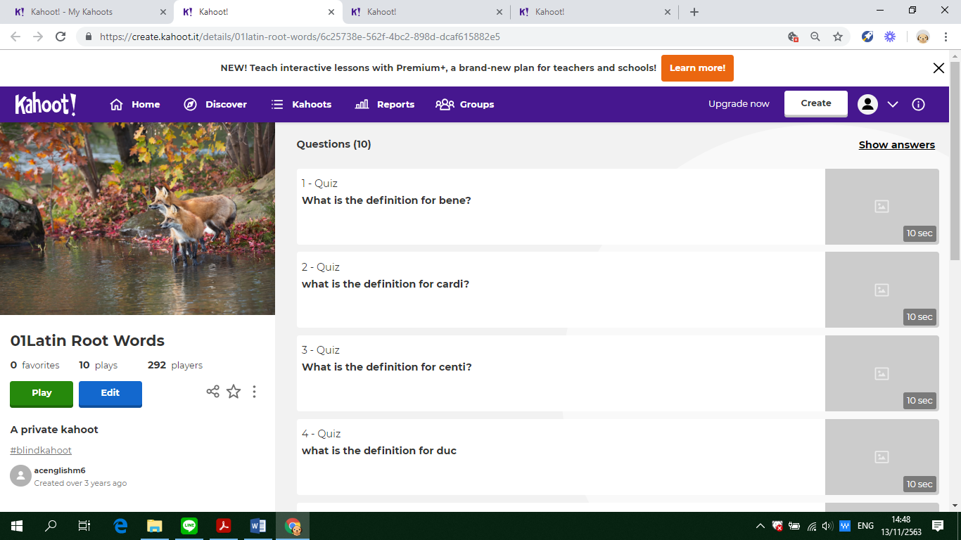

**Assumption College**

**Learning Management Plan**

**Semester: 2 Academic Year: 2025 Week: 2**

**Subject Code: EN30230 Subject: English Skill Development 2**

**Level of Students: M. 6 Learning Unit: The Power of Word Roots**

**Topic: Word Parts Time: 1 Period**

**Learning Outcomes (2):** Demonstrate understanding of language patterns, including vocabulary, grammar, and syntax, to enhance communication and problem-solving across different contexts.

**Learning Objective:**

**Knowledge:** The students will be able to identify root words.

**Process/Skill:** The students will be able togive the meaning of the root words.

**Desirable Characteristics:** Self-discipline

**Learners’ Key Competencies**

🞎communication capability

**☑** thinking capability

🞎 problem solving capability

🞎 capability in applying life skills and

🞎 capability in technological application

**Content: Identifying and giving the definition of the root words given**

**Activities: (Explicit Teaching Model)**

1. Review the lesson of last period. Then, write the following word on the board: ANTIDISESTABLISHMENTARIANISM

Ask students if they recognize any word or word parts. Have them share the word parts that they see, and as they share, underline or circle those word parts. Example: Anti-dis-establish-ment-arian-ism

Explain that when you know what each of the word parts means, you can use those meanings as clues to figure out the meaning of the whole word.

Ask students if they have heard of any other words that use any of these word parts (prefixes or suffixes). Example: Anti → Antiperspirant. Explain that to perspire is to sweat so what might ANTIperspirant be used for? **(Revision)**

1. Have students study the lesson in the book. Introduce the root word column, the meaning column, and the example column. Have students work in small groups for 20 minutes to see how many additional examples they can generate using the roots provided. After 20 minutes, share examples. After that, explain the rules appearing in the book rule by rule with exercises to help increase their understanding. **(Teaching)**
2. Let students do exercises after teaching rules. Then, randomly choose students to answer questions. If students can give clear explanation, continue next question, but if not, the teacher should explain it clearly. After that, provide time for students to do exercises by themselves. **(Practice under supervision)**
3. Random some students to answer each question with the correction, and tell the reason why they correct it like that with the help and suggestion of the teacher. **(Giving correction)**
4. **Promote the 21st century learning skills in terms of digital literacy by encouraging students to use smartphones to play interactive quizzes.** Ask students to login in **‘Socrative’** and do the exercises provided by the teacher. **(Individual practice)**
5. Give some assignments to students to practice. **(Revision)**

**Learning Materials**

**☑** Textbook

**☑** PowerPoint Presentation

🞎 Dictionary

🞎 Websites

**☑** Google Forms, Google Slides

🞎 Kahoot! Quizizz or Quizlet, AC Online Classroom

🞎 Socrative

**Teaching Procedures:**

**Teaching Model □** 5E Model **□** PPP **☑**Explicit Teaching Model

**□** CIPPA **□** CALLA **□** SIOP

**□** Others**………**

**Teaching Method □** CLT **□** CBL **□** TBL

**□** The Direct Method **□** Real**-**life scenarios

**□** The Structural Approach **□** Cooperative Learning

**□** Others**………**

**Teaching Technique □** KWL-Plus **□** CIRC **□** Brainstorming

**□** STAD **□** Dramatization **□** Group discussion

**□** Pair work **□** Peer Teaching **□** Mind Maps

**□** Group work **□** Others**………**

**Evaluation:**

|  |  |  |
| --- | --- | --- |
| **Learning Objective** | **Evaluation Method** | **Evaluation Tools** |
| Knowledge | Checking the quizzes in the textbook | Quizzes/Test |
| Process/Skill | Oral recitation of passages/answers | Oral evaluation |
| Desirable Characteristics | Observation | Observationform |

**Post-Teaching Recommendation:**

|  |  |  |  |  |  |  |  |
| --- | --- | --- | --- | --- | --- | --- | --- |
| Post Evaluation | CLASS | % of students who passed | | | % of students who didn’t pass | | |
| Indicator | | | Indicator | | |
| 1 |  |  | 1 |  |  |
| KNOWLEDGE | M.6/1 |  |  |  |  |  |  |
| M.6/2 |  |  |  |  |  |  |
| M.6/3 |  |  |  |  |  |  |
| M.6/4 |  |  |  |  |  |  |
| M.6/5 |  |  |  |  |  |  |
| M.6/6 |  |  |  |  |  |  |
| M.6/7 |  |  |  |  |  |  |
| M.6/8 |  |  |  |  |  |  |
|  |  |  |  |  |  |  |

**How to solve the problem**: Knowledge

🞎 Review students’ prior knowledge

🞎 Review what students have learned again slowly.

🞎 Advise students to search further information on internet

🞎 Spare some time to teach them individually or in group

🞎 Give some more exercises / reports

🞎 Assign students to do group work or pair work

🞎 Let the encounter “Learning by Doing” process as much as possible.

|  |  |  |  |  |  |  |  |
| --- | --- | --- | --- | --- | --- | --- | --- |
| Post Evaluation | CLASS | % of students who passed | | | % of students who didn’t pass | | |
| Indicator | | | Indicator | | |
| 1 |  |  | 1 |  |  |
| PROCESS/SKILL | M.6/1 |  |  |  |  |  |  |
| M.6/2 |  |  |  |  |  |  |
| M.6/3 |  |  |  |  |  |  |
| M.6/4 |  |  |  |  |  |  |
| M.6/5 |  |  |  |  |  |  |
| M.6/6 |  |  |  |  |  |  |
| M.6/7 |  |  |  |  |  |  |
| M.6/8 |  |  |  |  |  |  |
|  |  |  |  |  |  |  |

**How to solve the problem**: Skill

🞎 Encourage them to listen / speak / read / or write from other sources.

🞎 Practice them to listen / speak / read / or write

🞎 Give them more chance to use all skills in English while teaching.

🞎 Let them criticize themselves the weak point in studying in that period and help them solve that problem.

|  |  |  |  |  |  |  |  |
| --- | --- | --- | --- | --- | --- | --- | --- |
| Post Evaluation | CLASS | % of students who passed | | | % of students who didn’t pass | | |
| Indicator | | | Indicator | | |
| 1 |  |  | 1 |  |  |
| DESIRABLE  CHARACTERISTICS | M.6/1 |  |  |  |  |  |  |
| M.6/2 |  |  |  |  |  |  |
| M.6/3 |  |  |  |  |  |  |
| M.6/4 |  |  |  |  |  |  |
| M.6/5 |  |  |  |  |  |  |
| M.6/6 |  |  |  |  |  |  |
| M.6/7 |  |  |  |  |  |  |
| M.6/8 |  |  |  |  |  |  |
|  |  |  |  |  |  |  |

**How to solve the problem**: Desirable Characteristics

🞎 Point out the importance of that qualification.

🞎 Give them some incentives

🞎 Give warning / suggestion / detention

🞎 Encourage them to have this desirable characteristic

**Follow-Up .....……………………..……………………………………………………..………………………………………………..………………**

………………………………..……………………………………………………..……………………………………………………..……………………

………………………………..……………………………………………………..……………………………………………………..……………………

Teacher Ms. Lapassanun J.

Head of Foreign Languages Department Ms. Lapassanun J.

|  |
| --- |
| แบบสรุปการใช้ ICT ระดับชั้นมัธยมศึกษาปีที่ 6 |
| วิชา การพัฒนาทักษะภาษาอังกฤษ 2 (อ30230) |
| ครูผู้สอน มิสลภัสนันท์ จันทน์โรจน์ |

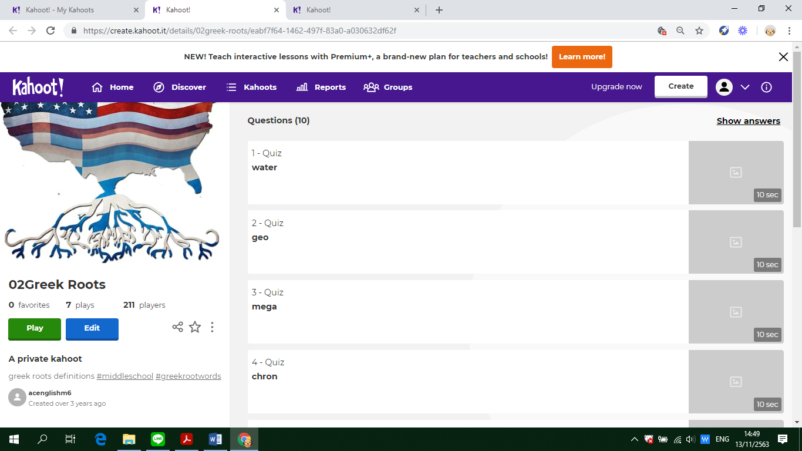

**Assumption College**

**Learning Management Plan**

**Semester: 2 Academic Year: 2025 Week: 3**

**Subject Code: EN30230 Subject: English Skill Development 2**

**Level of Students: M. 6 Learning Unit: The Power of Word Roots**

**Topic: Vocabulary Time: 1 Period**

**Learning Outcomes (8):** Communicate ideas effectively through accurate and sophisticated use of vocabulary, grammar, and language structures in diverse academic and real-life scenarios.

**Learning Objective:**

**Knowledge:** The students will be able to identify the meaning of new vocabulary and its pronunciation.

**Process/Skill:** The students will be able tomatch the meaning of new vocabulary.

**Desirable Characteristics:** Cherishing Thai-ness

**Learners’ Key Competencies**

🞎communication capability

🞎 thinking capability

**☑** problem solving capability

🞎 capability in applying life skills and

🞎 capability in technological application

**Content: The structure of inversion in English**

**Activities: KWL-Plus**

1. Discuss the topic with students. Distribute K-W-L chart to each student. **(Preparation)**
2. Based on what they have learnt about the new vocabulary, ask students to write as many words from the previous lessons as possible and mark What I Know. **(Pre teaching)**
3. **Promote the 21st century learning skills in terms of communication by allowing students to communicate in English and work in group** to brainstorm the pronunciation of each word. Write each pronunciation in the W column. After that, have students listen to the pronunciation and check whether what they have done is correct in the L column. **(While teaching)**
4. To continue with the KWL-Plus Strategy, ask students to categorize the new word with plus and minus signs. **(After teaching)**
5. Next, ask students to develop a concept map about the root words. **(Mind-Mapping)**
6. Have students use the concept map or graphic organizer to write a summary about the root words. **(Summarizing)**
7. Have them play Kahoot in teams. **(Evaluation)**

**Learning Materials**

**☑** Textbook

**☑** PowerPoint Presentation

🞎 Dictionary

🞎 Websites

🞎 Google Forms, Google Slides

🞎 Kahoot!, Quizizz or Quizlet, AC Online Classroom

🞎 Socrative

**Teaching Procedures:**

**Teaching Model □** 5E Model **□** PPP **□** Explicit Teaching Model

**□** CIPPA **□** CALLA **□** SIOP

**□** Others**………**

**Teaching Method □** CLT **□** CBL **□** TBL

**□** The Direct Method **□** Real**-**life scenarios

**□** The Structural Approach **□** Cooperative Learning

**□** Others**………**

**Teaching Technique ☑** KWL-Plus **□** CIRC **□** Brainstorming

**□** STAD **□** Dramatization **□** Group discussion

**□** Pair work **□** Peer Teaching **□** Mind Maps

**□** Group work **□** Others**………**

**Evaluation:**

|  |  |  |
| --- | --- | --- |
| **Learning Objective** | **Evaluation Method** | **Evaluation Tools** |
| Knowledge | Checking the quizzes in the textbook | Quizzes/Test |
| Process/Skill | Oral recitation of passages/answers | Oral evaluation |
| Desirable Characteristics | Observation | Observationform |

**Post-Teaching Recommendation:**

|  |  |  |  |  |  |  |  |
| --- | --- | --- | --- | --- | --- | --- | --- |
| Post Evaluation | CLASS | % of students who passed | | | % of students who didn’t pass | | |
| Indicator | | | Indicator | | |
| 1 |  |  | 1 |  |  |
| KNOWLEDGE | M.6/1 |  |  |  |  |  |  |
| M.6/2 |  |  |  |  |  |  |
| M.6/3 |  |  |  |  |  |  |
| M.6/4 |  |  |  |  |  |  |
| M.6/5 |  |  |  |  |  |  |
| M.6/6 |  |  |  |  |  |  |
| M.6/7 |  |  |  |  |  |  |
| M.6/8 |  |  |  |  |  |  |
|  |  |  |  |  |  |  |

**How to solve the problem**: Knowledge

🞎 Review students’ prior knowledge

🞎 Review what students have learned again slowly.

🞎 Advise students to search further information on internet

🞎 Spare some time to teach them individually or in group

🞎 Give some more exercises / reports

🞎 Assign students to do group work or pair work

🞎 Let the encounter “Learning by Doing” process as much as possible.

|  |  |  |  |  |  |  |  |
| --- | --- | --- | --- | --- | --- | --- | --- |
| Post Evaluation | CLASS | % of students who passed | | | % of students who didn’t pass | | |
| Indicator | | | Indicator | | |
| 1 |  |  | 1 |  |  |
| PROCESS/SKILL | M.6/1 |  |  |  |  |  |  |
| M.6/2 |  |  |  |  |  |  |
| M.6/3 |  |  |  |  |  |  |
| M.6/4 |  |  |  |  |  |  |
| M.6/5 |  |  |  |  |  |  |
| M.6/6 |  |  |  |  |  |  |
| M.6/7 |  |  |  |  |  |  |
| M.6/8 |  |  |  |  |  |  |
|  |  |  |  |  |  |  |

**How to solve the problem**: Skill

🞎 Encourage them to listen / speak / read / or write from other sources.

🞎 Practice them to listen / speak / read / or write

🞎 Give them more chance to use all skills in English while teaching.

🞎 Let them criticize themselves the weak point in studying in that period and help them solve that problem.

|  |  |  |  |  |  |  |  |
| --- | --- | --- | --- | --- | --- | --- | --- |
| Post Evaluation | CLASS | % of students who passed | | | % of students who didn’t pass | | |
| Indicator | | | Indicator | | |
| 1 |  |  | 1 |  |  |
| DESIRABLE  CHARACTERISTICS | M.6/1 |  |  |  |  |  |  |
| M.6/2 |  |  |  |  |  |  |
| M.6/3 |  |  |  |  |  |  |
| M.6/4 |  |  |  |  |  |  |
| M.6/5 |  |  |  |  |  |  |
| M.6/6 |  |  |  |  |  |  |
| M.6/7 |  |  |  |  |  |  |
| M.6/8 |  |  |  |  |  |  |
|  |  |  |  |  |  |  |

**How to solve the problem**: Desirable Characteristics

🞎 Point out the importance of that qualification.

🞎 Give them some incentives

🞎 Give warning / suggestion / detention

🞎 Encourage them to have this desirable characteristic

**Follow-Up .....……………………..……………………………………………………..………………………………………………..………………**

………………………………..……………………………………………………..……………………………………………………..……………………

………………………………..……………………………………………………..……………………………………………………..……………………

Teacher Ms. Lapassanun J.

Head of Foreign Languages Department Ms. Lapassanun J.

|  |
| --- |
| แบบสรุปการใช้ ICT ระดับชั้นมัธยมศึกษาปีที่ 6 |
| วิชา การพัฒนาทักษะภาษาอังกฤษ 2 (อ30230) |
| ครูผู้สอน มิสลภัสนันท์ จันทน์โรจน์ |

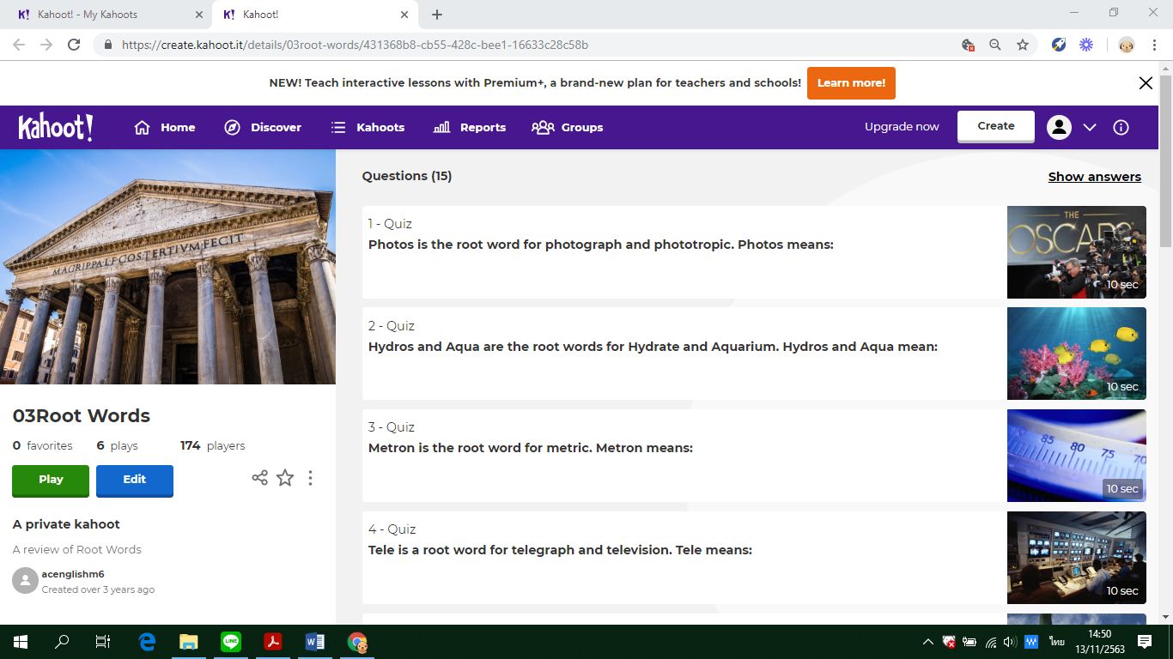

**Assumption College**

**Learning Management Plan**

**Semester: 2 Academic Year: 2025 Week: 4**

**Subject Code: EN30230 Subject: English Skill Development 2**

**Level of Students: M. 6 Learning Unit: Vocabulary Growth**

**Topic: Cloze test Time: 1 Period**

**Learning Outcomes (10):** Utilize linguistic and cultural knowledge to interpret and produce texts that align with academic, social, and professional expectations.

**Learning Objective:**

**Knowledge:** The students will be able to understand the passage.

**Process/Skill:** The students will be able tocomplete a fill-in-the-blank summary of the passage.

**Desirable Characteristics:** Honesty and integrity

**Learners’ Key Competencies**

🞎communication capability

🞎 thinking capability

🞎 problem solving capability

**☑** capability in applying life skills and

🞎 capability in technological application

**Content: Completing a cloze test**

**Activities: (PPP & CIRC)**

1. Explain the learning objectives. Introduce the new topic using PowerPoint Presentation and give some questions related to the topic. Tell them that a cloze test is an exercise where a passage is provided with certain words missing from it. Actually, it is a combination of fill in the blanks and reading comprehension. It is important to understand the flow and context of a passage. **(Warm Up / Lead-In)**
2. Divide students into 6-member cooperative learning teams. Students are grouped heterogeneously. Let them read the passage thoroughly to get an idea of the passage. Read slowly and gain an understanding of the text. Link the sentences together and predict type of word to fill in **(Presentation)**
3. Have students work in teams to complete a fill-in-the-blank summary of the passage. After that, let each group present their answers. Next, let students answer the questions based on the text with their group members. Then, let them present their answers. **(Practice)**
4. Have them play Quizizz to complete a cloze test with their groups. **(Production)**
5. Give students assignment to do more exercises about the topic learnt. **(Assignment)**

**Learning Materials**

**☑** Textbook

**☑** PowerPoint Presentation

🞎 Dictionary

🞎 Websites

🞎 Google Forms, Google Slides

**☑** Kahoot!, Quizizz or Quizlet, AC Online Classroom

🞎 Socrative

**Teaching Procedures:**

**Teaching Model □** 5E Model **☑** PPP **□** Explicit Teaching Model

**□** CIPPA **□** CALLA **□** SIOP

**□** Others**………**

**Teaching Method □** CLT **□** CBL **□** TBL

**□** The Direct Method **□** Real**-**life scenarios

**□** The Structural Approach **□** Cooperative Learning

**□** Others**………**

**Teaching Technique □** KWL-Plus **☑** CIRC **□** Brainstorming

**□** STAD **□** Dramatization **□** Group discussion

**□** Pair work **□** Peer Teaching **□** Mind Maps

**□** Group work **□** Others**………**

**Evaluation:**

|  |  |  |
| --- | --- | --- |
| **Learning Objective** | **Evaluation Method** | **Evaluation Tools** |
| Knowledge | Checking the quizzes in the textbook | Quizzes/Test |
| Process/Skill | Oral recitation of passages/answers | Oral evaluation |
| Desirable Characteristics | Observation | Observationform |

**Post-Teaching Recommendation:**

|  |  |  |  |  |  |  |  |
| --- | --- | --- | --- | --- | --- | --- | --- |
| Post Evaluation | CLASS | % of students who passed | | | % of students who didn’t pass | | |
| Indicator | | | Indicator | | |
| 1 |  |  | 1 |  |  |
| KNOWLEDGE | M.6/1 |  |  |  |  |  |  |
| M.6/2 |  |  |  |  |  |  |
| M.6/3 |  |  |  |  |  |  |
| M.6/4 |  |  |  |  |  |  |
| M.6/5 |  |  |  |  |  |  |
| M.6/6 |  |  |  |  |  |  |
| M.6/7 |  |  |  |  |  |  |
| M.6/8 |  |  |  |  |  |  |
|  |  |  |  |  |  |  |

**How to solve the problem**: Knowledge

🞎 Review students’ prior knowledge

🞎 Review what students have learned again slowly.

🞎 Advise students to search further information on internet

🞎 Spare some time to teach them individually or in group

🞎 Give some more exercises / reports

🞎 Assign students to do group work or pair work

🞎 Let the encounter “Learning by Doing” process as much as possible.

|  |  |  |  |  |  |  |  |
| --- | --- | --- | --- | --- | --- | --- | --- |
| Post Evaluation | CLASS | % of students who passed | | | % of students who didn’t pass | | |
| Indicator | | | Indicator | | |
| 1 |  |  | 1 |  |  |
| PROCESS/SKILL | M.6/1 |  |  |  |  |  |  |
| M.6/2 |  |  |  |  |  |  |
| M.6/3 |  |  |  |  |  |  |
| M.6/4 |  |  |  |  |  |  |
| M.6/5 |  |  |  |  |  |  |
| M.6/6 |  |  |  |  |  |  |
| M.6/7 |  |  |  |  |  |  |
| M.6/8 |  |  |  |  |  |  |
|  |  |  |  |  |  |  |

**How to solve the problem**: Skill

🞎 Encourage them to listen / speak / read / or write from other sources.

🞎 Practice them to listen / speak / read / or write

🞎 Give them more chance to use all skills in English while teaching.

🞎 Let them criticize themselves the weak point in studying in that period and help them solve that problem.

|  |  |  |  |  |  |  |  |
| --- | --- | --- | --- | --- | --- | --- | --- |
| Post Evaluation | CLASS | % of students who passed | | | % of students who didn’t pass | | |
| Indicator | | | Indicator | | |
| 1 |  |  | 1 |  |  |
| DESIRABLE  CHARACTERISTICS | M.6/1 |  |  |  |  |  |  |
| M.6/2 |  |  |  |  |  |  |
| M.6/3 |  |  |  |  |  |  |
| M.6/4 |  |  |  |  |  |  |
| M.6/5 |  |  |  |  |  |  |
| M.6/6 |  |  |  |  |  |  |
| M.6/7 |  |  |  |  |  |  |
| M.6/8 |  |  |  |  |  |  |
|  |  |  |  |  |  |  |

**How to solve the problem**: Desirable Characteristics

🞎 Point out the importance of that qualification.

🞎 Give them some incentives

🞎 Give warning / suggestion / detention

🞎 Encourage them to have this desirable characteristic

**Follow-Up .....……………………..……………………………………………………..………………………………………………..………………**

………………………………..……………………………………………………..……………………………………………………..……………………

………………………………..……………………………………………………..……………………………………………………..……………………

Teacher Ms. Lapassanun J.

Head of Foreign Languages Department Ms. Lapassanun J.

|  |
| --- |
| แบบสรุปการใช้ ICT ระดับชั้นมัธยมศึกษาปีที่ 6 |
| วิชา การพัฒนาทักษะภาษาอังกฤษ 2 (อ30230) |
| ครูผู้สอน มิสลภัสนันท์ จันทน์โรจน์ |

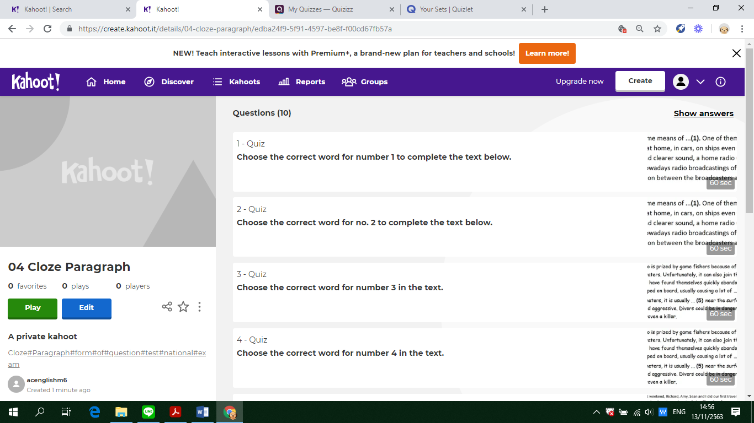

**Assumption College**

**Learning Management Plan**

**Semester: 2 Academic Year: 2025 Week: 5**

**Subject Code: EN30230 Subject: English Skill Development 2**

**Level of Students: M. 6 Learning Unit: Vocabulary Growth**

**Topic: Graphs and charts Time: 1 Period**

**Learning Outcomes (1):** Analyze and interpret spoken and written texts to identify main ideas, comprehend relationships, and express opinions using logical reasoning and relevant examples**.**

**Learning Objective:**

**Knowledge:** The students will be able to read and analyze graphs and chart text features**.**

**Process/Skill:** The students will be able tofill in the information from the graphs and charts.

**Desirable Characteristics:** Observance of principles of Sufficiency Economy Philosophy in one’s way of life

**Learners’ Key Competencies**

🞎communication capability

🞎 thinking capability

🞎 problem solving capability

🞎 capability in applying life skills and

**☑** capability in technological application

**Content: Filling in graphs and charts**

**Activities: CIRC and Cooperative Learning**

1. Tell students that they will be talking about specific types of text features: charts and graphs. Explain to students that these features give them more information to help them understand what they are reading. **(Presentation)**
2. Form groups of 4 students heterogeneously.Ask students to match the words to the pictures relating the **principles of Sufficiency Economy Philosophy**. Then have them complete the sentences using prepositions of time and other words appropriate for each picture. **(Team practice)**
3. Let students work individually to **r**ead the description and draw a line graph and put the words in the appropriate column. **(Independent practice)**
4. Allow students to assess each other's performance. Have them revise and edit each other’s work. It gives students the opportunity to encounter diversity in different ways, critique and judge each other’s work**. (Peer pre-assessment)**
5. Have students work in groups to fill in the blanks with a suitable verb to describe a trend and match the sentences given with the graphs. **(Additional practic**e)
6. **Promote the 21st century learning skills in terms of digital literacy by encouraging students to use smartphones to play interactive quizzes.** Assess them using **Quizizz** to check if the students understand the concepts of the lesson. In the assessment stage, each student individually takes a quiz. Then their scores are combined and compared to their own past averages and points**. (Testing)**
7. Each team will be awarded based on the degree to which students meet or exceed their own earlier performance**. (Team Recognition)**

**Learning Materials**

**☑** Textbook

**☑** PowerPoint Presentation

🞎 Dictionary

🞎 Websites

🞎 Google Forms, Google Slides

**☑** Kahoot!, Quizizz or Quizlet, AC Online Classroom

🞎 Socrative

**Teaching Procedures:**

**Teaching Model □** 5E Model **□** PPP **□** Explicit Teaching Model

**□** CIPPA **□** CALLA **□** SIOP

**□** Others**………**

**Teaching Method □** CLT **□** CBL **□** TBL

**□** The Direct Method **□** Real**-**life scenarios

**□** The Structural Approach **☑** Cooperative Learning

**□** Others**………**

**Teaching Technique □** KWL-Plus **☑** CIRC **□** Brainstorming

**□** STAD **□** Dramatization **□** Group discussion

**□** Pair work **□** Peer Teaching **□** Mind Maps

**□** Group work **□** Others**………**

**Evaluation:**

|  |  |  |
| --- | --- | --- |
| **Learning Objective** | **Evaluation Method** | **Evaluation Tools** |
| Knowledge | Checking the quizzes in the textbook | Quizzes/Test |
| Process/Skill | Oral recitation of passages/answers | Oral evaluation |
| Desirable Characteristics | Observation | Observationform |

**Post-Teaching Recommendation:**

|  |  |  |  |  |  |  |  |
| --- | --- | --- | --- | --- | --- | --- | --- |
| Post Evaluation | CLASS | % of students who passed | | | % of students who didn’t pass | | |
| Indicator | | | Indicator | | |
| 1 |  |  | 1 |  |  |
| KNOWLEDGE | M.6/1 |  |  |  |  |  |  |
| M.6/2 |  |  |  |  |  |  |
| M.6/3 |  |  |  |  |  |  |
| M.6/4 |  |  |  |  |  |  |
| M.6/5 |  |  |  |  |  |  |
| M.6/6 |  |  |  |  |  |  |
| M.6/7 |  |  |  |  |  |  |
| M.6/8 |  |  |  |  |  |  |
|  |  |  |  |  |  |  |

**How to solve the problem**: Knowledge

🞎 Review students’ prior knowledge

🞎 Review what students have learned again slowly.

🞎 Advise students to search further information on internet

🞎 Spare some time to teach them individually or in group

🞎 Give some more exercises / reports

🞎 Assign students to do group work or pair work

🞎 Let the encounter “Learning by Doing” process as much as possible.

|  |  |  |  |  |  |  |  |
| --- | --- | --- | --- | --- | --- | --- | --- |
| Post Evaluation | CLASS | % of students who passed | | | % of students who didn’t pass | | |
| Indicator | | | Indicator | | |
| 1 |  |  | 1 |  |  |
| PROCESS/SKILL | M.6/1 |  |  |  |  |  |  |
| M.6/2 |  |  |  |  |  |  |
| M.6/3 |  |  |  |  |  |  |
| M.6/4 |  |  |  |  |  |  |
| M.6/5 |  |  |  |  |  |  |
| M.6/6 |  |  |  |  |  |  |
| M.6/7 |  |  |  |  |  |  |
| M.6/8 |  |  |  |  |  |  |
|  |  |  |  |  |  |  |

**How to solve the problem**: Skill

🞎 Encourage them to listen / speak / read / or write from other sources.

🞎 Practice them to listen / speak / read / or write

🞎 Give them more chance to use all skills in English while teaching.

🞎 Let them criticize themselves the weak point in studying in that period and help them solve that problem.

|  |  |  |  |  |  |  |  |
| --- | --- | --- | --- | --- | --- | --- | --- |
| Post Evaluation | CLASS | % of students who passed | | | % of students who didn’t pass | | |
| Indicator | | | Indicator | | |
| 1 |  |  | 1 |  |  |
| DESIRABLE  CHARACTERISTICS | M.6/1 |  |  |  |  |  |  |
| M.6/2 |  |  |  |  |  |  |
| M.6/3 |  |  |  |  |  |  |
| M.6/4 |  |  |  |  |  |  |
| M.6/5 |  |  |  |  |  |  |
| M.6/6 |  |  |  |  |  |  |
| M.6/7 |  |  |  |  |  |  |
| M.6/8 |  |  |  |  |  |  |
|  |  |  |  |  |  |  |

**How to solve the problem**: Desirable Characteristics

🞎 Point out the importance of that qualification.

🞎 Give them some incentives

🞎 Give warning / suggestion / detention

🞎 Encourage them to have this desirable characteristic

**Follow-Up .....……………………..……………………………………………………..………………………………………………..………………**

………………………………..……………………………………………………..……………………………………………………..……………………

………………………………..……………………………………………………..……………………………………………………..……………………

Teacher Ms. Lapassanun J.

Head of Foreign Languages Department Ms. Lapassanun J.

|  |
| --- |
| แบบสรุปการใช้ ICT ระดับชั้นมัธยมศึกษาปีที่ 6 |
| วิชา การพัฒนาทักษะภาษาอังกฤษ 2 (อ30230) |
| ครูผู้สอน มิสลภัสนันท์ จันทน์โรจน์ |

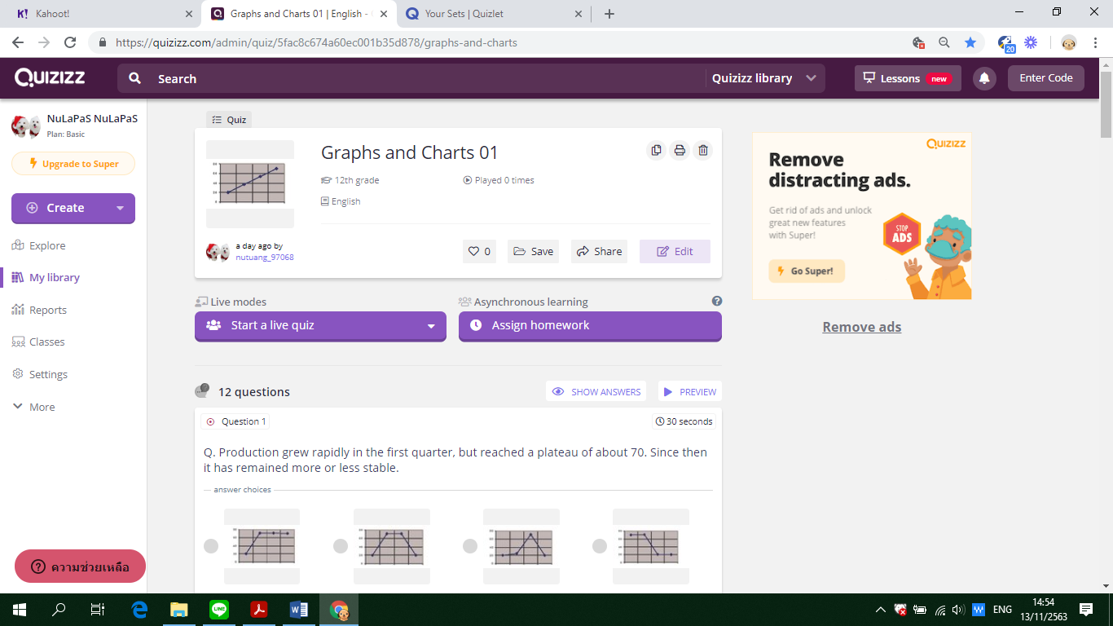

**Assumption College**

**Learning Management Plan**

**Semester: 2 Academic Year: 2025 Week: 6**

**Subject Code: EN30230 Subject: English Skill Development 2**

**Level of Students: M. 6 Learning Unit: Vocabulary Growth**

**Topic: Line graphs Time: 1 Period**

**Learning Outcomes (4):** Develop accuracy and fluency by identifying and correcting errors in grammar, sentence structure, and word usage in both written and spoken communication.

**Learning Objective:**

**Knowledge:** The students will be able to match phrases with the trends.

**Process/Skill:** The students will be able todescribe a line graph.

**Desirable Characteristics:** Gentlemen of Assumption College

**Learners’ Key Competencies**

**☑** communication capability

🞎 thinking capability

🞎 problem solving capability

🞎 capability in applying life skills and

🞎 capability in technological application

**Content: Describing a line graph**

**Activities: (SIOP + Cooperative Learning + STAD)**

1. Students are shown clearly defined content objectives. Tell them that they will be discussing how to describe a line graph. **(Preparation)**  
2.Concepts should be directly linked to students’ background experience. Ask students to work in **groups of 4** **with different levels of ability**. Ask them about paraphrasing. Give examples of paraphrasing an introduction of the graph. Then discuss the pattern. (**Building Background**)

3.Use speech that is appropriate for students' language proficiency to talk about the outline of a line graph. Let them find the mistakes in the line graph to make them become familiar with it. (**Comprehensible Input**)

4.Use of a variety of question types, including those that promote higher level thinking skills. Have them look at the line graph and analyze the topic of the graph. What they should conclude in the introduction. Provide ample opportunities for students to use learning strategies. (**Student Strategies for Success**)

5. Have them work in group again and let them write the introduction of the graph. Ample wait time for student-student interactions. Students share the answers. The class talks about whether the word formation is correct. (**Interactions**)

6.Accommodate students and keep them engaged for at least 90% of the lesson. (**Lesson Delivery**)

7.Ask each team to look match the phrases with the graphs and describe trends. **Provide activities for each team to apply content and language knowledge in the classroom and work cooperatively with teacher-provided worksheets and answer sheets**. **Have the STAD teams play games concerning** word formation using **Quizlet.**  (**Practice / Application**)

8.Handout assignment and explain. Review material and ask students if they have any questions. Assess them using **Kahoot!!** to check if the students understand the concepts of the lesson. **In the assessment stage, each student individually takes a quiz.** **Then their scores are combined and compared to their own past averages and points. Each team will be awarded on the basis of the degree to which students meet or exceed their own earlier performance**. (**Review and Assessment**)

**Learning Materials**

**☑** Textbook

**☑** PowerPoint Presentation

🞎 Dictionary

🞎 Websites

🞎 Google Forms, Google Slides

**☑** Kahoot!, Quizizz or Quizlet, AC Online Classroom

🞎 Socrative

**Teaching Procedures:**

**Teaching Model □** 5E Model **□** PPP **□** Explicit Teaching Model

**□** CIPPA **□** CALLA **☑** SIOP

**□** Others**………**

**Teaching Method □** CLT **□** CBL **□** TBL

**□** The Direct Method **□** Real**-**life scenarios

**□** The Structural Approach **☑** Cooperative Learning

**□** Others**………**

**Teaching Technique □** KWL-Plus **□** CIRC **□** Brainstorming

**☑** STAD **□** Dramatization **□** Group discussion

**□** Pair work **□** Peer Teaching **□** Mind Maps

**□** Group work **□** Others**………**

**Evaluation:**

|  |  |  |
| --- | --- | --- |
| **Learning Objective** | **Evaluation Method** | **Evaluation Tools** |
| Knowledge | Checking the quizzes in the textbook | Quizzes/Test |
| Process/Skill | Oral recitation of passages/answers | Oral evaluation |
| Desirable Characteristics | Observation | Observationform |

**Post-Teaching Recommendation:**

|  |  |  |  |  |  |  |  |
| --- | --- | --- | --- | --- | --- | --- | --- |
| Post Evaluation | CLASS | % of students who passed | | | % of students who didn’t pass | | |
| Indicator | | | Indicator | | |
| 1 |  |  | 1 |  |  |
| KNOWLEDGE | M.6/1 |  |  |  |  |  |  |
| M.6/2 |  |  |  |  |  |  |
| M.6/3 |  |  |  |  |  |  |
| M.6/4 |  |  |  |  |  |  |
| M.6/5 |  |  |  |  |  |  |
| M.6/6 |  |  |  |  |  |  |
| M.6/7 |  |  |  |  |  |  |
| M.6/8 |  |  |  |  |  |  |
|  |  |  |  |  |  |  |

**How to solve the problem**: Knowledge

🞎 Review students’ prior knowledge

🞎 Review what students have learned again slowly.

🞎 Advise students to search further information on internet

🞎 Spare some time to teach them individually or in group

🞎 Give some more exercises / reports

🞎 Assign students to do group work or pair work

🞎 Let the encounter “Learning by Doing” process as much as possible.

|  |  |  |  |  |  |  |  |
| --- | --- | --- | --- | --- | --- | --- | --- |
| Post Evaluation | CLASS | % of students who passed | | | % of students who didn’t pass | | |
| Indicator | | | Indicator | | |
| 1 |  |  | 1 |  |  |
| PROCESS/SKILL | M.6/1 |  |  |  |  |  |  |
| M.6/2 |  |  |  |  |  |  |
| M.6/3 |  |  |  |  |  |  |
| M.6/4 |  |  |  |  |  |  |
| M.6/5 |  |  |  |  |  |  |
| M.6/6 |  |  |  |  |  |  |
| M.6/7 |  |  |  |  |  |  |
| M.6/8 |  |  |  |  |  |  |
|  |  |  |  |  |  |  |

**How to solve the problem**: Skill

🞎 Encourage them to listen / speak / read / or write from other sources.

🞎 Practice them to listen / speak / read / or write

🞎 Give them more chance to use all skills in English while teaching.

🞎 Let them criticize themselves the weak point in studying in that period and help them solve that problem.

|  |  |  |  |  |  |  |  |
| --- | --- | --- | --- | --- | --- | --- | --- |
| Post Evaluation | CLASS | % of students who passed | | | % of students who didn’t pass | | |
| Indicator | | | Indicator | | |
| 1 |  |  | 1 |  |  |
| DESIRABLE  CHARACTERISTICS | M.6/1 |  |  |  |  |  |  |
| M.6/2 |  |  |  |  |  |  |
| M.6/3 |  |  |  |  |  |  |
| M.6/4 |  |  |  |  |  |  |
| M.6/5 |  |  |  |  |  |  |
| M.6/6 |  |  |  |  |  |  |
| M.6/7 |  |  |  |  |  |  |
| M.6/8 |  |  |  |  |  |  |
|  |  |  |  |  |  |  |

**How to solve the problem**: Desirable Characteristics

🞎 Point out the importance of that qualification.

🞎 Give them some incentives

🞎 Give warning / suggestion / detention

🞎 Encourage them to have this desirable characteristic

**Follow-Up .....……………………..……………………………………………………..………………………………………………..………………**

………………………………..……………………………………………………..……………………………………………………..……………………

………………………………..……………………………………………………..……………………………………………………..……………………

Teacher Ms. Lapassanun J.

Head of Foreign Languages Department Ms. Lapassanun J.

|  |
| --- |
| แบบสรุปการใช้ ICT ระดับชั้นมัธยมศึกษาปีที่ 6 |
| วิชา การพัฒนาทักษะภาษาอังกฤษ 2 (อ30230) |
| ครูผู้สอน มิสลภัสนันท์ จันทน์โรจน์ |

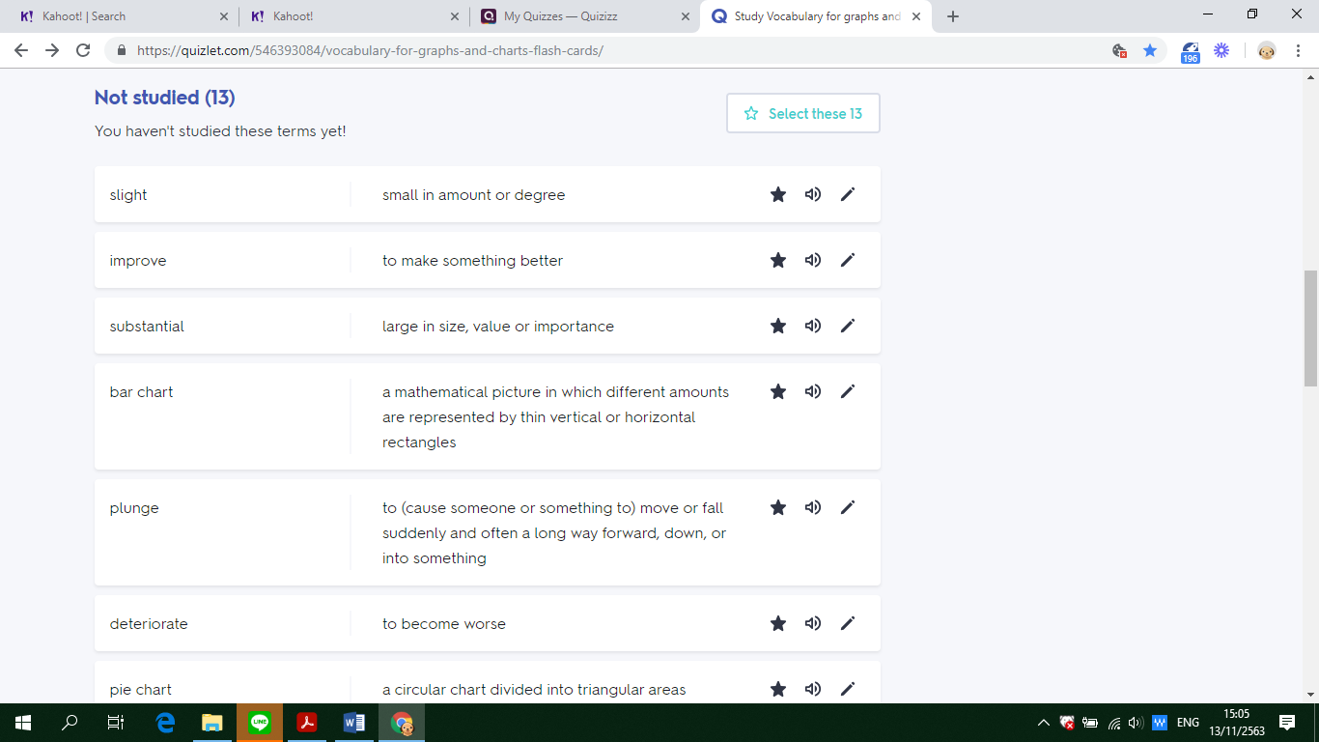

**Assumption College**

**Learning Management Plan**

**Semester: 2 Academic Year: 2025 Week: 7**

**Subject Code: EN30230 Subject: English Skill Development 2**

**Level of Students: M. 6 Learning Unit: The Art of Sentence Variety Topic: Bar charts Time: 1 Period**

**Learning Outcomes (8):** Communicate ideas effectively through accurate and sophisticated use of vocabulary, grammar, and language structures in diverse academic and real-life scenarios.

**Learning Objective:**

**Knowledge:** The students will be able to fill in the blanks with correct answers.

**Process/Skill:** The students will be able todescribe a bar chart.

**Desirable Characteristics:** Public mindedness

**Learners’ Key Competencies**

🞎communication capability

**☑** thinking capability

🞎 problem solving capability

🞎 capability in applying life skills and

🞎 capability in technological application

**Content: Describing a bar chart**

**Activities: (CALLA)**

1. Engage students in the topic and identify objectives for the lesson. Find out what students already know about it and motivate them to learn more. Tell students that in this lesson, they are going to learn to describe a bar chart. **(Preparation)**
2. Present new information. Have students work in pairs. Let them look at the bar chart and fill in the blanks with correct answers. Discuss connections to students' prior knowledge. Explain the target learning strategy for the lesson. **(Presentation)**
3. Have students form groups of four. Have them look at the chart and fill in the blanks with the most suitable words or phrases given to describe the bar charts. Remind students to use the learning strategyand have them write the introduction from the bar chart given. **(Practice)**
4. Question students so they will reflect on their own learning. Ask students to their own learning rather than wait for the teacher to assess them. **(Self-Evaluation)**
5. Students are told to describe the graph. Therefore, students will have to practice more. Guide students on how to apply what they learned to their own lives. Point out other contexts where the learning strategy may help. **(Expansion)**

**Learning Materials**

**☑** Textbook

**☑** PowerPoint Presentation

🞎 Dictionary

🞎 Websites

🞎 Google Forms, Google Slides

**☑** Kahoot!, Quizizz or Quizlet, AC Online Classroom

🞎 Socrative

**Teaching Procedures:**

**Teaching Model □** 5E Model **□** PPP **□** Explicit Teaching Model

**□** CIPPA **☑** CALLA **□** SIOP

**□** Others**………**

**Teaching Method □** CLT **□** CBL **□** TBL

**□** The Direct Method **□** Real**-**life scenarios

**□** The Structural Approach **□** Cooperative Learning

**□** Others**………**

**Teaching Technique □** KWL-Plus **□** CIRC **□** Brainstorming

**□** STAD **□** Dramatization **□** Group discussion

**□** Pair work **□** Peer Teaching **□** Mind Maps

**□** Group work **□** Others**………**

**Evaluation:**

|  |  |  |
| --- | --- | --- |
| **Learning Objective** | **Evaluation Method** | **Evaluation Tools** |
| Knowledge | Checking the quizzes in the textbook | Quizzes/Test |
| Process/Skill | Oral recitation of passages/answers | Oral evaluation |
| Desirable Characteristics | Observation | Observationform |

**Post-Teaching Recommendation:**

|  |  |  |  |  |  |  |  |
| --- | --- | --- | --- | --- | --- | --- | --- |
| Post Evaluation | CLASS | % of students who passed | | | % of students who didn’t pass | | |
| Indicator | | | Indicator | | |
| 1 |  |  | 1 |  |  |
| KNOWLEDGE | M.6/1 |  |  |  |  |  |  |
| M.6/2 |  |  |  |  |  |  |
| M.6/3 |  |  |  |  |  |  |
| M.6/4 |  |  |  |  |  |  |
| M.6/5 |  |  |  |  |  |  |
| M.6/6 |  |  |  |  |  |  |
| M.6/7 |  |  |  |  |  |  |
| M.6/8 |  |  |  |  |  |  |
|  |  |  |  |  |  |  |

**How to solve the problem**: Knowledge

🞎 Review students’ prior knowledge

🞎 Review what students have learned again slowly.

🞎 Advise students to search further information on internet

🞎 Spare some time to teach them individually or in group

🞎 Give some more exercises / reports

🞎 Assign students to do group work or pair work

🞎 Let the encounter “Learning by Doing” process as much as possible.

|  |  |  |  |  |  |  |  |
| --- | --- | --- | --- | --- | --- | --- | --- |
| Post Evaluation | CLASS | % of students who passed | | | % of students who didn’t pass | | |
| Indicator | | | Indicator | | |
| 1 |  |  | 1 |  |  |
| PROCESS/SKILL | M.6/1 |  |  |  |  |  |  |
| M.6/2 |  |  |  |  |  |  |
| M.6/3 |  |  |  |  |  |  |
| M.6/4 |  |  |  |  |  |  |
| M.6/5 |  |  |  |  |  |  |
| M.6/6 |  |  |  |  |  |  |
| M.6/7 |  |  |  |  |  |  |
| M.6/8 |  |  |  |  |  |  |
|  |  |  |  |  |  |  |

**How to solve the problem**: Skill

🞎 Encourage them to listen / speak / read / or write from other sources.

🞎 Practice them to listen / speak / read / or write

🞎 Give them more chance to use all skills in English while teaching.

🞎 Let them criticize themselves the weak point in studying in that period and help them solve that problem.

|  |  |  |  |  |  |  |  |
| --- | --- | --- | --- | --- | --- | --- | --- |
| Post Evaluation | CLASS | % of students who passed | | | % of students who didn’t pass | | |
| Indicator | | | Indicator | | |
| 1 |  |  | 1 |  |  |
| DESIRABLE  CHARACTERISTICS | M.6/1 |  |  |  |  |  |  |
| M.6/2 |  |  |  |  |  |  |
| M.6/3 |  |  |  |  |  |  |
| M.6/4 |  |  |  |  |  |  |
| M.6/5 |  |  |  |  |  |  |
| M.6/6 |  |  |  |  |  |  |
| M.6/7 |  |  |  |  |  |  |
| M.6/8 |  |  |  |  |  |  |
|  |  |  |  |  |  |  |

**How to solve the problem**: Desirable Characteristics

🞎 Point out the importance of that qualification.

🞎 Give them some incentives

🞎 Give warning / suggestion / detention

🞎 Encourage them to have this desirable characteristic

**Follow-Up .....……………………..……………………………………………………..………………………………………………..………………**

………………………………..……………………………………………………..……………………………………………………..……………………

………………………………..……………………………………………………..……………………………………………………..……………………

Teacher Ms. Lapassanun J.

Head of Foreign Languages Department Ms. Lapassanun J.

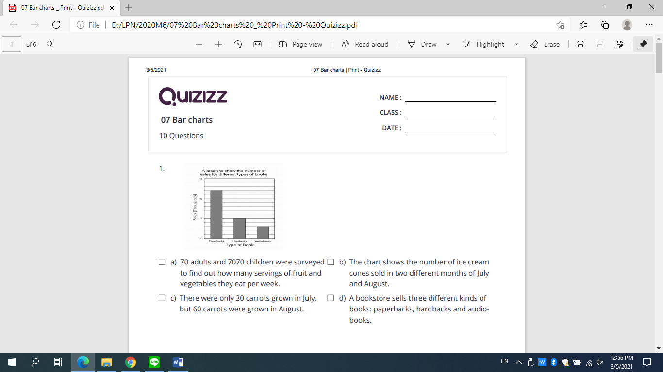

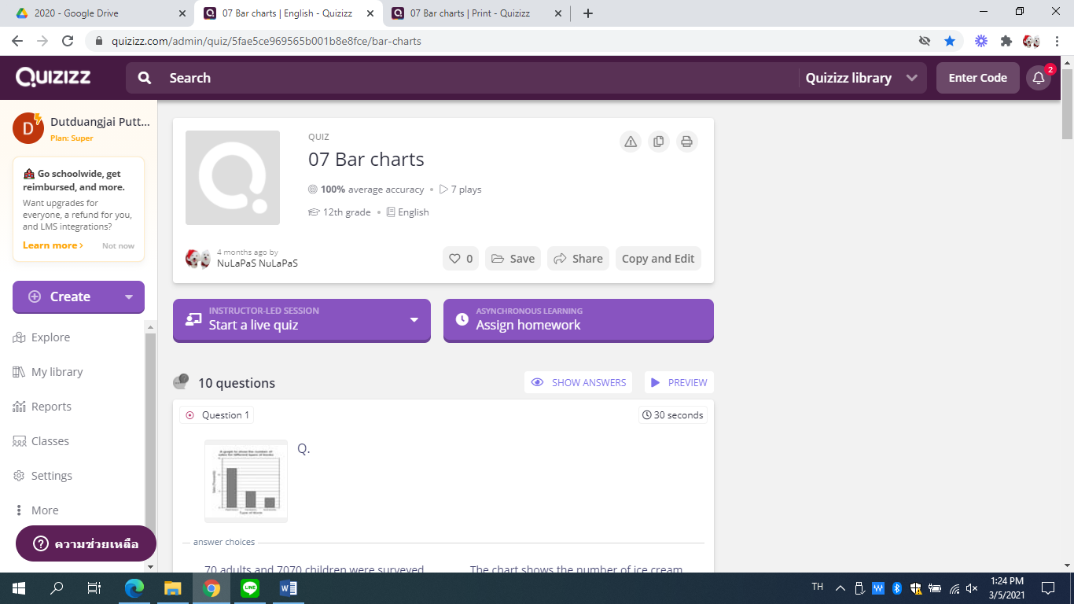

**Assumption College**

**Learning Management Plan**

**Semester: 2 Academic Year: 2025 Week: 8**

**Subject Code: EN30230 Subject: English Skill Development 2 Level of Students: M. 6 Learning Unit: The Art of Sentence Variety Topic: Summative Test Time: 1 Period**

**Summative Examination**

**Assumption College**

**Learning Management Plan**

**Semester: 2 Academic Year: 2025 Week:9**

**Subject Code: EN30230 Subject: English Skill Development 2 Level of Students: M. 6 Learning Unit: The Art of Sentence Variety Topic: Summative Test Time: 1 Period**

**Summative Examination**

**Assumption College**

**Learning Management Plan**

**Semester: 2 Academic Year: 2025 Week: 10**

**Subject Code: EN30230 Subject: English Skill Development 2**

**Level of Students: M. 6 Learning Unit: Precision in Sentence Construction**

**Topic: Summative Test Time: 1 Period**

**Holidays**

**Assumption College**

**Learning Management Plan**

**Semester: 2 Academic Year: 2025 Week: 11**

**Subject Code: EN30230 Subject: English Skill Development 2**

**Level of Students: M. 6 Learning Unit: Precision in Sentence Construction**

**Topic: Pie charts Time: 1 Period**

**Learning Outcomes (5):** Integrate advanced sentence structures and cohesive devices to produce clear, organized, and contextually appropriate responses in writing and speaking**.**

**Learning Objective:**

**Knowledge:** The students will be able to fill in the blanks with correct answers.

**Process/Skill:** The students will be able to describe a pie chart.

**Desirable Characteristics:** Dedication and commitment to work

**Learners’ Key Competencies**

🞎communication capability

🞎 thinking capability

**☑** problem solving capability

🞎 capability in applying life skills and

🞎 capability in technological application

**Content: Describing pie charts**

**Activities: (Explicit Teaching Model)**

1. Review the lesson of last period. **(Revision)**
2. Have the students learn in groups and let them discuss in group about how to describe a pie chart using their schemata from the previous lessons. **(Teaching)**
3. Let students look at the charts and fill in the charts with the most suitable linking words. Provide time for students to do exercises by themselves. **(Practice under supervision)**
4. Explain them why each item is right or wrong. Give them more suggestions of how to answer about the charts. **(Giving correction)**
5. Ask students to login to ‘https://www.rapidtables.com/tools/pie-chart.html’ and create a pie chart. **(Individual practice)**
6. Mr. X monthly income is $ 14400. The monthly expenses of his family on various items are given below.

|  |  |  |  |  |  |
| --- | --- | --- | --- | --- | --- |
| **Item** | **Rent** | **Food** | **Clothing** | **Education** | **Savings** |
| Expenditure (in Dollar) | 4000 | 5400 | 2800 | 1800 | 400 |

Represent the above data by a pie chart.

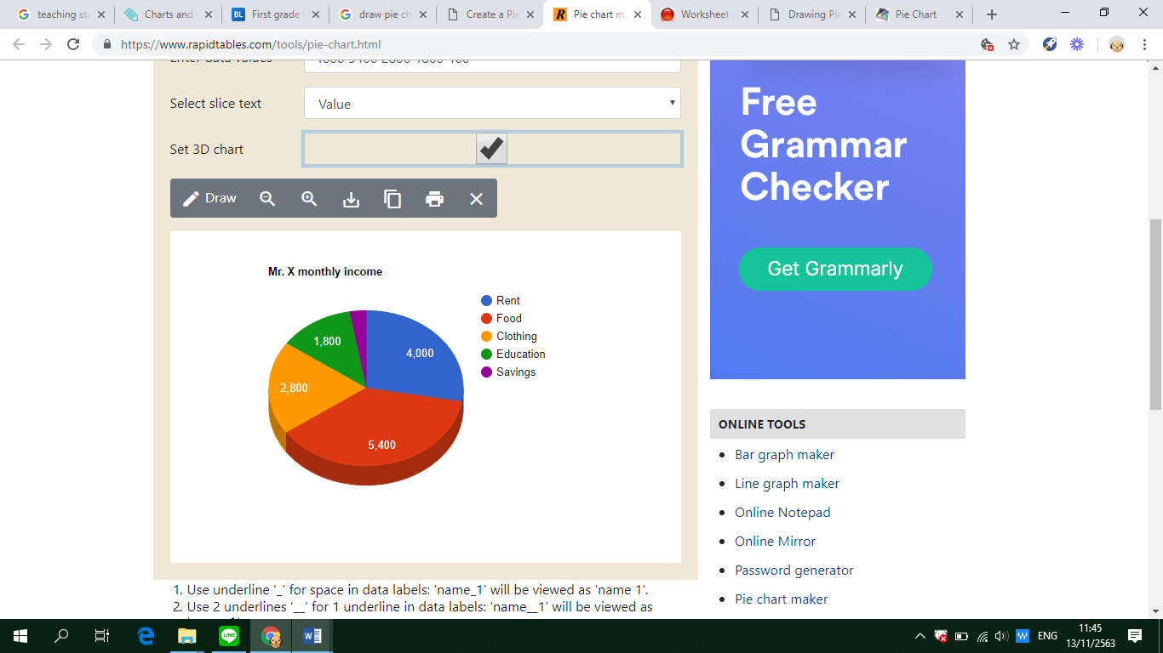

1. In a Zoological park there are 1000 creatures as per the following table given below:

|  |  |  |  |  |
| --- | --- | --- | --- | --- |
| **Beast Animals** | **Other Land Animals** | **Birds** | **Water Animals** | **Reptiles** |
| 150 | 400 | 225 | 175 | 50 |

Represent the above data by a pie chart.

1. Various modes of transport used by 1260 students in a given school are given below:

|  |  |  |  |  |
| --- | --- | --- | --- | --- |
| **School Bus** | **Private Bus** | **Bicycle** | **Rickshaw** | **On foot** |
| 350 | 245 | 210 | 175 | 280 |

Represent the above data by a pie chart.

1. The data given below shows number of hours spent by a school boy on different activities on a working day.

|  |  |  |  |  |  |  |
| --- | --- | --- | --- | --- | --- | --- |
| **Activity** | **School** | **Homework** | **Play** | **Sleep** | **Others** | **Total** |
| No. of hours | 7 | 4 | 2 | 8 | 3 | 24 |

Represent the above data by a pie graph.

1. In a company there are 1080 workers of different religions. The data of the different religion are given below:

|  |  |  |  |  |
| --- | --- | --- | --- | --- |
| **Religion** | **Hindu** | **Nepali** | **Islam** | **Christian** |
| No. of workers | 450 | 270 | 255 | 105 |

1. Give some assignments to students to practice. **(Revision)**

**Learning Materials**

**☑** Textbook

**☑** PowerPoint Presentation

🞎 Dictionary

🞎 Websites

**☑** Google Forms, Google Slides

**☑** Kahoot!, Quizizz or Quizlet, AC Online Classroom

🞎 Socrative

**Teaching Procedures:**

**Teaching Model □** 5E Model **□** PPP **☑** Explicit Teaching Model

**□** CIPPA **□** CALLA **□** SIOP

**□** Others**………**

**Teaching Method □** CLT **□** CBL **□** TBL

**□** The Direct Method **□** Real**-**life scenarios

**□** The Structural Approach **□** Cooperative Learning

**□** Others**………**

**Teaching Technique □** KWL-Plus **□** CIRC **□** Brainstorming

**□** STAD **□** Dramatization **□** Group discussion

**□** Pair work **□** Peer Teaching **□** Mind Maps

**□** Group work **□** Others**………**

**Evaluation:**

|  |  |  |
| --- | --- | --- |
| **Learning Objective** | **Evaluation Method** | **Evaluation Tools** |
| Knowledge | Checking the quizzes in the textbook | Quizzes/Test |
| Process/Skill | Oral recitation of passages/answers | Oral evaluation |
| Desirable Characteristics | Observation | Observationform |

**Post-Teaching Recommendation:**

|  |  |  |  |  |  |  |  |
| --- | --- | --- | --- | --- | --- | --- | --- |
| Post Evaluation | CLASS | % of students who passed | | | % of students who didn’t pass | | |
| Indicator | | | Indicator | | |
| 1 |  |  | 1 |  |  |
| KNOWLEDGE | M.6/1 |  |  |  |  |  |  |
| M.6/2 |  |  |  |  |  |  |
| M.6/3 |  |  |  |  |  |  |
| M.6/4 |  |  |  |  |  |  |
| M.6/5 |  |  |  |  |  |  |
| M.6/6 |  |  |  |  |  |  |
| M.6/7 |  |  |  |  |  |  |
| M.6/8 |  |  |  |  |  |  |
|  |  |  |  |  |  |  |

**How to solve the problem**: Knowledge

🞎 Review students’ prior knowledge

🞎 Review what students have learned again slowly.

🞎 Advise students to search further information on internet

🞎 Spare some time to teach them individually or in group

🞎 Give some more exercises / reports

🞎 Assign students to do group work or pair work

🞎 Let the encounter “Learning by Doing” process as much as possible.

|  |  |  |  |  |  |  |  |
| --- | --- | --- | --- | --- | --- | --- | --- |
| Post Evaluation | CLASS | % of students who passed | | | % of students who didn’t pass | | |
| Indicator | | | Indicator | | |
| 1 |  |  | 1 |  |  |
| PROCESS/SKILL | M.6/1 |  |  |  |  |  |  |
| M.6/2 |  |  |  |  |  |  |
| M.6/3 |  |  |  |  |  |  |
| M.6/4 |  |  |  |  |  |  |
| M.6/5 |  |  |  |  |  |  |
| M.6/6 |  |  |  |  |  |  |
| M.6/7 |  |  |  |  |  |  |
| M.6/8 |  |  |  |  |  |  |
|  |  |  |  |  |  |  |

**How to solve the problem**: Skill

🞎 Encourage them to listen / speak / read / or write from other sources.

🞎 Practice them to listen / speak / read / or write

🞎 Give them more chance to use all skills in English while teaching.

🞎 Let them criticize themselves the weak point in studying in that period and help them solve that problem.

|  |  |  |  |  |  |  |  |
| --- | --- | --- | --- | --- | --- | --- | --- |
| Post Evaluation | CLASS | % of students who passed | | | % of students who didn’t pass | | |
| Indicator | | | Indicator | | |
| 1 |  |  | 1 |  |  |
| DESIRABLE  CHARACTERISTICS | M.6/1 |  |  |  |  |  |  |
| M.6/2 |  |  |  |  |  |  |
| M.6/3 |  |  |  |  |  |  |
| M.6/4 |  |  |  |  |  |  |
| M.6/5 |  |  |  |  |  |  |
| M.6/6 |  |  |  |  |  |  |
| M.6/7 |  |  |  |  |  |  |
| M.6/8 |  |  |  |  |  |  |
|  |  |  |  |  |  |  |

**How to solve the problem**: Desirable Characteristics

🞎 Point out the importance of that qualification.

🞎 Give them some incentives

🞎 Give warning / suggestion / detention

🞎 Encourage them to have this desirable characteristic

**Follow-Up .....……………………..……………………………………………………..………………………………………………..………………**

………………………………..……………………………………………………..……………………………………………………..……………………

………………………………..……………………………………………………..……………………………………………………..……………………

Teacher Ms. Lapassanun J.

Head of Foreign Languages Department Ms. Lapassanun J.

**Assumption College**

**Learning Management Plan**

**Semester: 2 Academic Year: 2025 Week: 12**

**Subject Code: EN30230 Subject: English Skill Development 2**

**Level of Students: M. 6 Learning Unit: Precision in Sentence Construction**

**Topic: Describing tables Time: 1 Period**

**Learning Outcomes (7):** Enhance listening and reading comprehension by extracting relevant information, making inferences, and predicting outcomes based on context.

**Learning Objective:**

**Knowledge:** The students will be able to extract data from a given passage and organize it into a chart.

**Process/Skill:** The students will be able to explain the data presented in the chart.

**Desirable Characteristics:** Cherishing Thai-ness

**Learners’ Key Competencies**

🞎communication capability

🞎 thinking capability

🞎 problem solving capability

**☑** capability in applying life skills and

🞎 capability in technological application

**Content: Identifying the main idea of the passage**

**Activities: (PPP)**

1. Start the lesson by displaying a passage containing statistical information. Highlight key data points and show an example of a chart or diagram that represents the data visually. Ask students to discuss how the chart reflects the passage. **(Warm Up / Lead-In)**
2. Present the correct chart based on the passage. Explain how specific pieces of information from the passage are organized into the chart. Discuss strategies for interpreting data and connecting it to the text. **(Presentation)**
3. **Promote the 21st century learning skills in terms of communication by allowing students to communicate in English and work in group.** Provide each group with a passage containing numerical or descriptive data. Ask them to extract the data and collaboratively create a chart to represent the information. Groups then present their charts to the class for review. **(Practice)**
4. Allow groups to exchange their charts and passages with another group for peer evaluation. Each group reviews the other’s chart for accuracy and clarity. Use Kahoot! to quiz students on interpreting charts and connecting them to the corresponding text. **(Practice)**
5. Have students individually create a chart from a new passage. Provide an example of a well-constructed chart for reference. End the session by reviewing their charts, offering constructive feedback, and addressing common mistakes. **(Production)**
6. Assign students a task to extract data from a passage provided on Socrative. They must create a chart and write a short explanation of how the chart summarizes the key points of the passage. **(Assignment)**

**Learning Materials**

**☑** Textbook

**☑** PowerPoint Presentation

🞎 Dictionary

🞎 Websites

**☑** Google Forms, Google Slides

**☑** Kahoot!, Quizizz or Quizlet, AC Online Classroom

🞎 Socrative

**Teaching Procedures:**

**Teaching Model □** 5E Model **☑** PPP **□** Explicit Teaching Model

**□** CIPPA **□** CALLA **□** SIOP

**□** Others**………**

**Teaching Method □** CLT **□** CBL **□** TBL

**□** The Direct Method **□** Real**-**life scenarios

**□** The Structural Approach **□** Cooperative Learning

**□** Others**………**

**Teaching Technique □** KWL-Plus **□** CIRC **□** Brainstorming

**□** STAD **□** Dramatization **□** Group discussion

**□** Pair work **□** Peer Teaching **□** Mind Maps

**□** Group work **□** Others**………**

**Evaluation:**

|  |  |  |
| --- | --- | --- |
| **Learning Objective** | **Evaluation Method** | **Evaluation Tools** |
| Knowledge | Checking the quizzes in the textbook | Quizzes/Test |
| Process/Skill | Oral recitation of passages/answers | Oral evaluation |
| Desirable Characteristics | Observation | Observationform |

**Post-Teaching Recommendation:**

|  |  |  |  |  |  |  |  |
| --- | --- | --- | --- | --- | --- | --- | --- |
| Post Evaluation | CLASS | % of students who passed | | | % of students who didn’t pass | | |
| Indicator | | | Indicator | | |
| 1 |  |  | 1 |  |  |
| KNOWLEDGE | M.6/1 |  |  |  |  |  |  |
| M.6/2 |  |  |  |  |  |  |
| M.6/3 |  |  |  |  |  |  |
| M.6/4 |  |  |  |  |  |  |
| M.6/5 |  |  |  |  |  |  |
| M.6/6 |  |  |  |  |  |  |
| M.6/7 |  |  |  |  |  |  |
| M.6/8 |  |  |  |  |  |  |
|  |  |  |  |  |  |  |

**How to solve the problem**: Knowledge

🞎 Review students’ prior knowledge

🞎 Review what students have learned again slowly.

🞎 Advise students to search further information on internet

🞎 Spare some time to teach them individually or in group

🞎 Give some more exercises / reports

🞎 Assign students to do group work or pair work

🞎 Let the encounter “Learning by Doing” process as much as possible.

|  |  |  |  |  |  |  |  |
| --- | --- | --- | --- | --- | --- | --- | --- |
| Post Evaluation | CLASS | % of students who passed | | | % of students who didn’t pass | | |
| Indicator | | | Indicator | | |
| 1 |  |  | 1 |  |  |
| PROCESS/SKILL | M.6/1 |  |  |  |  |  |  |
| M.6/2 |  |  |  |  |  |  |
| M.6/3 |  |  |  |  |  |  |
| M.6/4 |  |  |  |  |  |  |
| M.6/5 |  |  |  |  |  |  |
| M.6/6 |  |  |  |  |  |  |
| M.6/7 |  |  |  |  |  |  |
| M.6/8 |  |  |  |  |  |  |
|  |  |  |  |  |  |  |

**How to solve the problem**: Skill

🞎 Encourage them to listen / speak / read / or write from other sources.

🞎 Practice them to listen / speak / read / or write

🞎 Give them more chance to use all skills in English while teaching.

🞎 Let them criticize themselves the weak point in studying in that period and help them solve that problem.

|  |  |  |  |  |  |  |  |
| --- | --- | --- | --- | --- | --- | --- | --- |
| Post Evaluation | CLASS | % of students who passed | | | % of students who didn’t pass | | |
| Indicator | | | Indicator | | |
| 1 |  |  | 1 |  |  |
| DESIRABLE  CHARACTERISTICS | M.6/1 |  |  |  |  |  |  |
| M.6/2 |  |  |  |  |  |  |
| M.6/3 |  |  |  |  |  |  |
| M.6/4 |  |  |  |  |  |  |
| M.6/5 |  |  |  |  |  |  |
| M.6/6 |  |  |  |  |  |  |
| M.6/7 |  |  |  |  |  |  |
| M.6/8 |  |  |  |  |  |  |
|  |  |  |  |  |  |  |

**How to solve the problem**: Desirable Characteristics

🞎 Point out the importance of that qualification.

🞎 Give them some incentives

🞎 Give warning / suggestion / detention

🞎 Encourage them to have this desirable characteristic

**Follow-Up .....……………………..……………………………………………………..………………………………………………..………………**

………………………………..……………………………………………………..……………………………………………………..……………………

………………………………..……………………………………………………..……………………………………………………..……………………

Teacher Ms. Lapassanun J.

Head of Foreign Languages Department Ms. Lapassanun J.

**Assumption College**

**Learning Management Plan**

**Semester: 2 Academic Year: 2025 Week: 13**

**Subject Code: EN30230 Subject: English Skill Development 2**

**Level of Students: M. 6 Learning Unit: Advanced Sentence Transformation**

**Topic: Sentence Completion Time: 1 Period**

**Learning Outcomes (6):** Apply critical thinking and analytical skills to complete tasks such as sentence completion, error identification, and reading comprehension across various text types.

**Learning Objective:**

**Knowledge:** The students will be able to identify the sentence structure used in each sentence.  
**Process/Skill:** The students will be able to choose the most appropriate structure to complete the sentences.

**Desirable Characteristics:** Honesty and integrity

**Learners’ Key Competencies**

🞎communication capability

🞎 thinking capability

🞎 problem solving capability

🞎 capability in applying life skills and

**☑** capability in technological application

**Content: Identifying the sentence structure**

**Activities: CIPPA**

1. Activate students’ prior knowledge by revisiting common sentence structures, such as simple, compound, and complex sentences. Compare these with Thai sentence structures and ask students to discuss examples in pairs. Present a few sentences with missing parts and ask students to suggest possible completions. **(Activating prior knowledge)**
2. Encourage students to seek new knowledge by showing 10 incomplete sentences. Provide options with different sentence structures for each sentence. Use colors to label the type of structure for each option. Let students analyze and discuss in pairs which structure fits best, with teacher guidance for corrections. **(Seeking new knowledge)**
3. Provide a worksheet with sentences requiring specific structures to be filled in (e.g., participial phrases, relative clauses, or absolute phrases). Explain the rules for selecting the most appropriate structure. Allow students to practice by completing the sentences together as a class. **(Integrating knowledge)**
4. Have students complete additional exercises in the textbook individually, focusing on filling in sentences with the perfect structure. Then, group them into teams of four to discuss their answers and justify their choices based on the rules they learned. **(Sharing knowledge)**
5. Ask groups to summarize the rules for selecting and using the appropriate sentence structure. Groups present their summaries to the class, and the teacher provides feedback to refine their understanding. **(Conclusion and knowledge organization)**
6. Have students share their answers to the textbook exercises with the class. Discuss the correct structures and clarify any common errors, ensuring that students understand how to use each structure effectively. **(Showing tasks)**
7. Divide students into heterogeneous groups of four. Use Kahoot! to quiz them on identifying and completing sentences with the correct structure. Discuss the correct answers after each question and reinforce the lesson's key points. **(Knowledge application)**

**Learning Materials**

**☑** Textbook

**☑** PowerPoint Presentation

🞎 Dictionary

🞎 Websites

**☑** Google Forms, Google Slides

**☑** Kahoot!, Quizizz or Quizlet, AC Online Classroom

🞎 Socrative

**Teaching Procedures:**

**Teaching Model □** 5E Model **□** PPP **□** Explicit Teaching Model

**☑** CIPPA **□** CALLA **□** SIOP

**□** Others**………**

**Teaching Method □** CLT **□** CBL **□** TBL

**□** The Direct Method **□** Real**-**life scenarios

**□** The Structural Approach **□** Cooperative Learning

**□** Others**………**

**Teaching Technique □** KWL-Plus **□** CIRC **□** Brainstorming

**□** STAD **□** Dramatization **□** Group discussion

**□** Pair work **□** Peer Teaching **□** Mind Maps

**□** Group work **□** Others**………**

**Evaluation:**

|  |  |  |
| --- | --- | --- |
| **Learning Objective** | **Evaluation Method** | **Evaluation Tools** |
| Knowledge | Checking the quizzes in the textbook | Quizzes/Test |
| Process/Skill | Oral recitation of passages/answers | Oral evaluation |
| Desirable Characteristics | Observation | Observationform |

**Post-Teaching Recommendation:**

|  |  |  |  |  |  |  |  |
| --- | --- | --- | --- | --- | --- | --- | --- |
| Post Evaluation | CLASS | % of students who passed | | | % of students who didn’t pass | | |
| Indicator | | | Indicator | | |
| 1 |  |  | 1 |  |  |
| KNOWLEDGE | M.6/1 |  |  |  |  |  |  |
| M.6/2 |  |  |  |  |  |  |
| M.6/3 |  |  |  |  |  |  |
| M.6/4 |  |  |  |  |  |  |
| M.6/5 |  |  |  |  |  |  |
| M.6/6 |  |  |  |  |  |  |
| M.6/7 |  |  |  |  |  |  |
| M.6/8 |  |  |  |  |  |  |
|  |  |  |  |  |  |  |

**How to solve the problem**: Knowledge

🞎 Review students’ prior knowledge

🞎 Review what students have learned again slowly.

🞎 Advise students to search further information on internet

🞎 Spare some time to teach them individually or in group

🞎 Give some more exercises / reports

🞎 Assign students to do group work or pair work

🞎 Let the encounter “Learning by Doing” process as much as possible.

|  |  |  |  |  |  |  |  |
| --- | --- | --- | --- | --- | --- | --- | --- |
| Post Evaluation | CLASS | % of students who passed | | | % of students who didn’t pass | | |
| Indicator | | | Indicator | | |
| 1 |  |  | 1 |  |  |
| PROCESS/SKILL | M.6/1 |  |  |  |  |  |  |
| M.6/2 |  |  |  |  |  |  |
| M.6/3 |  |  |  |  |  |  |
| M.6/4 |  |  |  |  |  |  |
| M.6/5 |  |  |  |  |  |  |
| M.6/6 |  |  |  |  |  |  |
| M.6/7 |  |  |  |  |  |  |
| M.6/8 |  |  |  |  |  |  |
|  |  |  |  |  |  |  |

**How to solve the problem**: Skill

🞎 Encourage them to listen / speak / read / or write from other sources.

🞎 Practice them to listen / speak / read / or write

🞎 Give them more chance to use all skills in English while teaching.

🞎 Let them criticize themselves the weak point in studying in that period and help them solve that problem.

|  |  |  |  |  |  |  |  |
| --- | --- | --- | --- | --- | --- | --- | --- |
| Post Evaluation | CLASS | % of students who passed | | | % of students who didn’t pass | | |
| Indicator | | | Indicator | | |
| 1 |  |  | 1 |  |  |
| DESIRABLE  CHARACTERISTICS | M.6/1 |  |  |  |  |  |  |
| M.6/2 |  |  |  |  |  |  |
| M.6/3 |  |  |  |  |  |  |
| M.6/4 |  |  |  |  |  |  |
| M.6/5 |  |  |  |  |  |  |
| M.6/6 |  |  |  |  |  |  |
| M.6/7 |  |  |  |  |  |  |
| M.6/8 |  |  |  |  |  |  |
|  |  |  |  |  |  |  |

**How to solve the problem**: Desirable Characteristics

🞎 Point out the importance of that qualification.

🞎 Give them some incentives

🞎 Give warning / suggestion / detention

🞎 Encourage them to have this desirable characteristic

**Follow-Up .....……………………..………………**

………………………………..……………………………………………………..……………………………………………………..……………………

………………………………..……………………………………………………..……………………………………………………..……………………

Teacher Ms. Lapassanun J.

Head of Foreign Languages Department Ms. Lapassanun J.

**Assumption College**

**Learning Management Plan**

**Semester: 2 Academic Year: 2025 Week: 14**

**Subject Code: EN30230 Subject: English Skill Development 2**

**Level of Students: M. 6 Learning Unit: Advanced Sentence Transformation**

**Topic: Sentence Completion Time: 1 Period**

**Learning Outcomes (10):** Utilize linguistic and cultural knowledge to interpret and produce texts that align with academic, social, and professional expectations.

**Learning Objective:**

**Knowledge:** The students will be able to identify the sentence structure used in each sentence.  
**Process/Skill:** The students will be able to choose the most appropriate structure to complete the sentences.

**Desirable Characteristics:** Honesty and integrity

**Learners’ Key Competencies**

**☑** communication capability

🞎 thinking capability

🞎 problem solving capability

🞎 capability in applying life skills and

🞎 capability in technological application

**Content: Identifying the sentence structure**

**Activities: CIPPA**

1. Activate students’ prior knowledge by revisiting common sentence structures, such as simple, compound, and complex sentences. Compare these with Thai sentence structures and ask students to discuss examples in pairs. Present a few sentences with missing parts and ask students to suggest possible completions. **(Activating prior knowledge)**
2. Encourage students to seek new knowledge by showing 10 incomplete sentences. Provide options with different sentence structures for each sentence. Use colors to label the type of structure for each option. Let students analyze and discuss in pairs which structure fits best, with teacher guidance for corrections. **(Seeking new knowledge)**
3. Provide a worksheet with sentences requiring specific structures to be filled in (e.g., participial phrases, relative clauses, or absolute phrases). Explain the rules for selecting the most appropriate structure. Allow students to practice by completing the sentences together as a class. **(Integrating knowledge)**
4. Have students complete additional exercises in the textbook individually, focusing on filling in sentences with the perfect structure. Then, group them into teams of four to discuss their answers and justify their choices based on the rules they learned. **(Sharing knowledge)**
5. Ask groups to summarize the rules for selecting and using the appropriate sentence structure. Groups present their summaries to the class, and the teacher provides feedback to refine their understanding. **(Conclusion and knowledge organization)**
6. Have students share their answers to the textbook exercises with the class. Discuss the correct structures and clarify any common errors, ensuring that students understand how to use each structure effectively. **(Showing tasks)**
7. Divide students into heterogeneous groups of four. Use Kahoot! to quiz them on identifying and completing sentences with the correct structure. Discuss the correct answers after each question and reinforce the lesson's key points. **(Knowledge application)**

**Learning Materials**

**☑** Textbook

**☑** PowerPoint Presentation

🞎 Dictionary

🞎 Websites

**☑** Google Forms, Google Slides

**☑** Kahoot!, Quizizz or Quizlet, AC Online Classroom

🞎 Socrative

**Teaching Procedures:**

**Teaching Model □** 5E Model **□** PPP **□** Explicit Teaching Model

**☑** CIPPA **□** CALLA **□** SIOP

**□** Others**………**

**Teaching Method □** CLT **□** CBL **□** TBL

**□** The Direct Method **□** Real**-**life scenarios

**□** The Structural Approach **□** Cooperative Learning

**□** Others**………**

**Teaching Technique □** KWL-Plus **□** CIRC **□** Brainstorming

**□** STAD **□** Dramatization **□** Group discussion

**□** Pair work **□** Peer Teaching **□** Mind Maps

**□** Group work **□** Others**………**

**Evaluation:**

|  |  |  |
| --- | --- | --- |
| **Learning Objective** | **Evaluation Method** | **Evaluation Tools** |
| Knowledge | Checking the quizzes in the textbook | Quizzes/Test |
| Process/Skill | Oral recitation of passages/answers | Oral evaluation |
| Desirable Characteristics | Observation | Observationform |

**Post-Teaching Recommendation:**

|  |  |  |  |  |  |  |  |
| --- | --- | --- | --- | --- | --- | --- | --- |
| Post Evaluation | CLASS | % of students who passed | | | % of students who didn’t pass | | |
| Indicator | | | Indicator | | |
| 1 |  |  | 1 |  |  |
| KNOWLEDGE | M.6/1 |  |  |  |  |  |  |
| M.6/2 |  |  |  |  |  |  |
| M.6/3 |  |  |  |  |  |  |
| M.6/4 |  |  |  |  |  |  |
| M.6/5 |  |  |  |  |  |  |
| M.6/6 |  |  |  |  |  |  |
| M.6/7 |  |  |  |  |  |  |
| M.6/8 |  |  |  |  |  |  |
|  |  |  |  |  |  |  |

**How to solve the problem**: Knowledge

🞎 Review students’ prior knowledge

🞎 Review what students have learned again slowly.

🞎 Advise students to search further information on internet

🞎 Spare some time to teach them individually or in group

🞎 Give some more exercises / reports

🞎 Assign students to do group work or pair work

🞎 Let the encounter “Learning by Doing” process as much as possible.

|  |  |  |  |  |  |  |  |
| --- | --- | --- | --- | --- | --- | --- | --- |
| Post Evaluation | CLASS | % of students who passed | | | % of students who didn’t pass | | |
| Indicator | | | Indicator | | |
| 1 |  |  | 1 |  |  |
| PROCESS/SKILL | M.6/1 |  |  |  |  |  |  |
| M.6/2 |  |  |  |  |  |  |
| M.6/3 |  |  |  |  |  |  |
| M.6/4 |  |  |  |  |  |  |
| M.6/5 |  |  |  |  |  |  |
| M.6/6 |  |  |  |  |  |  |
| M.6/7 |  |  |  |  |  |  |
| M.6/8 |  |  |  |  |  |  |
|  |  |  |  |  |  |  |

**How to solve the problem**: Skill

🞎 Encourage them to listen / speak / read / or write from other sources.

🞎 Practice them to listen / speak / read / or write

🞎 Give them more chance to use all skills in English while teaching.

🞎 Let them criticize themselves the weak point in studying in that period and help them solve that problem.

|  |  |  |  |  |  |  |  |
| --- | --- | --- | --- | --- | --- | --- | --- |
| Post Evaluation | CLASS | % of students who passed | | | % of students who didn’t pass | | |
| Indicator | | | Indicator | | |
| 1 |  |  | 1 |  |  |
| DESIRABLE  CHARACTERISTICS | M.6/1 |  |  |  |  |  |  |
| M.6/2 |  |  |  |  |  |  |
| M.6/3 |  |  |  |  |  |  |
| M.6/4 |  |  |  |  |  |  |
| M.6/5 |  |  |  |  |  |  |
| M.6/6 |  |  |  |  |  |  |
| M.6/7 |  |  |  |  |  |  |
| M.6/8 |  |  |  |  |  |  |
|  |  |  |  |  |  |  |

**How to solve the problem**: Desirable Characteristics

🞎 Point out the importance of that qualification.

🞎 Give them some incentives

🞎 Give warning / suggestion / detention

🞎 Encourage them to have this desirable characteristic

**Follow-Up .....……………………..……………………………………………………..………………………………………………..………………**

Teacher Ms. Lapassanun J.

Head of Foreign Languages Department Ms. Lapassanun J.

**Assumption College**

**Learning Management Plan**

**Semester: 2 Academic Year: 2025 Week: 15**

**Subject Code: EN30230 Subject: English Skill Development 2**

**Level of Students: M. 6 Learning Unit: Advanced Sentence Transformation**

**Topic: Final Examination Time: 1 Period**

**Final Examination**