

**Assumption College**

Content Group: Foreign Languages

Subject Code: 30220

Subject: Academic English

Transition Year: Secondary 6/1-9

Semester: 2

Academic Year: 2021

Teacher (s) Ms. Lapassanun Juntarote

Head of Content Group: Ms. Lapassanun Juntarote

|  |  |  |  |  |  |  |  |  |  |  |  |
| --- | --- | --- | --- | --- | --- | --- | --- | --- | --- | --- | --- |
| Miss Lapassanun Juntarote Class M. 6/1-9 1 Period: Week | | | | | | | | | | | |
| Learning Management Plan Analysis | | | | | | | | | | | |
| Plan | Learning Outcomes | | | | | | | Proc | Desi | Note |
| Period | 1 | 2 | 3 | 4 | 5 | 6 | 7 |  |  |  |
| 1 |  |  |  |  |  | **/** |  | 5E | Avidity for learning |  |
| 2 |  |  |  | **/** |  |  |  | Explicit | Self-discipline |  |
| 3 |  |  |  |  |  |  | **/** | KWL-Plus | Cherishing Thai-ness |  |
| 4 |  |  | **/** |  |  |  |  | PPP&CIRC | Honesty and integrity |  |
| 5 | **/** |  |  |  |  |  |  | CIRC and Cooperative Learning | Observance of principles of Sufficiency Economy Philosophy in one’s way of life |  |
| 6 |  |  |  |  | **/** |  |  | (SIOP + Cooperative Learning + STAD) | Gentlemen of Assumption College |  |
| 7 |  |  |  |  | **/** |  |  | CALLA | Public-mindedness |  |
| 8 |  |  |  |  |  |  |  |  |  | Exam |
| 9 |  |  |  |  |  |  |  |  |  | Exam |
| 10 |  |  |  |  |  |  |  |  |  | Holidays |
| 11 |  | **/** |  |  |  |  |  | Explicit | Dedication and commitment to work |  |
| 12 |  |  |  |  |  |  | **/** | PPP | Cherishing Thai-ness |  |
| 13 |  |  |  | **/** |  |  |  | CIPPA | Honesty and integrity |  |
| 14 |  |  |  | **/** |  |  |  | CIPPA | Honesty and integrity |  |
| 15 |  |  |  |  |  |  |  |  |  | Exam |

**Learning Standards and Indicators**

**The Department of Foreign Languages Level of Students: M. 6**

**Subject Code: EN30220 Subject: English for IELTS 2**

|  |  |  |  |  |
| --- | --- | --- | --- | --- |
| **Indicators/Learning outcomes** | **Key Word** | **Learners’ Key Competencies - Activities** | **21st-Century Skill/**  **Local Wisdom/Thai Wisdom/**  **Sufficiency Economy Philosophy /School Focus** | **Desirables** |
| 1. Identify topic sentences of paragraphs, identify main ideas and overall meaning of texts to complete diagrams, match headings with paragraphs, and differentiate paragraph headings according to content | identify, analyze, provide, match, differentiate, choose, give examples | Learners’ Key Competencies  communication capability  thinking capability  problem solving capability  capability in applying life skills and  capability in technological application  Activities  5E Model / PPP / Explicit Teaching Model / CIPPA / CALLA / SIOP / CLT/ CBL / TBL / The Direct Method / Real-life scenarios / The Structural Approach / Cooperative Learning/ KWL-Plus / CIRC / Brainstorming / STAD/ Dramatization / Group discussion / Pair work / Peer Teaching / Mind Maps / Group works | Reading, Writing, Critical Thinking and Problem Solving, Creativity and Innovation,  Cross-cultural Understanding, Collaboration, Teamwork and Leadership,  Communications, Information, and Media Literacy,  Computing and ICT Literacy,  Career and Learning Skills,  Compassion,  Learning, Leadership | 1. Love of nation, religion and king  2. Honesty and integrity  3. Self-discipline  4. Avidity for learning  5. Observance of principles of Sufficiency Economy Philosophy in one’s way of life  6. Dedication and commitment to work  7. Cherishing Thai-ness  8. Public-mindedness  9. Gentlemen of Assumption College |
| 2. Demonstrate comprehension of text details to perform sentence completion tasks, extract key points from academic texts, identify antonyms and synonyms in written text, employ strategies to deal with unknown vocabulary and interpret written texts to identify and match detailed information | demonstrate, identify, complete, employ, use, interpret, match |
| 3. Combine and organise paragraphs to respond to an opinion essay, employ complex connectors to link cause and effect clauses, formulate a clear thesis statement, identify main features of a diagram and write a paragraph plan under time restraints by using self-assess own writing for grammatical mistakes | write, exchange, speak,  explain, express, discuss, provide, describe, combine, organize, use, employ, identify |
| 4. Write to describe non-text media such as graphs and charts, argue a position in an essay and apply the conventions of academic writing in English | write, describe, explain, express, argue, discuss, compose, provide, summarize, conclude |
| 5. Identify key information to complete notes or to complete gaps in sentences from a listening or a lecture, identify correct word forms in a listening task, identify relevant details in a listening to discern correct answer among multiple choices, listen to identify specific information needed to complete a flow chart and discern key points in a lecture to chronologically arrange stages in a process | identify, explain, analyze, discuss, provide, compare, contrast, apply, use, express, summarize, conclude |
| 6. Use a wide range of structures, comprehensive vocabulary and effective pronunciation features with full flexibility, fluency and accuracy, to clearly present arguments according to common conventions with logically organized information and ideas, in either speaking or writing to the questions asked | employ, use, pronounce, identify, classify, present, develop, organize, discuss,  conclude, summarize, |
| 7. Explain, analyse and discuss hobbies, interests, feelings, beliefs and origins of customs and traditions of native speakers along with similarities and differences between the lifestyles, beliefs and culture of native speakers and those of Thais, and apply them appropriately | employ, use, state, define, arrange, justify, provide, categorize, critique, differentiate, debate, compare, contrast |

**Course Description**

**The Department of Foreign Languages Level of Students: M. 6**

**Subject Code: EN30220 Subject: English for IELTS 2**

**Number of Credit: 0.5 Time: 20 Periods**

**Learning Outcomes**

1. Identify topic sentences of paragraphs, identify main ideas and overall meaning of texts to complete diagrams, match headings with paragraphs, and differentiate paragraph headings according to content

2. Demonstrate comprehension of text details to perform sentence completion tasks, extract key points from academic texts, identify antonyms and synonyms in written text, employ strategies to deal with unknown vocabulary and interpret written texts to identify and match detailed information

3. Combine and organise paragraphs to respond to an opinion essay, employ complex connectors to link cause and effect clauses, formulate a clear thesis statement, identify main features of a diagram and write a paragraph plan under time restraints by using self-assess own writing for grammatical mistakes

4. Write to describe non-text media such as graphs and charts, argue a position in an essay and apply the conventions of academic writing in English

5. Identify key information to complete notes or to complete gaps in sentences from a listening or a lecture, identify correct word forms in a listening task, identify relevant details in a listening to discern correct answer among multiple choices, listen to identify specific information needed to complete a flow chart and discern key points in a lecture to chronologically arrange stages in a process

6. Use a wide range of structures, comprehensive vocabulary and effective pronunciation features with full flexibility, fluency and accuracy, to clearly present arguments according to common conventions with logically organized information and ideas, in either speaking or writing to the questions asked

7. Explain, analyse and discuss hobbies, interests, feelings, beliefs and origins of customs and traditions of native speakers along with similarities and differences between the lifestyles, beliefs and culture of native speakers and those of Thais, and apply them appropriately

**Course Description**

**Students will** identify topic sentences and main ideas of paragraphs and antonyms and synonyms in written text, match headings with paragraphs, differentiate paragraph headings according to content, demonstrate comprehension of text details to perform sentence completion tasks, employ strategies to deal with unknown vocabulary and interpret written texts to identify and match detailed information. They will combine and organise paragraphs to respond to an opinion essay, employ complex connectors to link clauses, formulate a clear thesis statement, identify main features of a diagram and write a paragraph plan under time restraints by using self-assess own writing for grammatical mistakes. They will write to describe non-text media, argue a position in an essay, apply the conventions of academic writing in English, identify key information to complete notes or to complete gaps in sentences from a listening or a lecture, discern key points in a lecture to chronologically arrange stages in a process. They will use a wide range of structures, comprehensive vocabulary and effective pronunciation features to clearly present arguments in either speaking or writing to the questions asked and explain, analyse and discuss hobbies, interests, feelings, beliefs and origins of customs and traditions of native speakers along with similarities and differences between the lifestyles, beliefs and culture of native speakers and those of Thais, and apply them appropriately.

**They will do this by using learning skills in the 21st century,** which encourages the students to be able to have **reading, writing, critical thinking and problem solving skills.** Other skills include **creativity and innovation, cross-cultural understanding, collaboration, teamwork and leadership.** They also promote the students to have skills in terms of **communications, information, and media literacy, computing and ICT literacy, career and learning skills, compassion, learning, and leadership.** The learning skills will be used to make students possess **learners’ key competencies**, which are **thinking capability, problem solving capability, capability in applying life skills and capability in technological application**.This will be done **through the teaching and learning** focusing on promoting **Thai wisdom** with respect to the language and literature and religion and tradition. Teaching and learning also promotes students to live under the **Sufficiency Economy Philosophy.** Students will be provided with **desirable characteristics** such as **love of nation, religion and king, honesty and integrity and self-discipline**. Additional important characteristics are **avidity for learning, observance of principles of Sufficiency Economy Philosophy in one’s way of life, dedication and commitment to work, cherishing Thai-ness, public-mindedness and gentlemen of Assumption College**.

**FSG’ Moral Values**

**Desirable Characteristics**

1. Love of nation, religion and king

2. Honesty and integrity

3. Self-discipline

4. Avidity for learning

5. Observance of principles of Sufficiency Economy Philosophy in one’s way of life

6. Dedication and commitment to work

7. Cherishing Thai-ness

8. Public-mindedness

9. Gentlemen of Assumption College

**Learning Unit**

**The Department of Foreign Languages Level of Students: M. 6**

**Subject Code: EN30220 Subject: English for IELTS 2**

**Number of Credit: 0.5 Time: 20 Periods**

|  |  |  |  |  |
| --- | --- | --- | --- | --- |
| **Learning Unit** | **Time/Period** | **Learners’ Key Competencies - Activities** | **Teaching Materials** | **Evaluation Tools** |
| **1. Graphs, charts and trends**  1. Listening Dialogue and Grammar and Structure  2. Reading Passages and vocabulary  3. Conversation and speaking  4. Writing and gap filling | **(4)**  1  1  1  1 | **Learners’ Key Competencies**  communication capability  thinking capability  problem solving capability  capability in applying life skills and  capability in technological application  **Activities**  5E Model / PPP / Explicit Teaching Model / CIPPA / CALLA / SIOP **/** CLT/ CBL / TBL / The Direct Method / Real-life scenarios / The Structural Approach / Cooperative Learning/ KWL-Plus / CIRC / Brainstorming / STAD/ Dramatization / Group discussion / Pair work / Peer Teaching / Mind Maps / Group work | 1. Textbook 2. PowerPoint Presentation 3. Dictionary 4. Websites 5. Google Forms 6. Google Slides 7. YouTube 8. Videos 9. Supplementary Sheets 10. Newspapers 11. Magazines 12. Kahoot! 13. Socrative | 1. Quizzes 2. Tests 3. Oral evaluation 4. Exercises 5. Mind-map 6. Observation form |

**Learning Unit**

**The Department of Foreign Languages Level of Students: M. 6**

**Subject Code: EN30220 Subject: Academic English 5**

**Number of Credit: 0.5 Time: 20 Periods**

|  |  |  |  |  |  |  |  |
| --- | --- | --- | --- | --- | --- | --- | --- |
| **Learning Unit** | | **Time/Period** | | **Learners’ Key Competencies - Activities** | | **Teaching Materials** | **Evaluation Method** |
| **2. Numbers and statistics**  1. Listening Dialogue and Grammar and Structure  2. Reading Passages and vocabulary  3. Conversation and speaking  4. Writing and gap filling | **(4)**  1  1  1  1 | | **Learners’ Key Competencies**  communication capability  thinking capability  problem solving capability  capability in applying life skills and  capability in technological application  **Activities**  5E Model / PPP / Explicit Teaching Model / CIPPA / CALLA / SIOP **/** CLT/ CBL / TBL / The Direct Method / Real-life scenarios / The Structural Approach / Cooperative Learning/ KWL-Plus / CIRC / Brainstorming / STAD/ Dramatization / Group discussion / Pair work / Peer Teaching / Mind Maps / Group work | | 1. Textbook 2. PowerPoint Presentation 3. Dictionary 4. Websites 5. Google Forms 6. Google Slides 7. YouTube 8. Videos 9. Supplementary Sheets 10. Newspapers 11. Magazines 12. Kahoot! 13. Socrative | | 1. Quizzes 2. Tests 3. Oral evaluation 4. Exercises 5. Mind-map 6. Observation form |

**Learning Unit**

**The Department of Foreign Languages Level of Students: M. 6**

**Subject Code: EN30220 Subject: Academic English 5**

**Number of Credit: 0.5 Time: 20 Periods**

|  |  |  |  |  |  |  |  |
| --- | --- | --- | --- | --- | --- | --- | --- |
| **Learning Unit** | | **Time/Period** | | **Learners’ Key Competencies - Activities** | | **Teaching Materials** | **Evaluation Method** |
| **3. Business and finance**  1. Listening Dialogue and Grammar and Structure  2. Reading Passages and vocabulary  3. Conversation and speaking  4. Writing and gap filling | **(4)**  1  1  1  1 | | **Learners’ Key Competencies**  communication capability  thinking capability  problem solving capability  capability in applying life skills and  capability in technological application  **Activities**  5E Model / PPP / Explicit Teaching Model / CIPPA / CALLA / SIOP **/** CLT/ CBL / TBL / The Direct Method / Real-life scenarios / The Structural Approach / Cooperative Learning/ KWL-Plus / CIRC / Brainstorming / STAD/ Dramatization / Group discussion / Pair work / Peer Teaching / Mind Maps / Group work | | 1. Textbook 2. PowerPoint Presentation 3. Dictionary 4. Websites 5. Google Forms 6. Google Slides 7. YouTube 8. Videos 9. Supplementary Sheets 10. Newspapers 11. Magazines 12. Kahoot! 13. Socrative | | 1. Quizzes 2. Tests 3. Oral evaluation 4. Exercises 5. Mind-map 6. Observation form |

**Learning Unit**

**The Department of Foreign Languages Level of Students: M. 6**

**Subject Code: EN30220 Subject: Academic English 5**

**Number of Credit: 0.5 Time: 20 Periods**

|  |  |  |  |  |
| --- | --- | --- | --- | --- |
| **Learning Unit** | **Time/Period** | **Learners’ Key Competencies - Activities** | **Teaching Materials** | **Evaluation Method** |
| **4. Infographics**  1. Listening Dialogue and Grammar and Structure  2. Reading Passages and vocabulary  3. Conversation and speaking  4. Writing and gap filling | **(4)**  1  1  1  1 | **Learners’ Key Competencies**  communication capability  thinking capability  problem solving capability  capability in applying life skills and  capability in technological application  **Activities**  5E Model / PPP / Explicit Teaching Model / CIPPA / CALLA / SIOP **/** CLT/ CBL / TBL / The Direct Method / Real-life scenarios / The Structural Approach / Cooperative Learning/ KWL-Plus / CIRC / Brainstorming / STAD/ Dramatization / Group discussion / Pair work / Peer Teaching / Mind Maps / Group work | 1. Textbook 2. PowerPoint Presentation 3. Dictionary 4. Websites 5. Google Forms 6. Google Slides 7. YouTube 8. Videos 9. Supplementary Sheets 10. Newspapers 11. Magazines 12. Kahoot! 13. Socrative | 1. Quizzes 2. Tests 3. Oral evaluation 4. Exercises 5. Mind-map 6. Observation form |

**Learning Unit**

**The Department of Foreign Languages Level of Students: M. 6**

**Subject Code: EN30220 Subject: Academic English 5**

**Number of Credit: 0.5 Time: 20 Periods**

|  |  |  |  |  |
| --- | --- | --- | --- | --- |
| **Learning Unit** | **Time/Period** | **Learners’ Key Competencies - Activities** | **Teaching Materials** | **Evaluation Method** |
| **5. Global learning**  1. Listening Dialogue and Grammar and Structure  2. Reading Passages and vocabulary  3. Conversation and speaking  4. Writing and gap filling | **(4)**  1  1  1  1 | **Learners’ Key Competencies**  communication capability  thinking capability  problem solving capability  capability in applying life skills and  capability in technological application  **Activities**  5E Model / PPP / Explicit Teaching Model / CIPPA / CALLA / SIOP **/** CLT/ CBL / TBL / The Direct Method / Real-life scenarios / The Structural Approach / Cooperative Learning/ KWL-Plus / CIRC / Brainstorming / STAD/ Dramatization / Group discussion / Pair work / Peer Teaching / Mind Maps / Group work | 1. Textbook 2. PowerPoint Presentation 3. Dictionary 4. Websites 5. Google Forms 6. Google Slides 7. YouTube 8. Videos 9. Supplementary Sheets 10. Newspapers 11. Magazines 12. Kahoot! 13. Socrative | 1. Quizzes 2. Tests 3. Oral evaluation 4. Exercises 5. Mind-map 6. Observation form |

|  |  |  |  |
| --- | --- | --- | --- |
| List of ICT Used | | | |
| Level: Secondary 6 | | | |
| Academic English (EN30220) | | | |
|  | | | |
| Semester 2 | | | |
| Week | Period | Topic | Website |
| 1 | 1 | Greek and Latin Root Words | Kahoot! |
| 2 | 1 | Root words | Kahoot! |
| 3 | 1 | Vocabulary | Kahoot! |
| 4 | 1 | Cloze test | Kahoot! |
| 5 | 1 | Graphs and charts | Quizizz |
| 6 | 1 | Vocabulary for graphs and charts | Quitlet |
| 7 | 1 | Bar charts | Quizizz |
| 8 |  | Summative test |  |
| 9 |  | Summative test |  |
| 11 | 1 | Pie charts | Rapidtable |
| 12 | 1 | Describing tables | Kahoot! |
| 13 | 1 | Sentence completion | Kahoot! |
| 14 | 1 | Sentence completion | Kahoot! |
| 15 |  | Final test |  |

**Assumption College**

**Learning Management Plan**

**Semester: 2 Academic Year: 2021 Week: 1**

**Subject Code: EN30220 Subject: Academic English 6**

**Level of Students: M. 6 Learning Unit: Graphs, charts and trends**

**Topic: Greek and Latin Root Words Time: 1 Period**

**Learning Outcomes (6):** Use a wide range of structures, comprehensive vocabulary and effective pronunciation features with full flexibility, fluency and accuracy, to clearly present arguments according to common conventions with logically organized information and ideas, in either speaking or writing to the questions asked

**Learning Objective:**

**Knowledge:** The students will be able to list Greek and Latin root words.

**Process/Skill:** The students will be able to match Greek and Latin root words of the same meaning.

**Desirable Characteristics:**Avidity for learning

**Learners’ Key Competencies**

**☑** communication capability

🞎 thinking capability

🞎 problem solving capability

🞎 capability in applying life skills and

🞎 capability in technological application

**Content: Greek and Latin Root Words**

**Activities: (5 E Learning Cycle Model)**

1. Students are asked several probing questions about Greek and Latin root words. **(Engagement)**
2. Student-to-student interaction is encouraged by having them work in groups. Observe and listen to the students as they interact.Have them do a warm-up activity from the document. Provide time for students to do the activity. **(Exploration)**
3. Students are encouraged to use their common experiences to compare and contrast the **Thai and English wisdoms in terms of Languages**. Have them identify **Greek and Latin root words**. Help them understand the synonyms of each kind. **(Explanation)**
4. Students' attention on conceptual connections between the topic is focused. Students work as a group to match the synonyms of the root words given. **(Elaboration)**
5. Students are assessed their understanding by playing a Kahoot! game. Encourage students to assess their own progress. **(Evaluation)**

**Learning Materials**

**☑** Textbook

**☑** PowerPoint Presentation

🞎 Dictionary

🞎 Websites

**☑** Google Forms, Google Slides

🞎 Kahoot!, Quizizz or Quizlet, AC Online Classroom

🞎 Socrative

**Teaching Procedures:**

**Teaching Model** ☑ 5E Model **□** PPP **□** Explicit Teaching Model

**□** CIPPA **□** CALLA **□** SIOP

**□** Others**………**

**Teaching Method □** CLT **□** CBL **□** TBL

**□** The Direct Method **□** Real**-**life scenarios

**□** The Structural Approach **□** Cooperative Learning

**□** Others**………**

**Teaching Technique □** KWL-Plus **□** CIRC **□** Brainstorming

**□** STAD **□** Dramatization **□** Group discussion

**□** Pair work **□** Peer Teaching **□** Mind Maps

**□** Group work **□** Others**………**

**Evaluation:**

|  |  |  |
| --- | --- | --- |
| **Learning Objective** | **Evaluation Method** | **Evaluation Tools** |
| Knowledge | Checking the quizzes in the textbook | Quizzes/Test |
| Process/Skill | Oral recitation of passages/answers | Oral evaluation |
| Desirable Characteristics | Observation | Observationform |

**Post-Teaching Recommendation:**

|  |  |  |  |  |  |  |  |
| --- | --- | --- | --- | --- | --- | --- | --- |
| Post Evaluation | CLASS | % of students who passed | | | % of students who didn’t pass | | |
| Indicator | | | Indicator | | |
| 1 |  |  | 1 |  |  |
| KNOWLEDGE | M.6/1 |  |  |  |  |  |  |
| M.6/2 |  |  |  |  |  |  |
| M.6/3 |  |  |  |  |  |  |
| M.6/4 |  |  |  |  |  |  |
| M.6/5 |  |  |  |  |  |  |
| M.6/6 |  |  |  |  |  |  |
| M.6/7 |  |  |  |  |  |  |
| M.6/8 |  |  |  |  |  |  |
| M.6/9 |  |  |  |  |  |  |

**How to solve the problem**: Knowledge

🞎 Review students’ prior knowledge

🞎 Review what students have learned again slowly.

🞎 Advise students to search further information on internet

🞎 Spare some time to teach them individually or in group

🞎 Give some more exercises / reports

🞎 Assign students to do group work or pair work

🞎 Let the encounter “Learning by Doing” process as much as possible.

|  |  |  |  |  |  |  |  |
| --- | --- | --- | --- | --- | --- | --- | --- |
| Post Evaluation | CLASS | % of students who passed | | | % of students who didn’t pass | | |
| Indicator | | | Indicator | | |
| 1 |  |  | 1 |  |  |
| PROCESS/SKILL | M.6/1 |  |  |  |  |  |  |
| M.6/2 |  |  |  |  |  |  |
| M.6/3 |  |  |  |  |  |  |
| M.6/4 |  |  |  |  |  |  |
| M.6/5 |  |  |  |  |  |  |
| M.6/6 |  |  |  |  |  |  |
| M.6/7 |  |  |  |  |  |  |
| M.6/8 |  |  |  |  |  |  |
| M.6/9 |  |  |  |  |  |  |

**How to solve the problem**: Skill

🞎 Encourage them to listen / speak / read / or write from other sources.

🞎 Practice them to listen / speak / read / or write

🞎 Give them more chance to use all skills in English while teaching.

🞎 Let them criticize themselves the weak point in studying in that period and help them solve that problem.

|  |  |  |  |  |  |  |  |
| --- | --- | --- | --- | --- | --- | --- | --- |
| Post Evaluation | CLASS | % of students who passed | | | % of students who didn’t pass | | |
| Indicator | | | Indicator | | |
| 1 |  |  | 1 |  |  |
| DESIRABLE  CHARACTERISTICS | M.6/1 |  |  |  |  |  |  |
| M.6/2 |  |  |  |  |  |  |
| M.6/3 |  |  |  |  |  |  |
| M.6/4 |  |  |  |  |  |  |
| M.6/5 |  |  |  |  |  |  |
| M.6/6 |  |  |  |  |  |  |
| M.6/7 |  |  |  |  |  |  |
| M.6/8 |  |  |  |  |  |  |
| M.6/9 |  |  |  |  |  |  |

**How to solve the problem**: Desirable Characteristics

🞎 Point out the importance of that qualification.

🞎 Give them some incentives

🞎 Give warning / suggestion / detention

🞎 Encourage them to have this desirable characteristic

**Follow-Up**………………………..……………………………………………………..………………………………………………..………………

………………………………..……………………………………………………..……………………………………………………..……………………

………………………………..……………………………………………………..……………………………………………………..……………………

Teacher Ms. Lapassanun J.

Head of Foreign Languages Department Ms. Lapassanun J.

|  |
| --- |
| แบบสรุปการใช้ ICT ระดับชั้นมัธยมศึกษาปีที่ 6 |
| วิชา ภาษาอังกฤษเชิงวิชาการ 6 (อ 30220) |
| ครูผู้สอน มิสลภัสนันท์ จันทน์โรจน์ |

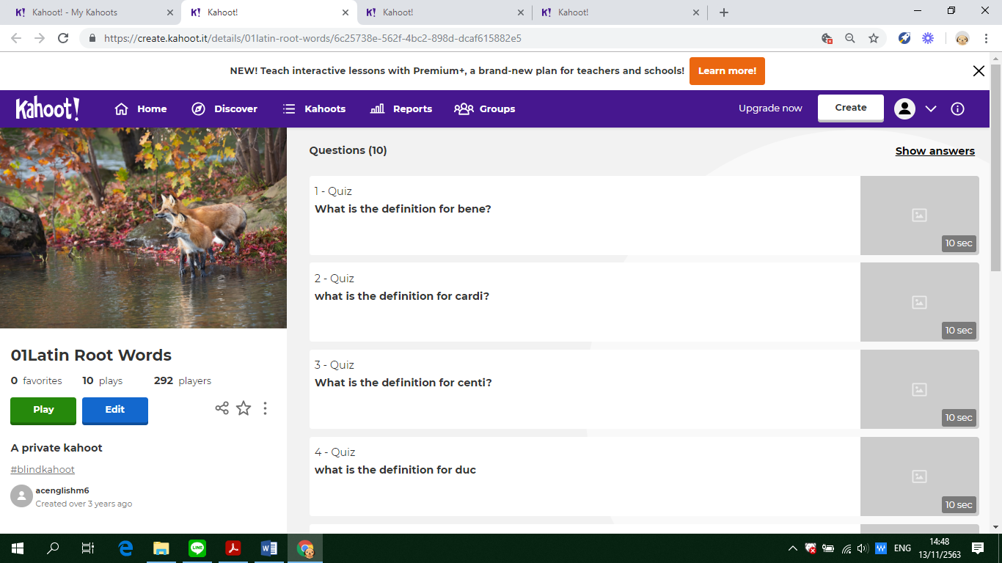

**Assumption College**

**Learning Management Plan**

**Semester: 2 Academic Year: 2021 Week: 2**

**Subject Code: EN30220 Subject: Academic English 6**

**Level of Students: M. 6 Learning Unit: Graphs, charts and trends**

**Topic: Word Parts Time: 1 Period**

**Learning Outcomes (4):** Write to describe non-text media such as graphs and charts, argue a position in an essay and apply the conventions of academic writing in English

**Learning Objective:**

**Knowledge:** The students will be able to identify root words.

**Process/Skill:** The students will be able togive the meaning of the root words.

**Desirable Characteristics:** Self-discipline

**Learners’ Key Competencies**

🞎communication capability

**☑** thinking capability

🞎 problem solving capability

🞎 capability in applying life skills and

🞎 capability in technological application

**Content: Identifying and giving the definition of the root words given**

**Activities: (Explicit Teaching Model)**

1. Review the lesson of last period. Then, write the following word on the board: ANTIDISESTABLISHMENTARIANISM

Ask students if they recognize any word or word parts. Have them share the word parts that they see, and as they share, underline or circle those word parts. Example: Anti-dis-establish-ment-arian-ism

Explain that when you know what each of the word parts means, you can use those meanings as clues to figure out the meaning of the whole word.

Ask students if they have heard of any other words that use any of these word parts (prefixes or suffixes). Example: Anti → Antiperspirant. Explain that to perspire is to sweat so what might ANTIperspirant be used for? **(Revision)**

1. Have students study the lesson in the book. Introduce the root word column, the meaning column, and the example column. Have students work in small groups for 20 minutes to see how many additional examples they can generate using the roots provided. After 20 minutes, share examples. After that, explain the rules appearing in the book rule by rule with exercises to help increase their understanding. **(Teaching)**
2. Let students do exercises after teaching rules. Then, randomly choose students to answer questions. If students can give clear explanation, continue next question, but if not, the teacher should explain it clearly. After that, provide time for students to do exercises by themselves. **(Practice under supervision)**
3. Random some students to answer each question with the correction, and tell the reason why they correct it like that with the help and suggestion of the teacher. **(Giving correction)**
4. **Promote the 21st century learning skills in terms of digital literacy by encouraging students to use smartphones to play interactive quizzes.** Ask students to login in **‘Socrative’** and do the exercises provided by the teacher. **(Individual practice)**
5. Give some assignments to students to practice. **(Revision)**

**Learning Materials**

**☑** Textbook

**☑** PowerPoint Presentation

🞎 Dictionary

🞎 Websites

**☑** Google Forms, Google Slides

🞎 Kahoot!, Quizizz or Quizlet, AC Online Classroom

🞎 Socrative

**Teaching Procedures:**

**Teaching Model □** 5E Model **□** PPP **☑**Explicit Teaching Model

**□** CIPPA **□** CALLA **□** SIOP

**□** Others**………**

**Teaching Method □** CLT **□** CBL **□** TBL

**□** The Direct Method **□** Real**-**life scenarios

**□** The Structural Approach **□** Cooperative Learning

**□** Others**………**

**Teaching Technique □** KWL-Plus **□** CIRC **□** Brainstorming

**□** STAD **□** Dramatization **□** Group discussion

**□** Pair work **□** Peer Teaching **□** Mind Maps

**□** Group work **□** Others**………**

**Evaluation:**

|  |  |  |
| --- | --- | --- |
| **Learning Objective** | **Evaluation Method** | **Evaluation Tools** |
| Knowledge | Checking the quizzes in the textbook | Quizzes/Test |
| Process/Skill | Oral recitation of passages/answers | Oral evaluation |
| Desirable Characteristics | Observation | Observationform |

**Post-Teaching Recommendation:**

|  |  |  |  |  |  |  |  |
| --- | --- | --- | --- | --- | --- | --- | --- |
| Post Evaluation | CLASS | % of students who passed | | | % of students who didn’t pass | | |
| Indicator | | | Indicator | | |
| 1 |  |  | 1 |  |  |
| KNOWLEDGE | M.6/1 |  |  |  |  |  |  |
| M.6/2 |  |  |  |  |  |  |
| M.6/3 |  |  |  |  |  |  |
| M.6/4 |  |  |  |  |  |  |
| M.6/5 |  |  |  |  |  |  |
| M.6/6 |  |  |  |  |  |  |
| M.6/7 |  |  |  |  |  |  |
| M.6/8 |  |  |  |  |  |  |
| M.6/9 |  |  |  |  |  |  |

**How to solve the problem**: Knowledge

🞎 Review students’ prior knowledge

🞎 Review what students have learned again slowly.

🞎 Advise students to search further information on internet

🞎 Spare some time to teach them individually or in group

🞎 Give some more exercises / reports

🞎 Assign students to do group work or pair work

🞎 Let the encounter “Learning by Doing” process as much as possible.

|  |  |  |  |  |  |  |  |
| --- | --- | --- | --- | --- | --- | --- | --- |
| Post Evaluation | CLASS | % of students who passed | | | % of students who didn’t pass | | |
| Indicator | | | Indicator | | |
| 1 |  |  | 1 |  |  |
| PROCESS/SKILL | M.6/1 |  |  |  |  |  |  |
| M.6/2 |  |  |  |  |  |  |
| M.6/3 |  |  |  |  |  |  |
| M.6/4 |  |  |  |  |  |  |
| M.6/5 |  |  |  |  |  |  |
| M.6/6 |  |  |  |  |  |  |
| M.6/7 |  |  |  |  |  |  |
| M.6/8 |  |  |  |  |  |  |
| M.6/9 |  |  |  |  |  |  |

**How to solve the problem**: Skill

🞎 Encourage them to listen / speak / read / or write from other sources.

🞎 Practice them to listen / speak / read / or write

🞎 Give them more chance to use all skills in English while teaching.

🞎 Let them criticize themselves the weak point in studying in that period and help them solve that problem.

|  |  |  |  |  |  |  |  |
| --- | --- | --- | --- | --- | --- | --- | --- |
| Post Evaluation | CLASS | % of students who passed | | | % of students who didn’t pass | | |
| Indicator | | | Indicator | | |
| 1 |  |  | 1 |  |  |
| DESIRABLE  CHARACTERISTICS | M.6/1 |  |  |  |  |  |  |
| M.6/2 |  |  |  |  |  |  |
| M.6/3 |  |  |  |  |  |  |
| M.6/4 |  |  |  |  |  |  |
| M.6/5 |  |  |  |  |  |  |
| M.6/6 |  |  |  |  |  |  |
| M.6/7 |  |  |  |  |  |  |
| M.6/8 |  |  |  |  |  |  |
| M.6/9 |  |  |  |  |  |  |

**How to solve the problem**: Desirable Characteristics

🞎 Point out the importance of that qualification.

🞎 Give them some incentives

🞎 Give warning / suggestion / detention

🞎 Encourage them to have this desirable characteristic

**Follow-Up**………………………..……………………………………………………..………………………………………………..………………

………………………………..……………………………………………………..……………………………………………………..……………………

………………………………..……………………………………………………..……………………………………………………..……………………

Teacher Ms. Lapassanun J.

Head of Foreign Languages Department Ms. Lapassanun J.

|  |
| --- |
| แบบสรุปการใช้ ICT ระดับชั้นมัธยมศึกษาปีที่ 6 |
| วิชา ภาษาอังกฤษเชิงวิชาการ 6 (อ 30220) |
| ครูผู้สอน มิสลภัสนันท์ จันทน์โรจน์ |

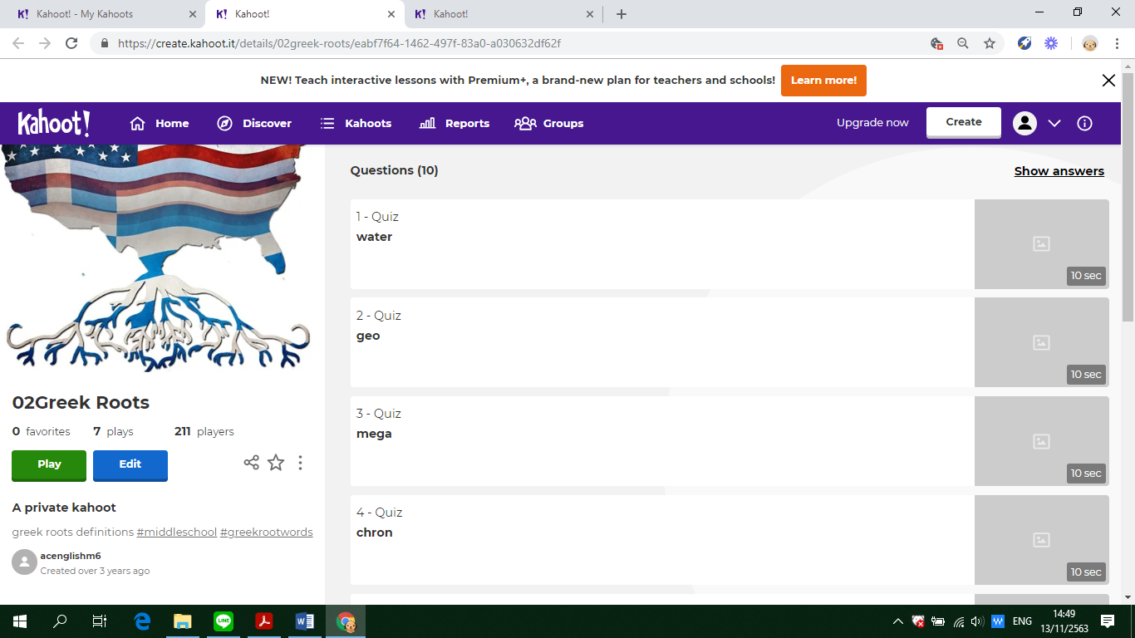

**Assumption College**

**Learning Management Plan**

**Semester: 2 Academic Year: 2021 Week: 3**

**Subject Code: EN30220 Subject: Academic English 6**

**Level of Students: M. 6 Learning Unit: Graphs, charts and trends**

**Topic: Vocabulary Time: 1 Period**

**Learning Outcomes (7):** Explain, analyse and discuss hobbies, interests, feelings, beliefs and origins of customs and traditions of native speakers along with similarities and differences between the lifestyles, beliefs and culture of native speakers and those of Thais, and apply them appropriately

**Learning Objective:**

**Knowledge:** The students will be able to identify the meaning of new vocabulary and its pronunciation.

**Process/Skill:** The students will be able tomatch the meaning of new vocabulary.

**Desirable Characteristics:** Cherishing Thai-ness

**Learners’ Key Competencies**

🞎communication capability

🞎 thinking capability

**☑** problem solving capability

🞎 capability in applying life skills and

🞎 capability in technological application

**Content: The structure of inversion in English**

**Activities: KWL-Plus**

1. Discuss the topic with students. Distribute K-W-L chart to each student. **(Preparation)**
2. Based on what they have learnt about the new vocabulary, ask students to write as many words from the previous lessons as possible and mark What I Know. **(Pre teaching)**
3. **Promote the 21st century learning skills in terms of communication by allowing students to communicate in English and work in group** to brainstorm the pronunciation of each word. Write each pronunciation in the W column. After that, have students listen to the pronunciation and check whether what they have done is correct in the L column. **(While teaching)**
4. To continue with the KWL-Plus Strategy, ask students to categorize the new word with plus and minus signs. **(After teaching)**
5. Next, ask students to develop a concept map about the root words. **(Mind-Mapping)**
6. Have students use the concept map or graphic organizer to write a summary about the root words. **(Summarizing)**
7. Have them play Kahoot in teams. **(Evaluation)**

**Learning Materials**

**☑** Textbook

**☑** PowerPoint Presentation

🞎 Dictionary

🞎 Websites

🞎 Google Forms, Google Slides

🞎 Kahoot!, Quizizz or Quizlet, AC Online Classroom

🞎 Socrative

**Teaching Procedures:**

**Teaching Model □** 5E Model **□** PPP **□** Explicit Teaching Model

**□** CIPPA **□** CALLA **□** SIOP

**□** Others**………**

**Teaching Method □** CLT **□** CBL **□** TBL

**□** The Direct Method **□** Real**-**life scenarios

**□** The Structural Approach **□** Cooperative Learning

**□** Others**………**

**Teaching Technique ☑** KWL-Plus **□** CIRC **□** Brainstorming

**□** STAD **□** Dramatization **□** Group discussion

**□** Pair work **□** Peer Teaching **□** Mind Maps

**□** Group work **□** Others**………**

**Evaluation:**

|  |  |  |
| --- | --- | --- |
| **Learning Objective** | **Evaluation Method** | **Evaluation Tools** |
| Knowledge | Checking the quizzes in the textbook | Quizzes/Test |
| Process/Skill | Oral recitation of passages/answers | Oral evaluation |
| Desirable Characteristics | Observation | Observationform |

**Post-Teaching Recommendation:**

|  |  |  |  |  |  |  |  |
| --- | --- | --- | --- | --- | --- | --- | --- |
| Post Evaluation | CLASS | % of students who passed | | | % of students who didn’t pass | | |
| Indicator | | | Indicator | | |
| 1 |  |  | 1 |  |  |
| KNOWLEDGE | M.6/1 |  |  |  |  |  |  |
| M.6/2 |  |  |  |  |  |  |
| M.6/3 |  |  |  |  |  |  |
| M.6/4 |  |  |  |  |  |  |
| M.6/5 |  |  |  |  |  |  |
| M.6/6 |  |  |  |  |  |  |
| M.6/7 |  |  |  |  |  |  |
| M.6/8 |  |  |  |  |  |  |
| M.6/9 |  |  |  |  |  |  |

**How to solve the problem**: Knowledge

🞎 Review students’ prior knowledge

🞎 Review what students have learned again slowly.

🞎 Advise students to search further information on internet

🞎 Spare some time to teach them individually or in group

🞎 Give some more exercises / reports

🞎 Assign students to do group work or pair work

🞎 Let the encounter “Learning by Doing” process as much as possible.

|  |  |  |  |  |  |  |  |
| --- | --- | --- | --- | --- | --- | --- | --- |
| Post Evaluation | CLASS | % of students who passed | | | % of students who didn’t pass | | |
| Indicator | | | Indicator | | |
| 1 |  |  | 1 |  |  |
| PROCESS/SKILL | M.6/1 |  |  |  |  |  |  |
| M.6/2 |  |  |  |  |  |  |
| M.6/3 |  |  |  |  |  |  |
| M.6/4 |  |  |  |  |  |  |
| M.6/5 |  |  |  |  |  |  |
| M.6/6 |  |  |  |  |  |  |
| M.6/7 |  |  |  |  |  |  |
| M.6/8 |  |  |  |  |  |  |
| M.6/9 |  |  |  |  |  |  |

**How to solve the problem**: Skill

🞎 Encourage them to listen / speak / read / or write from other sources.

🞎 Practice them to listen / speak / read / or write

🞎 Give them more chance to use all skills in English while teaching.

🞎 Let them criticize themselves the weak point in studying in that period and help them solve that problem.

|  |  |  |  |  |  |  |  |
| --- | --- | --- | --- | --- | --- | --- | --- |
| Post Evaluation | CLASS | % of students who passed | | | % of students who didn’t pass | | |
| Indicator | | | Indicator | | |
| 1 |  |  | 1 |  |  |
| DESIRABLE  CHARACTERISTICS | M.6/1 |  |  |  |  |  |  |
| M.6/2 |  |  |  |  |  |  |
| M.6/3 |  |  |  |  |  |  |
| M.6/4 |  |  |  |  |  |  |
| M.6/5 |  |  |  |  |  |  |
| M.6/6 |  |  |  |  |  |  |
| M.6/7 |  |  |  |  |  |  |
| M.6/8 |  |  |  |  |  |  |
| M.6/9 |  |  |  |  |  |  |

**How to solve the problem**: Desirable Characteristics

🞎 Point out the importance of that qualification.

🞎 Give them some incentives

🞎 Give warning / suggestion / detention

🞎 Encourage them to have this desirable characteristic

**Follow-Up**………………………..……………………………………………………..………………………………………………..………………

………………………………..……………………………………………………..……………………………………………………..……………………

………………………………..……………………………………………………..……………………………………………………..……………………

Teacher Ms. Lapassanun J.

Head of Foreign Languages Department Ms. Lapassanun J.

|  |
| --- |
| แบบสรุปการใช้ ICT ระดับชั้นมัธยมศึกษาปีที่ 6 |
| วิชา ภาษาอังกฤษเชิงวิชาการ 6 (อ 30220) |
| ครูผู้สอน มิสลภัสนันท์ จันทน์โรจน์ |

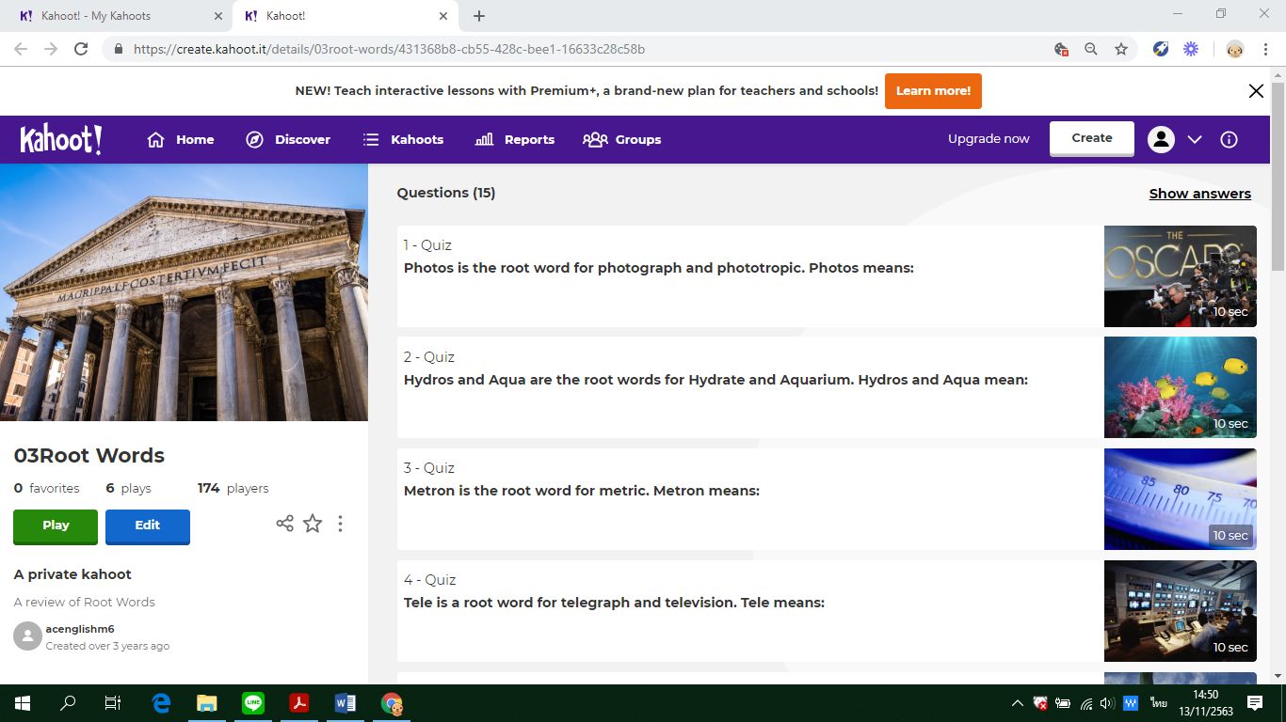

**Assumption College**

**Learning Management Plan**

**Semester: 2 Academic Year: 2021 Week: 4**

**Subject Code: EN30220 Subject: Academic English 6**

**Level of Students: M. 6 Learning Unit: Numbers and statistics**

**Topic: Cloze test Time: 1 Period**

**Learning Outcomes (3):** Combine and organise paragraphs to respond to an opinion essay, employ complex connectors to link cause and effect clauses, formulate a clear thesis statement, identify main features of a diagram and write a paragraph plan under time restraints by using self-assess own writing for grammatical mistakes

**Learning Objective:**

**Knowledge:** The students will be able to understand the passage.

**Process/Skill:** The students will be able tocomplete a fill-in-the-blank summary of the passage.

**Desirable Characteristics:** Honesty and integrity

**Learners’ Key Competencies**

🞎communication capability

🞎 thinking capability

🞎 problem solving capability

**☑** capability in applying life skills and

🞎 capability in technological application

**Content: Completing a cloze test**

**Activities: (PPP & CIRC)**

1. Explain the learning objectives. Introduce the new topic using PowerPoint Presentation and give some questions related to the topic. Tell them that a cloze test is an exercise where a passage is provided with certain words missing from it. Actually it is a combination of fill in the blanks and reading comprehension. It is important to understand the flow and context of a passage. **(Warm Up / Lead-In)**
2. Divide students into 6-member cooperative learning teams. Students are grouped heterogeneously. Let them read the passage thoroughly to get an idea of the passage. Read slowly and gain an understanding of the text. Link the sentences together and predict type of word to fill in **(Presentation)**
3. Have students work in teams to complete a fill-in-the-blank summary of the passage. After that, let each group present their answers. Next, let students answer the questions based on the text with their group members. Then, let them present their answers. **(Practice)**
4. Have them play Quizizz to complete a cloze test with their groups. **(Production)**
5. Give students assignment to do more exercises about the topic learnt. **(Assignment)**

**Learning Materials**

**☑** Textbook

**☑** PowerPoint Presentation

🞎 Dictionary

🞎 Websites

🞎 Google Forms, Google Slides

**☑** Kahoot!, Quizizz or Quizlet, AC Online Classroom

🞎 Socrative

**Teaching Procedures:**

**Teaching Model □** 5E Model **☑** PPP **□** Explicit Teaching Model

**□** CIPPA **□** CALLA **□** SIOP

**□** Others**………**

**Teaching Method □** CLT **□** CBL **□** TBL

**□** The Direct Method **□** Real**-**life scenarios

**□** The Structural Approach **□** Cooperative Learning

**□** Others**………**

**Teaching Technique □** KWL-Plus **☑** CIRC **□** Brainstorming

**□** STAD **□** Dramatization **□** Group discussion

**□** Pair work **□** Peer Teaching **□** Mind Maps

**□** Group work **□** Others**………**

**Evaluation:**

|  |  |  |
| --- | --- | --- |
| **Learning Objective** | **Evaluation Method** | **Evaluation Tools** |
| Knowledge | Checking the quizzes in the textbook | Quizzes/Test |
| Process/Skill | Oral recitation of passages/answers | Oral evaluation |
| Desirable Characteristics | Observation | Observationform |

**Post-Teaching Recommendation:**

|  |  |  |  |  |  |  |  |
| --- | --- | --- | --- | --- | --- | --- | --- |
| Post Evaluation | CLASS | % of students who passed | | | % of students who didn’t pass | | |
| Indicator | | | Indicator | | |
| 1 |  |  | 1 |  |  |
| KNOWLEDGE | M.6/1 |  |  |  |  |  |  |
| M.6/2 |  |  |  |  |  |  |
| M.6/3 |  |  |  |  |  |  |
| M.6/4 |  |  |  |  |  |  |
| M.6/5 |  |  |  |  |  |  |
| M.6/6 |  |  |  |  |  |  |
| M.6/7 |  |  |  |  |  |  |
| M.6/8 |  |  |  |  |  |  |
| M.6/9 |  |  |  |  |  |  |

**How to solve the problem**: Knowledge

🞎 Review students’ prior knowledge

🞎 Review what students have learned again slowly.

🞎 Advise students to search further information on internet

🞎 Spare some time to teach them individually or in group

🞎 Give some more exercises / reports

🞎 Assign students to do group work or pair work

🞎 Let the encounter “Learning by Doing” process as much as possible.

|  |  |  |  |  |  |  |  |
| --- | --- | --- | --- | --- | --- | --- | --- |
| Post Evaluation | CLASS | % of students who passed | | | % of students who didn’t pass | | |
| Indicator | | | Indicator | | |
| 1 |  |  | 1 |  |  |
| PROCESS/SKILL | M.6/1 |  |  |  |  |  |  |
| M.6/2 |  |  |  |  |  |  |
| M.6/3 |  |  |  |  |  |  |
| M.6/4 |  |  |  |  |  |  |
| M.6/5 |  |  |  |  |  |  |
| M.6/6 |  |  |  |  |  |  |
| M.6/7 |  |  |  |  |  |  |
| M.6/8 |  |  |  |  |  |  |
| M.6/9 |  |  |  |  |  |  |

**How to solve the problem**: Skill

🞎 Encourage them to listen / speak / read / or write from other sources.

🞎 Practice them to listen / speak / read / or write

🞎 Give them more chance to use all skills in English while teaching.

🞎 Let them criticize themselves the weak point in studying in that period and help them solve that problem.

|  |  |  |  |  |  |  |  |
| --- | --- | --- | --- | --- | --- | --- | --- |
| Post Evaluation | CLASS | % of students who passed | | | % of students who didn’t pass | | |
| Indicator | | | Indicator | | |
| 1 |  |  | 1 |  |  |
| DESIRABLE  CHARACTERISTICS | M.6/1 |  |  |  |  |  |  |
| M.6/2 |  |  |  |  |  |  |
| M.6/3 |  |  |  |  |  |  |
| M.6/4 |  |  |  |  |  |  |
| M.6/5 |  |  |  |  |  |  |
| M.6/6 |  |  |  |  |  |  |
| M.6/7 |  |  |  |  |  |  |
| M.6/8 |  |  |  |  |  |  |
| M.6/9 |  |  |  |  |  |  |

**How to solve the problem**: Desirable Characteristics

🞎 Point out the importance of that qualification.

🞎 Give them some incentives

🞎 Give warning / suggestion / detention

🞎 Encourage them to have this desirable characteristic

**Follow-Up**………………………..……………………………………………………..………………………………………………..………………

………………………………..……………………………………………………..……………………………………………………..……………………

………………………………..……………………………………………………..……………………………………………………..……………………

Teacher Ms. Lapassanun J.

Head of Foreign Languages Department Ms. Lapassanun J.

|  |
| --- |
| แบบสรุปการใช้ ICT ระดับชั้นมัธยมศึกษาปีที่ 6 |
| วิชา ภาษาอังกฤษเชิงวิชาการ 6 (อ 30220) |
| ครูผู้สอน มิสลภัสนันท์ จันทน์โรจน์ |

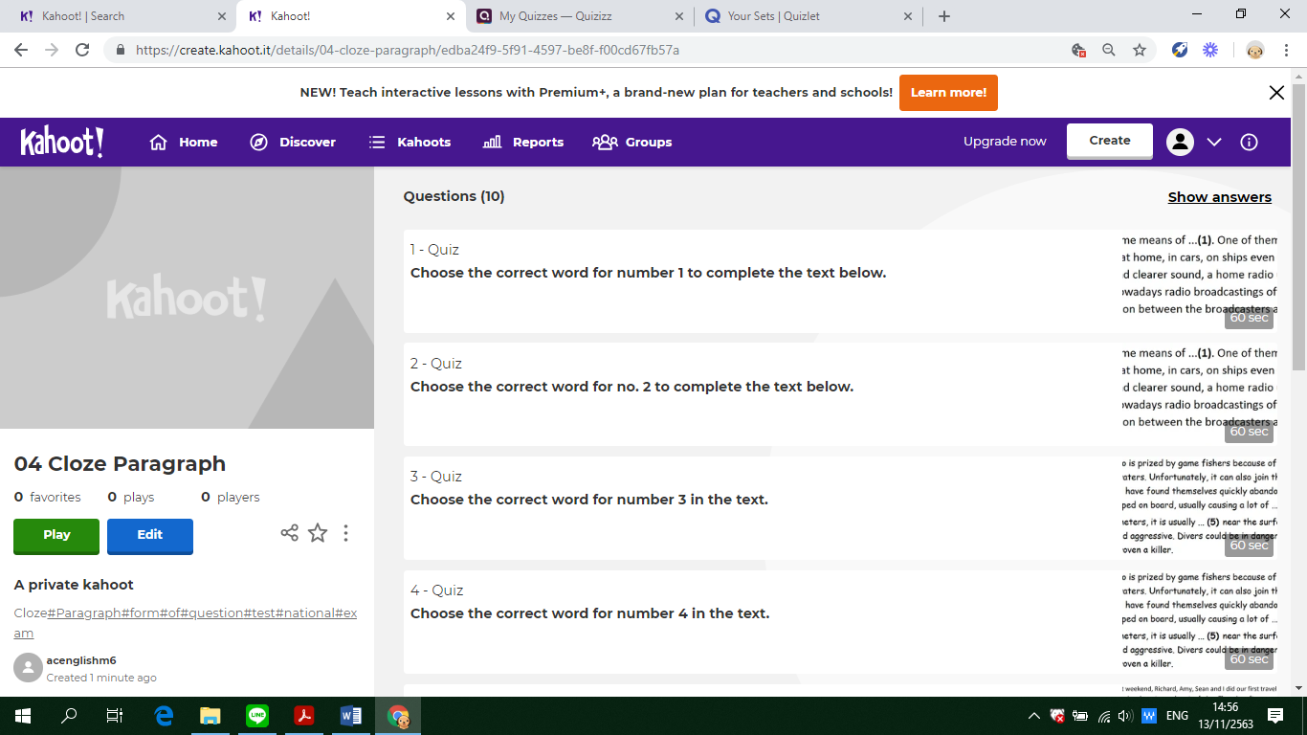

**Assumption College**

**Learning Management Plan**

**Semester: 2 Academic Year: 2021 Week: 5**

**Subject Code: EN30220 Subject: Academic English 6**

**Level of Students: M. 6 Learning Unit: Numbers and statistics**

**Topic: Graphs and charts Time: 1 Period**

**Learning Outcomes (1):** Identify topic sentences of paragraphs, identify main ideas and overall meaning of texts to complete diagrams, match headings with paragraphs, and differentiate paragraph headings according to content

**Learning Objective:**

**Knowledge:** The students will be able to read and analyze graphs and chart text features**.**

**Process/Skill:** The students will be able tofill in the information from the graphs and charts.

**Desirable Characteristics:** Observance of principles of Sufficiency Economy Philosophy in one’s way of life

**Learners’ Key Competencies**

🞎communication capability

🞎 thinking capability

🞎 problem solving capability

🞎 capability in applying life skills and

**☑** capability in technological application

**Content: Filling in graphs and charts**

**Activities: CIRC and Cooperative Learning**

1. Tell students that they will be talking about specific types of text features: charts and graphs. Explain to students that these features give them more information to help them understand what they are reading. **(Presentation)**
2. Form groups of 4 students heterogeneously.Ask students to match the words to the pictures relating the **principles of Sufficiency Economy Philosophy**. Then have them complete the sentences using prepositions of time and other words appropriate for each picture. **(Team practice)**
3. Let students work individually to **r**ead the description and draw a line graph and put the words in the appropriate column. **(Independent practice)**
4. Allow students to assess each other's performance. Have them revise and edit each other’s work. It gives students the opportunity to encounter diversity in different ways, critique and judge each other’s work**. (Peer pre-assessment)**
5. Have students work in groups to fill in the blanks with a suitable verb to describe a trend and match the sentences given with the graphs. **(Additional practic**e)
6. **Promote the 21st century learning skills in terms of digital literacy by encouraging students to use smartphones to play interactive quizzes.** Assess them using **Quizizz** to check if the students understand the concepts of the lesson. In the assessment stage, each student individually takes a quiz. Then their scores are combined and compared to their own past averages and points**. (Testing)**
7. Each team will be awarded based on the degree to which students meet or exceed their own earlier performance**. (Team Recognition)**

**Learning Materials**

**☑** Textbook

**☑** PowerPoint Presentation

🞎 Dictionary

🞎 Websites

🞎 Google Forms, Google Slides

**☑** Kahoot!, Quizizz or Quizlet, AC Online Classroom

🞎 Socrative

**Teaching Procedures:**

**Teaching Model □** 5E Model **□** PPP **□** Explicit Teaching Model

**□** CIPPA **□** CALLA **□** SIOP

**□** Others**………**

**Teaching Method □** CLT **□** CBL **□** TBL

**□** The Direct Method **□** Real**-**life scenarios

**□** The Structural Approach **☑** Cooperative Learning

**□** Others**………**

**Teaching Technique □** KWL-Plus **☑** CIRC **□** Brainstorming

**□** STAD **□** Dramatization **□** Group discussion

**□** Pair work **□** Peer Teaching **□** Mind Maps

**□** Group work **□** Others**………**

**Evaluation:**

|  |  |  |
| --- | --- | --- |
| **Learning Objective** | **Evaluation Method** | **Evaluation Tools** |
| Knowledge | Checking the quizzes in the textbook | Quizzes/Test |
| Process/Skill | Oral recitation of passages/answers | Oral evaluation |
| Desirable Characteristics | Observation | Observationform |

**Post-Teaching Recommendation:**

|  |  |  |  |  |  |  |  |
| --- | --- | --- | --- | --- | --- | --- | --- |
| Post Evaluation | CLASS | % of students who passed | | | % of students who didn’t pass | | |
| Indicator | | | Indicator | | |
| 1 |  |  | 1 |  |  |
| KNOWLEDGE | M.6/1 |  |  |  |  |  |  |
| M.6/2 |  |  |  |  |  |  |
| M.6/3 |  |  |  |  |  |  |
| M.6/4 |  |  |  |  |  |  |
| M.6/5 |  |  |  |  |  |  |
| M.6/6 |  |  |  |  |  |  |
| M.6/7 |  |  |  |  |  |  |
| M.6/8 |  |  |  |  |  |  |
| M.6/9 |  |  |  |  |  |  |

**How to solve the problem**: Knowledge

🞎 Review students’ prior knowledge

🞎 Review what students have learned again slowly.

🞎 Advise students to search further information on internet

🞎 Spare some time to teach them individually or in group

🞎 Give some more exercises / reports

🞎 Assign students to do group work or pair work

🞎 Let the encounter “Learning by Doing” process as much as possible.

|  |  |  |  |  |  |  |  |
| --- | --- | --- | --- | --- | --- | --- | --- |
| Post Evaluation | CLASS | % of students who passed | | | % of students who didn’t pass | | |
| Indicator | | | Indicator | | |
| 1 |  |  | 1 |  |  |
| PROCESS/SKILL | M.6/1 |  |  |  |  |  |  |
| M.6/2 |  |  |  |  |  |  |
| M.6/3 |  |  |  |  |  |  |
| M.6/4 |  |  |  |  |  |  |
| M.6/5 |  |  |  |  |  |  |
| M.6/6 |  |  |  |  |  |  |
| M.6/7 |  |  |  |  |  |  |
| M.6/8 |  |  |  |  |  |  |
| M.6/9 |  |  |  |  |  |  |

**How to solve the problem**: Skill

🞎 Encourage them to listen / speak / read / or write from other sources.

🞎 Practice them to listen / speak / read / or write

🞎 Give them more chance to use all skills in English while teaching.

🞎 Let them criticize themselves the weak point in studying in that period and help them solve that problem.

|  |  |  |  |  |  |  |  |
| --- | --- | --- | --- | --- | --- | --- | --- |
| Post Evaluation | CLASS | % of students who passed | | | % of students who didn’t pass | | |
| Indicator | | | Indicator | | |
| 1 |  |  | 1 |  |  |
| DESIRABLE  CHARACTERISTICS | M.6/1 |  |  |  |  |  |  |
| M.6/2 |  |  |  |  |  |  |
| M.6/3 |  |  |  |  |  |  |
| M.6/4 |  |  |  |  |  |  |
| M.6/5 |  |  |  |  |  |  |
| M.6/6 |  |  |  |  |  |  |
| M.6/7 |  |  |  |  |  |  |
| M.6/8 |  |  |  |  |  |  |
| M.6/9 |  |  |  |  |  |  |

**How to solve the problem**: Desirable Characteristics

🞎 Point out the importance of that qualification.

🞎 Give them some incentives

🞎 Give warning / suggestion / detention

🞎 Encourage them to have this desirable characteristic

**Follow-Up**………………………..……………………………………………………..………………………………………………..………………

………………………………..……………………………………………………..……………………………………………………..……………………

………………………………..……………………………………………………..……………………………………………………..……………………

Teacher Ms. Lapassanun J.

Head of Foreign Languages Department Ms. Lapassanun J.

|  |
| --- |
| แบบสรุปการใช้ ICT ระดับชั้นมัธยมศึกษาปีที่ 6 |
| วิชา ภาษาอังกฤษเชิงวิชาการ 6 (อ 30220) |
| ครูผู้สอน มิสลภัสนันท์ จันทน์โรจน์ |

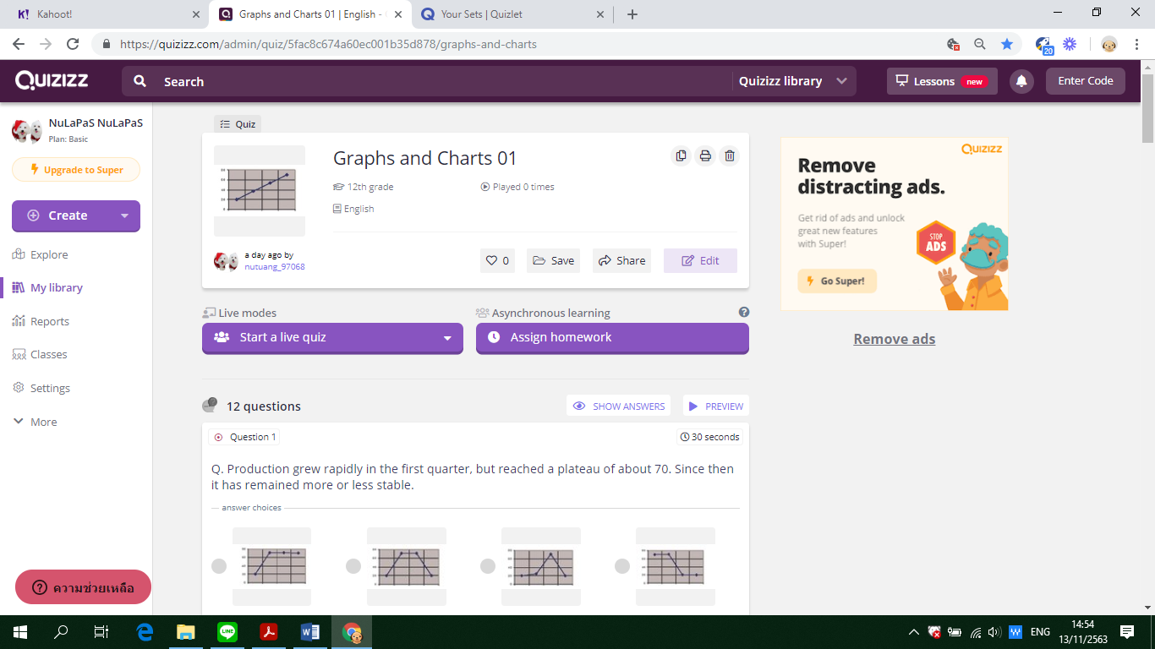

**Assumption College**

**Learning Management Plan**

**Semester: 2 Academic Year: 2021 Week: 6**

**Subject Code: EN30220 Subject: Academic English 6**

**Level of Students: M. 6 Learning Unit: Numbers and statistics**

**Topic: Line graphs Time: 1 Period**

**Learning Outcomes (5):** Identify key information to complete notes or to complete gaps in sentences from a listening or a lecture, identify correct word forms in a listening task, identify relevant details in a listening to discern correct answer among multiple choices, listen to identify specific information needed to complete a flow chart and discern key points in a lecture to chronologically arrange stages in a process

**Learning Objective:**

**Knowledge:** The students will be able to match phrases with the trends.

**Process/Skill:** The students will be able todescribe a line graph.

**Desirable Characteristics:** Gentlemen of Assumption College

**Learners’ Key Competencies**

**☑** communication capability

🞎 thinking capability

🞎 problem solving capability

🞎 capability in applying life skills and

🞎 capability in technological application

**Content: Describing a line graph**

**Activities: (SIOP + Cooperative Learning + STAD)**

1. Students are shown clearly defined content objectives. Tell them that they will be discussing how to describe a line graph. **(Preparation)**  
2.Concepts should be directly linked to students’ background experience. Ask students to work in **groups of 4** **with different levels of ability**. Ask them about paraphrasing. Give examples of paraphrasing an introduction of the graph. Then discuss the pattern. (**Building Background**)

3.Use speech that is appropriate for students' language proficiency to talk about the outline of a line graph. (**Comprehensible Input**)

4.Use of a variety of question types, including those that promote higher level thinking skills. Have them look at the line graph and analyze the topic of the graph. What they should conclude in the introduction. Provide ample opportunities for students to use learning strategies. (**Student Strategies for Success**)

5. Have them work in group again and let them write the introduction of the graph. Ample wait time for student-student interactions. Students share the answers. The class talks about whether the word formation is correct. (**Interactions**)

6.Accommodate students and keep them engaged for at least 90% of the lesson. (**Lesson Delivery**)

7.Ask each team to look match the phrases with the graphs and describe trends. **Provide activities for each team to apply content and language knowledge in the classroom and work cooperatively with teacher-provided worksheets and answer sheets**. **Have the STAD teams play games concerning** word formation using **Quizlet.**  (**Practice / Application**)

8.Handout assignment and explain. Review material and ask students if they have any questions. Assess them using **Kahoot!!** to check if the students understand the concepts of the lesson. **In the assessment stage, each student individually takes a quiz.** **Then their scores are combined and compared to their own past averages and points. Each team will be awarded on the basis of the degree to which students meet or exceed their own earlier performance**. (**Review and Assessment**)

**Learning Materials**

**☑** Textbook

**☑** PowerPoint Presentation

🞎 Dictionary

🞎 Websites

🞎 Google Forms, Google Slides

**☑** Kahoot!, Quizizz or Quizlet, AC Online Classroom

🞎 Socrative

**Teaching Procedures:**

**Teaching Model □** 5E Model **□** PPP **□** Explicit Teaching Model

**□** CIPPA **□** CALLA **☑** SIOP

**□** Others**………**

**Teaching Method □** CLT **□** CBL **□** TBL

**□** The Direct Method **□** Real**-**life scenarios

**□** The Structural Approach **☑** Cooperative Learning

**□** Others**………**

**Teaching Technique □** KWL-Plus **□** CIRC **□** Brainstorming

**☑** STAD **□** Dramatization **□** Group discussion

**□** Pair work **□** Peer Teaching **□** Mind Maps

**□** Group work **□** Others**………**

**Evaluation:**

|  |  |  |
| --- | --- | --- |
| **Learning Objective** | **Evaluation Method** | **Evaluation Tools** |
| Knowledge | Checking the quizzes in the textbook | Quizzes/Test |
| Process/Skill | Oral recitation of passages/answers | Oral evaluation |
| Desirable Characteristics | Observation | Observationform |

**Post-Teaching Recommendation:**

|  |  |  |  |  |  |  |  |
| --- | --- | --- | --- | --- | --- | --- | --- |
| Post Evaluation | CLASS | % of students who passed | | | % of students who didn’t pass | | |
| Indicator | | | Indicator | | |
| 1 |  |  | 1 |  |  |
| KNOWLEDGE | M.6/1 |  |  |  |  |  |  |
| M.6/2 |  |  |  |  |  |  |
| M.6/3 |  |  |  |  |  |  |
| M.6/4 |  |  |  |  |  |  |
| M.6/5 |  |  |  |  |  |  |
| M.6/6 |  |  |  |  |  |  |
| M.6/7 |  |  |  |  |  |  |
| M.6/8 |  |  |  |  |  |  |
| M.6/9 |  |  |  |  |  |  |

**How to solve the problem**: Knowledge

🞎 Review students’ prior knowledge

🞎 Review what students have learned again slowly.

🞎 Advise students to search further information on internet

🞎 Spare some time to teach them individually or in group

🞎 Give some more exercises / reports

🞎 Assign students to do group work or pair work

🞎 Let the encounter “Learning by Doing” process as much as possible.

|  |  |  |  |  |  |  |  |
| --- | --- | --- | --- | --- | --- | --- | --- |
| Post Evaluation | CLASS | % of students who passed | | | % of students who didn’t pass | | |
| Indicator | | | Indicator | | |
| 1 |  |  | 1 |  |  |
| PROCESS/SKILL | M.6/1 |  |  |  |  |  |  |
| M.6/2 |  |  |  |  |  |  |
| M.6/3 |  |  |  |  |  |  |
| M.6/4 |  |  |  |  |  |  |
| M.6/5 |  |  |  |  |  |  |
| M.6/6 |  |  |  |  |  |  |
| M.6/7 |  |  |  |  |  |  |
| M.6/8 |  |  |  |  |  |  |
| M.6/9 |  |  |  |  |  |  |

**How to solve the problem**: Skill

🞎 Encourage them to listen / speak / read / or write from other sources.

🞎 Practice them to listen / speak / read / or write

🞎 Give them more chance to use all skills in English while teaching.

🞎 Let them criticize themselves the weak point in studying in that period and help them solve that problem.

|  |  |  |  |  |  |  |  |
| --- | --- | --- | --- | --- | --- | --- | --- |
| Post Evaluation | CLASS | % of students who passed | | | % of students who didn’t pass | | |
| Indicator | | | Indicator | | |
| 1 |  |  | 1 |  |  |
| DESIRABLE  CHARACTERISTICS | M.6/1 |  |  |  |  |  |  |
| M.6/2 |  |  |  |  |  |  |
| M.6/3 |  |  |  |  |  |  |
| M.6/4 |  |  |  |  |  |  |
| M.6/5 |  |  |  |  |  |  |
| M.6/6 |  |  |  |  |  |  |
| M.6/7 |  |  |  |  |  |  |
| M.6/8 |  |  |  |  |  |  |
| M.6/9 |  |  |  |  |  |  |

**How to solve the problem**: Desirable Characteristics

🞎 Point out the importance of that qualification.

🞎 Give them some incentives

🞎 Give warning / suggestion / detention

🞎 Encourage them to have this desirable characteristic

**Follow-Up**………………………..……………………………………………………..………………………………………………..………………

………………………………..……………………………………………………..……………………………………………………..……………………

………………………………..……………………………………………………..……………………………………………………..……………………

Teacher Ms. Lapassanun J.

Head of Foreign Languages Department Ms. Lapassanun J.

|  |
| --- |
| แบบสรุปการใช้ ICT ระดับชั้นมัธยมศึกษาปีที่ 6 |
| วิชา ภาษาอังกฤษเชิงวิชาการ 6 (อ 30220) |
| ครูผู้สอน มิสลภัสนันท์ จันทน์โรจน์ |

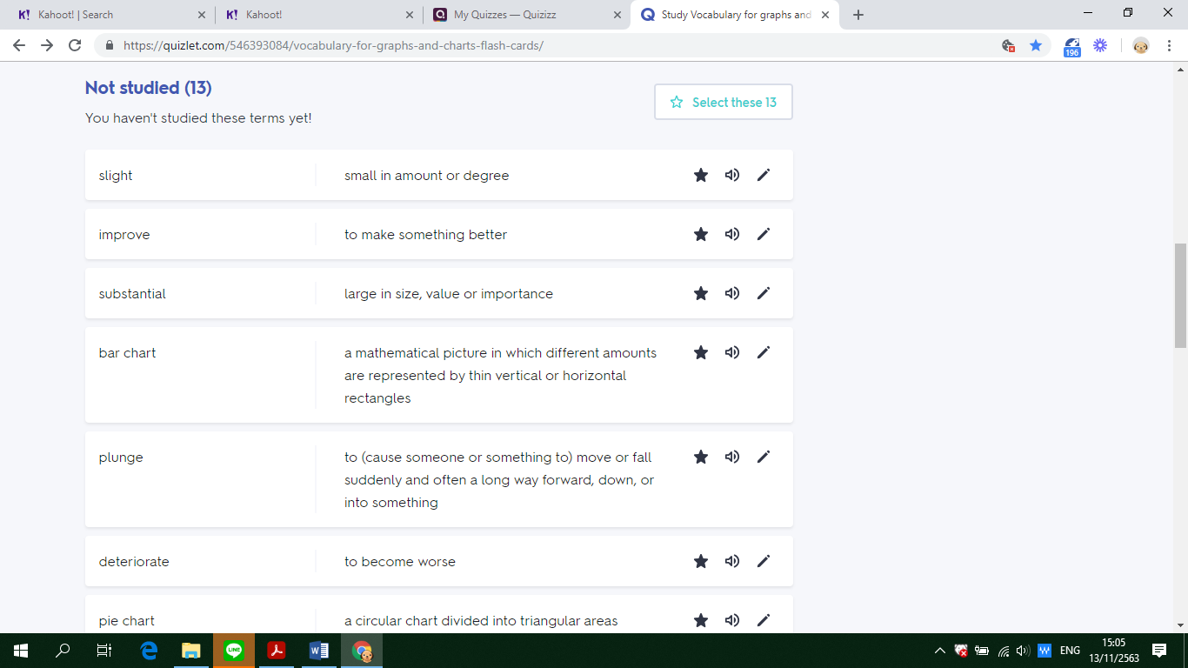

**Assumption College**

**Learning Management Plan**

**Semester: 2 Academic Year: 2021 Week: 7**

**Subject Code: EN30220 Subject: Academic English 6**

**Level of Students: M. 6 Learning Unit: Business and finance**

**Topic: Bar charts Time: 1 Period**

**Learning Outcomes (5):** Identify key information to complete notes or to complete gaps in sentences from a listening or a lecture, identify correct word forms in a listening task, identify relevant details in a listening to discern correct answer among multiple choices, listen to identify specific information needed to complete a flow chart and discern key points in a lecture to chronologically arrange stages in a process

**Learning Objective:**

**Knowledge:** The students will be able to fill in the blanks with correct answers.

**Process/Skill:** The students will be able todescribe a bar chart.

**Desirable Characteristics:** Public-mindedness

**Learners’ Key Competencies**

🞎communication capability

**☑** thinking capability

🞎 problem solving capability

🞎 capability in applying life skills and

🞎 capability in technological application

**Content: Describing a bar chart**

**Activities: (CALLA)**

1. Engage students in the topic and identify objectives for the lesson. Find out what students already know about it and motivate them to learn more. Tell students that in this lesson, they are going to learn to describe a bar chart. **(Preparation)**
2. Present new information. Have students work in pairs. Let them look at the bar chart and fill in the blanks with correct answers. Discuss connections to students' prior knowledge. Explain the target learning strategy for the lesson. **(Presentation)**
3. Have students form groups of four. Have them look at the chart and answer its questions. Remind students to use the learning strategyand have them write the introduction from the bar chart given. **(Practice)**
4. Question students so they will reflect on their own learning. Ask students to their own learning rather than wait for the teacher to assess them. **(Self-Evaluation)**
5. Students are told to describe the graph. Therefore, students will have to practice more. Guide students on how to apply what they learned to their own lives. Point out other contexts where the learning strategy may help. **(Expansion)**

**Learning Materials**

**☑** Textbook

**☑** PowerPoint Presentation

🞎 Dictionary

🞎 Websites

🞎 Google Forms, Google Slides

**☑** Kahoot!, Quizizz or Quizlet, AC Online Classroom

🞎 Socrative

**Teaching Procedures:**

**Teaching Model □** 5E Model **□** PPP **□** Explicit Teaching Model

**□** CIPPA **☑** CALLA **□** SIOP

**□** Others**………**

**Teaching Method □** CLT **□** CBL **□** TBL

**□** The Direct Method **□** Real**-**life scenarios

**□** The Structural Approach **□** Cooperative Learning

**□** Others**………**

**Teaching Technique □** KWL-Plus **□** CIRC **□** Brainstorming

**□** STAD **□** Dramatization **□** Group discussion

**□** Pair work **□** Peer Teaching **□** Mind Maps

**□** Group work **□** Others**………**

**Evaluation:**

|  |  |  |
| --- | --- | --- |
| **Learning Objective** | **Evaluation Method** | **Evaluation Tools** |
| Knowledge | Checking the quizzes in the textbook | Quizzes/Test |
| Process/Skill | Oral recitation of passages/answers | Oral evaluation |
| Desirable Characteristics | Observation | Observationform |

**Post-Teaching Recommendation:**

|  |  |  |  |  |  |  |  |
| --- | --- | --- | --- | --- | --- | --- | --- |
| Post Evaluation | CLASS | % of students who passed | | | % of students who didn’t pass | | |
| Indicator | | | Indicator | | |
| 1 |  |  | 1 |  |  |
| KNOWLEDGE | M.6/1 |  |  |  |  |  |  |
| M.6/2 |  |  |  |  |  |  |
| M.6/3 |  |  |  |  |  |  |
| M.6/4 |  |  |  |  |  |  |
| M.6/5 |  |  |  |  |  |  |
| M.6/6 |  |  |  |  |  |  |
| M.6/7 |  |  |  |  |  |  |
| M.6/8 |  |  |  |  |  |  |
| M.6/9 |  |  |  |  |  |  |

**How to solve the problem**: Knowledge

🞎 Review students’ prior knowledge

🞎 Review what students have learned again slowly.

🞎 Advise students to search further information on internet

🞎 Spare some time to teach them individually or in group

🞎 Give some more exercises / reports

🞎 Assign students to do group work or pair work

🞎 Let the encounter “Learning by Doing” process as much as possible.

|  |  |  |  |  |  |  |  |
| --- | --- | --- | --- | --- | --- | --- | --- |
| Post Evaluation | CLASS | % of students who passed | | | % of students who didn’t pass | | |
| Indicator | | | Indicator | | |
| 1 |  |  | 1 |  |  |
| PROCESS/SKILL | M.6/1 |  |  |  |  |  |  |
| M.6/2 |  |  |  |  |  |  |
| M.6/3 |  |  |  |  |  |  |
| M.6/4 |  |  |  |  |  |  |
| M.6/5 |  |  |  |  |  |  |
| M.6/6 |  |  |  |  |  |  |
| M.6/7 |  |  |  |  |  |  |
| M.6/8 |  |  |  |  |  |  |
| M.6/9 |  |  |  |  |  |  |

**How to solve the problem**: Skill

🞎 Encourage them to listen / speak / read / or write from other sources.

🞎 Practice them to listen / speak / read / or write

🞎 Give them more chance to use all skills in English while teaching.

🞎 Let them criticize themselves the weak point in studying in that period and help them solve that problem.

|  |  |  |  |  |  |  |  |
| --- | --- | --- | --- | --- | --- | --- | --- |
| Post Evaluation | CLASS | % of students who passed | | | % of students who didn’t pass | | |
| Indicator | | | Indicator | | |
| 1 |  |  | 1 |  |  |
| DESIRABLE  CHARACTERISTICS | M.6/1 |  |  |  |  |  |  |
| M.6/2 |  |  |  |  |  |  |
| M.6/3 |  |  |  |  |  |  |
| M.6/4 |  |  |  |  |  |  |
| M.6/5 |  |  |  |  |  |  |
| M.6/6 |  |  |  |  |  |  |
| M.6/7 |  |  |  |  |  |  |
| M.6/8 |  |  |  |  |  |  |
| M.6/9 |  |  |  |  |  |  |

**How to solve the problem**: Desirable Characteristics

🞎 Point out the importance of that qualification.

🞎 Give them some incentives

🞎 Give warning / suggestion / detention

🞎 Encourage them to have this desirable characteristic

**Follow-Up**………………………..……………………………………………………..………………………………………………..………………

………………………………..……………………………………………………..……………………………………………………..……………………

………………………………..……………………………………………………..……………………………………………………..……………………

Teacher Ms. Lapassanun J.

Head of Foreign Languages Department Ms. Lapassanun J.

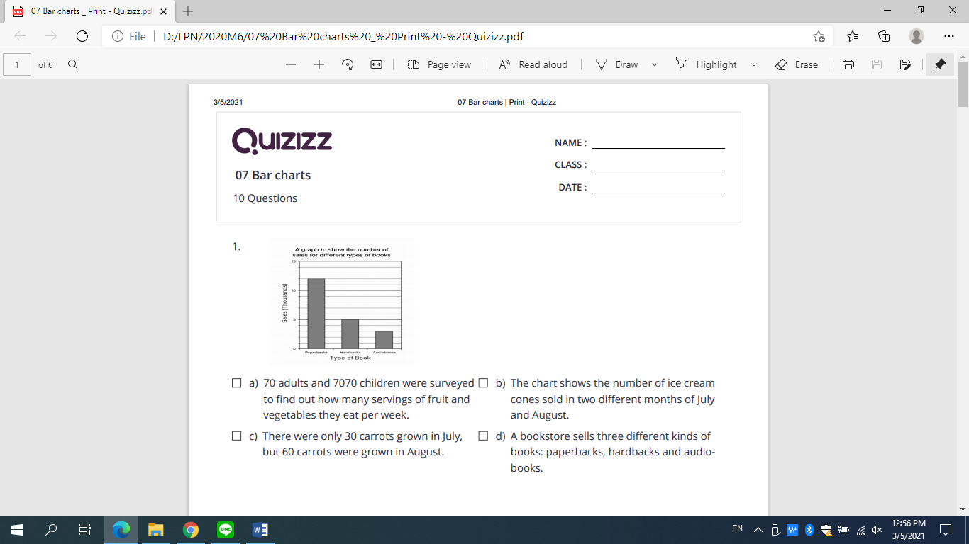

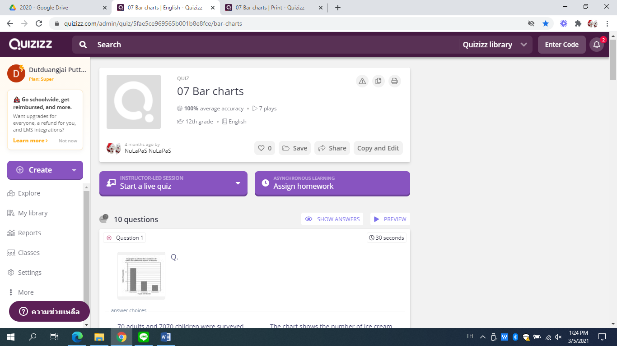

**Assumption College**

**Learning Management Plan**

**Semester: 2 Academic Year: 2021 Week: 8**

**Subject Code: EN30220 Subject: Academic English 6**

**Level of Students: M. 6 Learning Unit: Business and finance**

**Topic: Summative Test Time: 1 Period**

**Summative Examination**

**Assumption College**

**Learning Management Plan**

**Semester: 2 Academic Year: 2021 Week:9**

**Subject Code: EN30220 Subject: Academic English 6**

**Level of Students: M. 6 Learning Unit: Business and finance**

**Topic: Summative Test Time: 1 Period**

**Summative Examination**

**Assumption College**

**Learning Management Plan**

**Semester: 2 Academic Year: 2021 Week: 10**

**Subject Code: EN30220 Subject: Academic English 6**

**Level of Students: M. 6 Learning Unit: Infographics**

**Topic: Summative Test Time: 1 Period**

**Holidays**

**Assumption College**

**Learning Management Plan**

**Semester: 2 Academic Year: 2021 Week: 11**

**Subject Code: EN30220 Subject: Academic English 6**

**Level of Students: M. 6 Learning Unit: Infographics**

**Topic: Pie charts Time: 1 Period**

**Learning Outcomes (2):** Demonstrate comprehension of text details to perform sentence completion tasks, extract key points from academic texts, identify antonyms and synonyms in written text, employ strategies to deal with unknown vocabulary and interpret written texts to identify and match detailed information

**Learning Objective:**

**Knowledge:** The students will be able to fill in the blanks with correct answers.

**Process/Skill:** The students will be able to describe a pie chart.

**Desirable Characteristics:** Dedication and commitment to work

**Learners’ Key Competencies**

🞎communication capability

🞎 thinking capability

**☑** problem solving capability

🞎 capability in applying life skills and

🞎 capability in technological application

**Content: Describing pie charts**

**Activities: (Explicit Teaching Model)**

1. Review the lesson of last period. **(Revision)**
2. Have the students learn in groups and let them discuss in group about how to describe a pie chart using their schemata from the previous lessons. **(Teaching)**
3. Let students look at the charts and answer the questions. Provide time for students to do exercises by themselves. **(Practice under supervision)**
4. Explain them why each item is right or wrong. Give them more suggestions of how to answer about the charts. **(Giving correction)**
5. Ask students to login to ‘https://www.rapidtables.com/tools/pie-chart.html’ and create a pie chart. **(Individual practice)**
6. Mr. X monthly income is $ 14400. The monthly expenses of his family on various items are given below.

|  |  |  |  |  |  |
| --- | --- | --- | --- | --- | --- |
| **Item** | **Rent** | **Food** | **Clothing** | **Education** | **Savings** |
| Expenditure (in Dollar) | 4000 | 5400 | 2800 | 1800 | 400 |

Represent the above data by a pie chart.

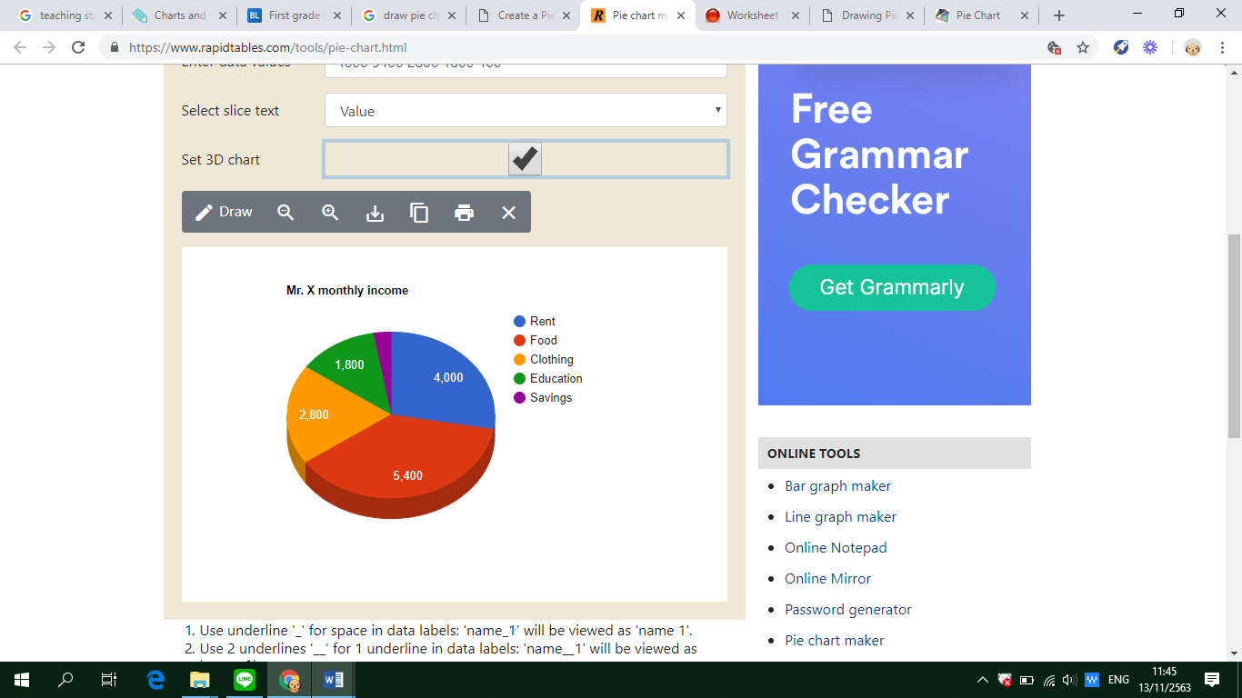

1. In a Zoological park there are 1000 creatures as per the following table given below:

|  |  |  |  |  |
| --- | --- | --- | --- | --- |
| **Beast Animals** | **Other Land Animals** | **Birds** | **Water Animals** | **Reptiles** |
| 150 | 400 | 225 | 175 | 50 |

Represent the above data by a pie chart.

1. Various modes of transport used by 1260 students in a given school are given below:

|  |  |  |  |  |
| --- | --- | --- | --- | --- |
| **School Bus** | **Private Bus** | **Bicycle** | **Rickshaw** | **On foot** |
| 350 | 245 | 210 | 175 | 280 |

Represent the above data by a pie chart.

1. The data given below shows number of hours spent by a school boy on different activities on a working day.

|  |  |  |  |  |  |  |
| --- | --- | --- | --- | --- | --- | --- |
| **Activity** | **School** | **Homework** | **Play** | **Sleep** | **Others** | **Total** |
| No. of hours | 7 | 4 | 2 | 8 | 3 | 24 |

Represent the above data by a pie graph.

1. In a company there are 1080 workers of different religions. The data of the different religion are given below:

|  |  |  |  |  |
| --- | --- | --- | --- | --- |
| **Religion** | **Hindu** | **Nepali** | **Islam** | **Christian** |
| No. of workers | 450 | 270 | 255 | 105 |

1. Give some assignments to students to practice. **(Revision)**

**Learning Materials**

**☑** Textbook

**☑** PowerPoint Presentation

🞎 Dictionary

🞎 Websites

**☑** Google Forms, Google Slides

**☑** Kahoot!, Quizizz or Quizlet, AC Online Classroom

🞎 Socrative

**Teaching Procedures:**

**Teaching Model □** 5E Model **□** PPP **☑** Explicit Teaching Model

**□** CIPPA **□** CALLA **□** SIOP

**□** Others**………**

**Teaching Method □** CLT **□** CBL **□** TBL

**□** The Direct Method **□** Real**-**life scenarios

**□** The Structural Approach **□** Cooperative Learning

**□** Others**………**

**Teaching Technique □** KWL-Plus **□** CIRC **□** Brainstorming

**□** STAD **□** Dramatization **□** Group discussion

**□** Pair work **□** Peer Teaching **□** Mind Maps

**□** Group work **□** Others**………**

**Evaluation:**

|  |  |  |
| --- | --- | --- |
| **Learning Objective** | **Evaluation Method** | **Evaluation Tools** |
| Knowledge | Checking the quizzes in the textbook | Quizzes/Test |
| Process/Skill | Oral recitation of passages/answers | Oral evaluation |
| Desirable Characteristics | Observation | Observationform |

**Post-Teaching Recommendation:**

|  |  |  |  |  |  |  |  |
| --- | --- | --- | --- | --- | --- | --- | --- |
| Post Evaluation | CLASS | % of students who passed | | | % of students who didn’t pass | | |
| Indicator | | | Indicator | | |
| 1 |  |  | 1 |  |  |
| KNOWLEDGE | M.6/1 |  |  |  |  |  |  |
| M.6/2 |  |  |  |  |  |  |
| M.6/3 |  |  |  |  |  |  |
| M.6/4 |  |  |  |  |  |  |
| M.6/5 |  |  |  |  |  |  |
| M.6/6 |  |  |  |  |  |  |
| M.6/7 |  |  |  |  |  |  |
| M.6/8 |  |  |  |  |  |  |
| M.6/9 |  |  |  |  |  |  |

**How to solve the problem**: Knowledge

🞎 Review students’ prior knowledge

🞎 Review what students have learned again slowly.

🞎 Advise students to search further information on internet

🞎 Spare some time to teach them individually or in group

🞎 Give some more exercises / reports

🞎 Assign students to do group work or pair work

🞎 Let the encounter “Learning by Doing” process as much as possible.

|  |  |  |  |  |  |  |  |
| --- | --- | --- | --- | --- | --- | --- | --- |
| Post Evaluation | CLASS | % of students who passed | | | % of students who didn’t pass | | |
| Indicator | | | Indicator | | |
| 1 |  |  | 1 |  |  |
| PROCESS/SKILL | M.6/1 |  |  |  |  |  |  |
| M.6/2 |  |  |  |  |  |  |
| M.6/3 |  |  |  |  |  |  |
| M.6/4 |  |  |  |  |  |  |
| M.6/5 |  |  |  |  |  |  |
| M.6/6 |  |  |  |  |  |  |
| M.6/7 |  |  |  |  |  |  |
| M.6/8 |  |  |  |  |  |  |
| M.6/9 |  |  |  |  |  |  |

**How to solve the problem**: Skill

🞎 Encourage them to listen / speak / read / or write from other sources.

🞎 Practice them to listen / speak / read / or write

🞎 Give them more chance to use all skills in English while teaching.

🞎 Let them criticize themselves the weak point in studying in that period and help them solve that problem.

|  |  |  |  |  |  |  |  |
| --- | --- | --- | --- | --- | --- | --- | --- |
| Post Evaluation | CLASS | % of students who passed | | | % of students who didn’t pass | | |
| Indicator | | | Indicator | | |
| 1 |  |  | 1 |  |  |
| DESIRABLE  CHARACTERISTICS | M.6/1 |  |  |  |  |  |  |
| M.6/2 |  |  |  |  |  |  |
| M.6/3 |  |  |  |  |  |  |
| M.6/4 |  |  |  |  |  |  |
| M.6/5 |  |  |  |  |  |  |
| M.6/6 |  |  |  |  |  |  |
| M.6/7 |  |  |  |  |  |  |
| M.6/8 |  |  |  |  |  |  |
| M.6/9 |  |  |  |  |  |  |

**How to solve the problem**: Desirable Characteristics

🞎 Point out the importance of that qualification.

🞎 Give them some incentives

🞎 Give warning / suggestion / detention

🞎 Encourage them to have this desirable characteristic

**Follow-Up**………………………..……………………………………………………..………………………………………………..………………

………………………………..……………………………………………………..……………………………………………………..……………………

………………………………..……………………………………………………..……………………………………………………..……………………

Teacher Ms. Lapassanun J.

Head of Foreign Languages Department Ms. Lapassanun J.

**Assumption College**

**Learning Management Plan**

**Semester: 2 Academic Year: 2021 Week: 12**

**Subject Code: EN30220 Subject: Academic English 6**

**Level of Students: M. 6 Learning Unit: Infographics**

**Topic: Describing tables Time: 1 Period**

**Learning Outcomes (7):** Explain, analyse and discuss hobbies, interests, feelings, beliefs and origins of customs and traditions of native speakers along with similarities and differences between the lifestyles, beliefs and culture of native speakers and those of Thais, and apply them appropriately

**Learning Objective:**

**Knowledge:** The students will be able to fill in the blanks with correct answers.

**Process/Skill:** The students will be able to describe a table.

**Desirable Characteristics:** Cherishing Thai-ness

**Learners’ Key Competencies**

🞎communication capability

🞎 thinking capability

🞎 problem solving capability

**☑** capability in applying life skills and

🞎 capability in technological application

**Content: Identifying the main idea of the passage**

**Activities: (PPP)**

1. Start the lesson by showing students an example of how to describe a table. Let them draw a table and put the information according to the information given. **(Warm Up / Lead-In)**
2. Give them the answers. Then, present the aspect of language in a context so that students are familiar with it. **(Presentation)**
3. **Promote the 21st century learning skills in terms of communication by allowing students to communicate in English and work in group to** practice doing more items through controlled activities to check comprehension.
4. Ample wait time for student-student interactions. Students share the answers. The class talks about whether the answers are correct. Have them play a game using **Kahoot!!** Show questions one-by-one as students answer with their mobile phones. After each question, discuss correct and incorrect answers. **(Practice)**
5. Students do more exercises in groups. Show students an exemplar of what they are going to do. Finish the lesson by giving the students feedback on the activity, explain any mistakes and correct them. **(Production)**
6. Give students more exercises about the topic. Have them do the exercise from **Socrative** provided by the teacher. **(Assignment)**

**Learning Materials**

**☑** Textbook

**☑** PowerPoint Presentation

🞎 Dictionary

🞎 Websites

**☑** Google Forms, Google Slides

**☑** Kahoot!, Quizizz or Quizlet, AC Online Classroom

🞎 Socrative

**Teaching Procedures:**

**Teaching Model □** 5E Model **☑** PPP **□** Explicit Teaching Model

**□** CIPPA **□** CALLA **□** SIOP

**□** Others**………**

**Teaching Method □** CLT **□** CBL **□** TBL

**□** The Direct Method **□** Real**-**life scenarios

**□** The Structural Approach **□** Cooperative Learning

**□** Others**………**

**Teaching Technique □** KWL-Plus **□** CIRC **□** Brainstorming

**□** STAD **□** Dramatization **□** Group discussion

**□** Pair work **□** Peer Teaching **□** Mind Maps

**□** Group work **□** Others**………**

**Evaluation:**

|  |  |  |
| --- | --- | --- |
| **Learning Objective** | **Evaluation Method** | **Evaluation Tools** |
| Knowledge | Checking the quizzes in the textbook | Quizzes/Test |
| Process/Skill | Oral recitation of passages/answers | Oral evaluation |
| Desirable Characteristics | Observation | Observationform |

**Post-Teaching Recommendation:**

|  |  |  |  |  |  |  |  |
| --- | --- | --- | --- | --- | --- | --- | --- |
| Post Evaluation | CLASS | % of students who passed | | | % of students who didn’t pass | | |
| Indicator | | | Indicator | | |
| 1 |  |  | 1 |  |  |
| KNOWLEDGE | M.6/1 |  |  |  |  |  |  |
| M.6/2 |  |  |  |  |  |  |
| M.6/3 |  |  |  |  |  |  |
| M.6/4 |  |  |  |  |  |  |
| M.6/5 |  |  |  |  |  |  |
| M.6/6 |  |  |  |  |  |  |
| M.6/7 |  |  |  |  |  |  |
| M.6/8 |  |  |  |  |  |  |
| M.6/9 |  |  |  |  |  |  |

**How to solve the problem**: Knowledge

🞎 Review students’ prior knowledge

🞎 Review what students have learned again slowly.

🞎 Advise students to search further information on internet

🞎 Spare some time to teach them individually or in group

🞎 Give some more exercises / reports

🞎 Assign students to do group work or pair work

🞎 Let the encounter “Learning by Doing” process as much as possible.

|  |  |  |  |  |  |  |  |
| --- | --- | --- | --- | --- | --- | --- | --- |
| Post Evaluation | CLASS | % of students who passed | | | % of students who didn’t pass | | |
| Indicator | | | Indicator | | |
| 1 |  |  | 1 |  |  |
| PROCESS/SKILL | M.6/1 |  |  |  |  |  |  |
| M.6/2 |  |  |  |  |  |  |
| M.6/3 |  |  |  |  |  |  |
| M.6/4 |  |  |  |  |  |  |
| M.6/5 |  |  |  |  |  |  |
| M.6/6 |  |  |  |  |  |  |
| M.6/7 |  |  |  |  |  |  |
| M.6/8 |  |  |  |  |  |  |
| M.6/9 |  |  |  |  |  |  |

**How to solve the problem**: Skill

🞎 Encourage them to listen / speak / read / or write from other sources.

🞎 Practice them to listen / speak / read / or write

🞎 Give them more chance to use all skills in English while teaching.

🞎 Let them criticize themselves the weak point in studying in that period and help them solve that problem.

|  |  |  |  |  |  |  |  |
| --- | --- | --- | --- | --- | --- | --- | --- |
| Post Evaluation | CLASS | % of students who passed | | | % of students who didn’t pass | | |
| Indicator | | | Indicator | | |
| 1 |  |  | 1 |  |  |
| DESIRABLE  CHARACTERISTICS | M.6/1 |  |  |  |  |  |  |
| M.6/2 |  |  |  |  |  |  |
| M.6/3 |  |  |  |  |  |  |
| M.6/4 |  |  |  |  |  |  |
| M.6/5 |  |  |  |  |  |  |
| M.6/6 |  |  |  |  |  |  |
| M.6/7 |  |  |  |  |  |  |
| M.6/8 |  |  |  |  |  |  |
| M.6/9 |  |  |  |  |  |  |

**How to solve the problem**: Desirable Characteristics

🞎 Point out the importance of that qualification.

🞎 Give them some incentives

🞎 Give warning / suggestion / detention

🞎 Encourage them to have this desirable characteristic

**Follow-Up**………………………..……………………………………………………..………………………………………………..………………

………………………………..……………………………………………………..……………………………………………………..……………………

………………………………..……………………………………………………..……………………………………………………..……………………

Teacher Ms. Lapassanun J.

Head of Foreign Languages Department Ms. Lapassanun J.

**Assumption College**

**Learning Management Plan**

**Semester: 2 Academic Year: 2021 Week: 13**

**Subject Code: EN30220 Subject: Academic English 6**

**Level of Students: M. 6 Learning Unit: Global learning**

**Topic: Sentence Completion Time: 1 Period**

**Learning Outcomes (4):** Write to describe non-text media such as graphs and charts, argue a position in an essay and apply the conventions of academic writing in English

**Learning Objective:**

**Knowledge:** The students will be able to identify the sentence structure used in each sentence.

**Process/Skill:** The students will be able tochoose the most appropriate structure to fill in the sentences.

**Desirable Characteristics:** Honesty and integrity

**Learners’ Key Competencies**

🞎communication capability

🞎 thinking capability

🞎 problem solving capability

🞎 capability in applying life skills and

**☑** capability in technological application

**Content: Identifying the sentence structure**

**Activities: CIPPA**

1. Activate students’ prior knowledge by mentioning the lesson about phrases and clauses. Compare the structure of phrases and clauses of English and Thai languages. Show students what sentence structure in English is. **(Activating prior knowledge)**
2. Encourage students to seek new knowledge by showing them 10 sentences with different sentence structures. Use different colors to differentiate the distinct structures. Ask them to find and explain the differences of each structure. Have their peers correct their thinking with the help of the teacher. **(Seeking new knowledge)**
3. Have them look at the worksheet and have them study the new knowledge. Explain rules to fill the sentences with the sentence structure using colors. Let them integrate their new knowledge with the prior knowledge. Compare the new learning with methods that they already used and understand. **(Integrating knowledge)**
4. Have them do some more exercises in the book by themselves. Walk around and give support. Then, have them exchange what they have learned by discussing in small groups of four. **(Sharing knowledge)**
5. Have them help one another conclude what they have learned and give the answer of the exercises in the book. **(Conclusion and knowledge organization)**
6. Have students share their answers to the class to check their understanding. **(Showing Tasks)**
7. Form groups of 4 students heterogeneously. Use **Kahoot!!** to check if the students understand the lesson. **(Knowledge application)**

**Learning Materials**

**☑** Textbook

**☑** PowerPoint Presentation

🞎 Dictionary

🞎 Websites

**☑** Google Forms, Google Slides

**☑** Kahoot!, Quizizz or Quizlet, AC Online Classroom

🞎 Socrative

**Teaching Procedures:**

**Teaching Model □** 5E Model **□** PPP **□** Explicit Teaching Model

**☑** CIPPA **□** CALLA **□** SIOP

**□** Others**………**

**Teaching Method □** CLT **□** CBL **□** TBL

**□** The Direct Method **□** Real**-**life scenarios

**□** The Structural Approach **□** Cooperative Learning

**□** Others**………**

**Teaching Technique □** KWL-Plus **□** CIRC **□** Brainstorming

**□** STAD **□** Dramatization **□** Group discussion

**□** Pair work **□** Peer Teaching **□** Mind Maps

**□** Group work **□** Others**………**

**Evaluation:**

|  |  |  |
| --- | --- | --- |
| **Learning Objective** | **Evaluation Method** | **Evaluation Tools** |
| Knowledge | Checking the quizzes in the textbook | Quizzes/Test |
| Process/Skill | Oral recitation of passages/answers | Oral evaluation |
| Desirable Characteristics | Observation | Observationform |

**Post-Teaching Recommendation:**

|  |  |  |  |  |  |  |  |
| --- | --- | --- | --- | --- | --- | --- | --- |
| Post Evaluation | CLASS | % of students who passed | | | % of students who didn’t pass | | |
| Indicator | | | Indicator | | |
| 1 |  |  | 1 |  |  |
| KNOWLEDGE | M.6/1 |  |  |  |  |  |  |
| M.6/2 |  |  |  |  |  |  |
| M.6/3 |  |  |  |  |  |  |
| M.6/4 |  |  |  |  |  |  |
| M.6/5 |  |  |  |  |  |  |
| M.6/6 |  |  |  |  |  |  |
| M.6/7 |  |  |  |  |  |  |
| M.6/8 |  |  |  |  |  |  |
| M.6/9 |  |  |  |  |  |  |

**How to solve the problem**: Knowledge

🞎 Review students’ prior knowledge

🞎 Review what students have learned again slowly.

🞎 Advise students to search further information on internet

🞎 Spare some time to teach them individually or in group

🞎 Give some more exercises / reports

🞎 Assign students to do group work or pair work

🞎 Let the encounter “Learning by Doing” process as much as possible.

|  |  |  |  |  |  |  |  |
| --- | --- | --- | --- | --- | --- | --- | --- |
| Post Evaluation | CLASS | % of students who passed | | | % of students who didn’t pass | | |
| Indicator | | | Indicator | | |
| 1 |  |  | 1 |  |  |
| PROCESS/SKILL | M.6/1 |  |  |  |  |  |  |
| M.6/2 |  |  |  |  |  |  |
| M.6/3 |  |  |  |  |  |  |
| M.6/4 |  |  |  |  |  |  |
| M.6/5 |  |  |  |  |  |  |
| M.6/6 |  |  |  |  |  |  |
| M.6/7 |  |  |  |  |  |  |
| M.6/8 |  |  |  |  |  |  |
| M.6/9 |  |  |  |  |  |  |

**How to solve the problem**: Skill

🞎 Encourage them to listen / speak / read / or write from other sources.

🞎 Practice them to listen / speak / read / or write

🞎 Give them more chance to use all skills in English while teaching.

🞎 Let them criticize themselves the weak point in studying in that period and help them solve that problem.

|  |  |  |  |  |  |  |  |
| --- | --- | --- | --- | --- | --- | --- | --- |
| Post Evaluation | CLASS | % of students who passed | | | % of students who didn’t pass | | |
| Indicator | | | Indicator | | |
| 1 |  |  | 1 |  |  |
| DESIRABLE  CHARACTERISTICS | M.6/1 |  |  |  |  |  |  |
| M.6/2 |  |  |  |  |  |  |
| M.6/3 |  |  |  |  |  |  |
| M.6/4 |  |  |  |  |  |  |
| M.6/5 |  |  |  |  |  |  |
| M.6/6 |  |  |  |  |  |  |
| M.6/7 |  |  |  |  |  |  |
| M.6/8 |  |  |  |  |  |  |
| M.6/9 |  |  |  |  |  |  |

**How to solve the problem**: Desirable Characteristics

🞎 Point out the importance of that qualification.

🞎 Give them some incentives

🞎 Give warning / suggestion / detention

🞎 Encourage them to have this desirable characteristic

**Follow-Up**………………………..……………………………………………………..………………………………………………..………………

………………………………..……………………………………………………..……………………………………………………..……………………

………………………………..……………………………………………………..……………………………………………………..……………………

Teacher Ms. Lapassanun J.

Head of Foreign Languages Department Ms. Lapassanun J.

**Assumption College**

**Learning Management Plan**

**Semester: 2 Academic Year: 2021 Week: 14**

**Subject Code: EN30220 Subject: Academic English 6**

**Level of Students: M. 6 Learning Unit: Global learning**

**Topic: Sentence Completion Time: 1 Period**

**Learning Outcomes (4):** Write to describe non-text media such as graphs and charts, argue a position in an essay and apply the conventions of academic writing in English

**Learning Objective:**

**Knowledge:** The students will be able to identify the sentence structure used in each sentence.

**Process/Skill:** The students will be able tochoose the most appropriate structure to fill in the sentences.

**Desirable Characteristics:** Honesty and integrity

**Learners’ Key Competencies**

**☑** communication capability

🞎 thinking capability

🞎 problem solving capability

🞎 capability in applying life skills and

🞎 capability in technological application

**Content: Identifying the sentence structure**

**Activities: CIPPA**

1. Activate students’ prior knowledge by mentioning the lesson about phrases and clauses. Compare the structure of phrases and clauses of English and Thai languages. Show students what sentence structure in English is. **(Activating prior knowledge)**
2. Encourage students to seek new knowledge by showing them 10 sentences with different sentence structures. Use different colors to differentiate the distinct structures. Ask them to find and explain the differences of each structure. Have their peers correct their thinking with the help of the teacher. **(Seeking new knowledge)**
3. Have them look at the worksheet and have them study the new knowledge. Explain rules to fill the sentences with the sentence structure using colors. Let them integrate their new knowledge with the prior knowledge. Compare the new learning with methods that they already used and understand. **(Integrating knowledge)**
4. Have them do some more exercises in the book by themselves. Walk around and give support. Then, have them exchange what they have learned by discussing in small groups of four. **(Sharing knowledge)**
5. Have them help one another conclude what they have learned and give the answer of the exercises in the book. **(Conclusion and knowledge organization)**
6. Have students share their answers to the class to check their understanding. **(Showing Tasks)**
7. Form groups of 4 students heterogeneously. Use **Kahoot!!** to check if the students understand the lesson. **(Knowledge application)**

**Learning Materials**

**☑** Textbook

**☑** PowerPoint Presentation

🞎 Dictionary

🞎 Websites

**☑** Google Forms, Google Slides

**☑** Kahoot!, Quizizz or Quizlet, AC Online Classroom

🞎 Socrative

**Teaching Procedures:**

**Teaching Model □** 5E Model **□** PPP **□** Explicit Teaching Model

**☑** CIPPA **□** CALLA **□** SIOP

**□** Others**………**

**Teaching Method □** CLT **□** CBL **□** TBL

**□** The Direct Method **□** Real**-**life scenarios

**□** The Structural Approach **□** Cooperative Learning

**□** Others**………**

**Teaching Technique □** KWL-Plus **□** CIRC **□** Brainstorming

**□** STAD **□** Dramatization **□** Group discussion

**□** Pair work **□** Peer Teaching **□** Mind Maps

**□** Group work **□** Others**………**

**Evaluation:**

|  |  |  |
| --- | --- | --- |
| **Learning Objective** | **Evaluation Method** | **Evaluation Tools** |
| Knowledge | Checking the quizzes in the textbook | Quizzes/Test |
| Process/Skill | Oral recitation of passages/answers | Oral evaluation |
| Desirable Characteristics | Observation | Observationform |

**Post-Teaching Recommendation:**

|  |  |  |  |  |  |  |  |
| --- | --- | --- | --- | --- | --- | --- | --- |
| Post Evaluation | CLASS | % of students who passed | | | % of students who didn’t pass | | |
| Indicator | | | Indicator | | |
| 1 |  |  | 1 |  |  |
| KNOWLEDGE | M.6/1 |  |  |  |  |  |  |
| M.6/2 |  |  |  |  |  |  |
| M.6/3 |  |  |  |  |  |  |
| M.6/4 |  |  |  |  |  |  |
| M.6/5 |  |  |  |  |  |  |
| M.6/6 |  |  |  |  |  |  |
| M.6/7 |  |  |  |  |  |  |
| M.6/8 |  |  |  |  |  |  |
| M.6/9 |  |  |  |  |  |  |

**How to solve the problem**: Knowledge

🞎 Review students’ prior knowledge

🞎 Review what students have learned again slowly.

🞎 Advise students to search further information on internet

🞎 Spare some time to teach them individually or in group

🞎 Give some more exercises / reports

🞎 Assign students to do group work or pair work

🞎 Let the encounter “Learning by Doing” process as much as possible.

|  |  |  |  |  |  |  |  |
| --- | --- | --- | --- | --- | --- | --- | --- |
| Post Evaluation | CLASS | % of students who passed | | | % of students who didn’t pass | | |
| Indicator | | | Indicator | | |
| 1 |  |  | 1 |  |  |
| PROCESS/SKILL | M.6/1 |  |  |  |  |  |  |
| M.6/2 |  |  |  |  |  |  |
| M.6/3 |  |  |  |  |  |  |
| M.6/4 |  |  |  |  |  |  |
| M.6/5 |  |  |  |  |  |  |
| M.6/6 |  |  |  |  |  |  |
| M.6/7 |  |  |  |  |  |  |
| M.6/8 |  |  |  |  |  |  |
| M.6/9 |  |  |  |  |  |  |

**How to solve the problem**: Skill

🞎 Encourage them to listen / speak / read / or write from other sources.

🞎 Practice them to listen / speak / read / or write

🞎 Give them more chance to use all skills in English while teaching.

🞎 Let them criticize themselves the weak point in studying in that period and help them solve that problem.

|  |  |  |  |  |  |  |  |
| --- | --- | --- | --- | --- | --- | --- | --- |
| Post Evaluation | CLASS | % of students who passed | | | % of students who didn’t pass | | |
| Indicator | | | Indicator | | |
| 1 |  |  | 1 |  |  |
| DESIRABLE  CHARACTERISTICS | M.6/1 |  |  |  |  |  |  |
| M.6/2 |  |  |  |  |  |  |
| M.6/3 |  |  |  |  |  |  |
| M.6/4 |  |  |  |  |  |  |
| M.6/5 |  |  |  |  |  |  |
| M.6/6 |  |  |  |  |  |  |
| M.6/7 |  |  |  |  |  |  |
| M.6/8 |  |  |  |  |  |  |
| M.6/9 |  |  |  |  |  |  |

**How to solve the problem**: Desirable Characteristics

🞎 Point out the importance of that qualification.

🞎 Give them some incentives

🞎 Give warning / suggestion / detention

🞎 Encourage them to have this desirable characteristic

**Follow-Up**………………………..……………………………………………………..………………………………………………..………………

………………………………..……………………………………………………..……………………………………………………..……………………

………………………………..……………………………………………………..……………………………………………………..……………………

Teacher Ms. Lapassanun J.

Head of Foreign Languages Department Ms. Lapassanun J.

**Assumption College**

**Learning Management Plan**

**Semester: 2 Academic Year: 2021 Week: 15**

**Subject Code: EN30220 Subject: Academic English 6**

**Level of Students: M. 6 Learning Unit: Global learning**

**Topic: Final Examination Time: 1 Period**

**Final Examination**