

**Assumption College**

Content Group: Foreign Languages

Subject Code: 30219

Subject: Academic English

Transition Year: Secondary 6/1-9

Semester: 1

Academic Year: 2021

Teacher (s) Ms. Lapassanun Juntarote

Head of Content Group: Ms. Lapassanun Juntarote

|  |  |  |  |  |  |  |  |  |  |  |  |
| --- | --- | --- | --- | --- | --- | --- | --- | --- | --- | --- | --- |
| Miss Lapassanun Juntarote Class M. 6/1-9 1 Period: Week | | | | | | | | | | | |
| Learning Management Plan Analysis | | | | | | | | | | | |
| Plan | Learning Outcomes | | | | | | | Proc | Desi | Note | |
| Period | 1 | 2 | 3 | 4 | 5 | 6 | 7 |  |  |  |
| 1 |  |  |  |  |  | P |  | 5E | 4 |  |
| 2 |  |  |  |  |  | P |  | PPP | 3 |  |
| 3 |  | P |  |  |  |  |  | Explicit | 6 |  |
| 4 |  | P |  |  |  |  |  | CIPPA | 1 |  |
| 5 |  |  |  |  |  |  | P | KWL-Plus | 7 |  |
| 6 |  |  | P |  |  |  |  | PPP & CIRC | 2 |  |
| 7 | P |  |  |  |  |  |  | CIRC and Cooperative Learning | 5 |  |
| 8 |  |  |  |  | P |  |  | SIOP | 9 |  |
| 9 |  |  |  |  | P |  |  | CALLA | 8 |  |
| 10 |  |  |  |  |  |  |  |  |  | Exam |
| 11 |  |  |  |  | P |  |  | 5E | 4 |  |
| 12 |  |  |  | P |  |  |  | Explicit | 3 |  |
| 13 |  |  |  | P |  |  |  | Explicit | 6 |  |
| 14 |  |  |  |  |  |  | P | CALLA | 1 |  |
| 15 |  |  | P |  |  |  |  | PPP | 7 |  |
| 16 |  |  |  | P |  |  |  | CIPPA | 2 |  |
| 17 |  |  |  | P |  |  |  | CIPPA | 5 |  |
| 18 | P |  |  |  |  |  |  | SIOP | 9 |  |
| 19 |  |  |  |  |  |  |  |  |  | Exam |
| 20 |  |  |  |  |  |  |  |  |  | Exam |

**Learning Standards and Indicators**

**The Department of Foreign Languages Level of Students: M. 6**

**Subject Code: EN30219 Subject: English for IELTS 1**

|  |  |  |  |  |
| --- | --- | --- | --- | --- |
| **Indicators/Learning outcomes** | **Key Word** | **Learners’ Key Competencies - Activities** | **21st-Century Skill/**  **Local Wisdom/Thai Wisdom/**  **Sufficiency Economy Philosophy /School Focus** | **Desirables** |
| 1. Identify topic sentences of paragraphs, identify main ideas and overall meaning of texts to complete diagrams, match headings with paragraphs, and differentiate paragraph headings according to content | identify, analyze, provide, match, differentiate, choose, give examples | Learners’ Key Competencies  communication capability  thinking capability  problem solving capability  capability in applying life skills and  capability in technological application  Activities  5E Model / PPP / Explicit Teaching Model / CIPPA / CALLA / SIOP / CLT/ CBL / TBL / The Direct Method / Real-life scenarios / The Structural Approach / Cooperative Learning/ KWL-Plus / CIRC / Brainstorming / STAD/ Dramatization / Group discussion / Pair work / Peer Teaching / Mind Maps / Group works | Reading, Writing, Critical Thinking and Problem Solving, Creativity and Innovation,  Cross-cultural Understanding, Collaboration, Teamwork and Leadership,  Communications, Information, and Media Literacy,  Computing and ICT Literacy,  Career and Learning Skills,  Compassion,  Learning, Leadership | 1. Love of nation, religion and king  2. Honesty and integrity  3. Self-discipline  4. Avidity for learning  5. Observance of principles of Sufficiency Economy Philosophy in one’s way of life  6. Dedication and commitment to work  7. Cherishing Thai-ness  8. Public-mindedness  9. Gentlemen of Assumption College |
| 2. Demonstrate comprehension of text details to perform sentence completion tasks, extract key points from academic texts, identify antonyms and synonyms in written text, employ strategies to deal with unknown vocabulary and interpret written texts to identify and match detailed information | demonstrate, identify, complete, employ, use, interpret, match |
| 3. Combine and organise paragraphs to respond to an opinion essay, employ complex connectors to link cause and effect clauses, formulate a clear thesis statement, identify main features of a diagram and write a paragraph plan under time restraints by using self-assess own writing for grammatical mistakes | write, exchange, speak,  explain, express, discuss, provide, describe, combine, organize, use, employ, identify |
| 4. Write to describe non-text media such as graphs and charts, argue a position in an essay and apply the conventions of academic writing in English | write, describe, explain, express, argue, discuss, compose, provide, summarize, conclude |
| 5. Identify key information to complete notes or to complete gaps in sentences from a listening or a lecture, identify correct word forms in a listening task, identify relevant details in a listening to discern correct answer among multiple choices, listen to identify specific information needed to complete a flow chart and discern key points in a lecture to chronologically arrange stages in a process | identify, explain, analyze, discuss, provide, compare, contrast, apply, use, express, summarize, conclude |
| 6. Use a wide range of structures, comprehensive vocabulary and effective pronunciation features with full flexibility, fluency and accuracy, to clearly present arguments according to common conventions with logically organized information and ideas, in either speaking or writing to the questions asked | employ, use, pronounce, identify, classify, present, develop, organize, discuss,  conclude, summarize, |
| 7. Explain, analyse and discuss hobbies, interests, feelings, beliefs and origins of customs and traditions of native speakers along with similarities and differences between the lifestyles, beliefs and culture of native speakers and those of Thais, and apply them appropriately | employ, use, state, define, arrange, justify, provide, categorize, critique, differentiate, debate, compare, contrast |

**Course Description**

**The Department of Foreign Languages Level of Students: M. 6**

**Subject Code: EN30219 Subject: English for IELTS 1**

**Number of Credit: 0.5 Time: 20 Periods**

**Learning Outcomes**

1. Identify topic sentences of paragraphs, identify main ideas and overall meaning of texts to complete diagrams, match headings with paragraphs, and differentiate paragraph headings according to content

2. Demonstrate comprehension of text details to perform sentence completion tasks, extract key points from academic texts, identify antonyms and synonyms in written text, employ strategies to deal with unknown vocabulary and interpret written texts to identify and match detailed information

3. Combine and organise paragraphs to respond to an opinion essay, employ complex connectors to link cause and effect clauses, formulate a clear thesis statement, identify main features of a diagram and write a paragraph plan under time restraints by using self-assess own writing for grammatical mistakes

4. Write to describe non-text media such as graphs and charts, argue a position in an essay and apply the conventions of academic writing in English

5. Identify key information to complete notes or to complete gaps in sentences from a listening or a lecture, identify correct word forms in a listening task, identify relevant details in a listening to discern correct answer among multiple choices, listen to identify specific information needed to complete a flow chart and discern key points in a lecture to chronologically arrange stages in a process

6. Use a wide range of structures, comprehensive vocabulary and effective pronunciation features with full flexibility, fluency and accuracy, to clearly present arguments according to common conventions with logically organized information and ideas, in either speaking or writing to the questions asked

7. Explain, analyse and discuss hobbies, interests, feelings, beliefs and origins of customs and traditions of native speakers along with similarities and differences between the lifestyles, beliefs and culture of native speakers and those of Thais, and apply them appropriately

**Course Description**

**Students will** identify topic sentences and main ideas of paragraphs and antonyms and synonyms in written text, match headings with paragraphs, differentiate paragraph headings according to content, demonstrate comprehension of text details to perform sentence completion tasks, employ strategies to deal with unknown vocabulary and interpret written texts to identify and match detailed information. They will combine and organise paragraphs to respond to an opinion essay, employ complex connectors to link clauses, formulate a clear thesis statement, identify main features of a diagram and write a paragraph plan under time restraints by using self-assess own writing for grammatical mistakes. They will write to describe non-text media, argue a position in an essay, apply the conventions of academic writing in English, identify key information to complete notes or to complete gaps in sentences from a listening or a lecture, discern key points in a lecture to chronologically arrange stages in a process. They will use a wide range of structures, comprehensive vocabulary and effective pronunciation features to clearly present arguments in either speaking or writing to the questions asked and explain, analyse and discuss hobbies, interests, feelings, beliefs and origins of customs and traditions of native speakers along with similarities and differences between the lifestyles, beliefs and culture of native speakers and those of Thais, and apply them appropriately.

**They will do this by using learning skills in the 21st century,** which encourages the students to be able to have **reading, writing, critical thinking and problem-solving skills.** Other skills include **creativity and innovation, cross-cultural understanding, collaboration, teamwork and leadership.** They also promote the students to have skills in terms of **communications, information, and media literacy, computing and ICT literacy, career and learning skills, compassion, learning, and leadership.** The learning skills will be used to make students possess **learners’ key competencies**, which are **thinking capability, problem solving capability, capability in applying life skills and capability in technological application**.This will be done **through the teaching and learning** focusing on promoting **Thai wisdom** with respect to the language and literature and religion and tradition. Teaching and learning also promotes students to live under the **Sufficiency Economy Philosophy.** Students will be provided with **desirable characteristics** such as **love of nation, religion and king, honesty and integrity and self-discipline**. Additional important characteristics are **avidity for learning, observance of principles of Sufficiency Economy Philosophy in one’s way of life, dedication and commitment to work, cherishing Thai-ness, public-mindedness and gentlemen of Assumption College**.

**FSG’ Moral Values**

**Desirable Characteristics**

1. Love of nation, religion and king
2. Honesty and integrity
3. Self-discipline
4. Avidity for learning
5. Observance of principles of Sufficiency Economy Philosophy in one’s way of life
6. Dedication and commitment to work
7. Cherishing Thai-ness
8. Public-mindedness
9. Gentlemen of Assumption College

**Learning Unit**

**The Department of Foreign Languages Level of Students: M. 6**

**Subject Code: EN302319 Subject: English for IELTS 1**

**Number of Credit: 0.5 Time: 20 Periods**

|  |  |  |  |  |
| --- | --- | --- | --- | --- |
| **Learning Unit** | **Time/Period** | **Learners’ Key Competencies - Activities** | **Teaching Materials** | **Evaluation Tools** |
| **1. Society and technology**  1. Listening Dialogue and Grammar and Structure  2. Reading Passages and vocabulary  3. Conversation and speaking  4. Writing and gap filling | **(4)**  1  1  1  1 | **Learners’ Key Competencies**  communication capability  thinking capability  problem solving capability  capability in applying life skills and  capability in technological application  **Activities**  5E Model / PPP / Explicit Teaching Model / CIPPA / CALLA / SIOP **/** CLT/ CBL / TBL / The Direct Method / Real-life scenarios / The Structural Approach / Cooperative Learning/ KWL-Plus / CIRC / Brainstorming / STAD/ Dramatization / Group discussion / Pair work / Peer Teaching / Mind Maps / Group work | 1. Textbook 2. PowerPoint Presentation 3. Dictionary 4. Websites 5. Google Forms 6. Google Slides 7. YouTube 8. Videos 9. Supplementary Sheets 10. Newspapers 11. Magazines 12. Kahoot! 13. Socrative | 1. Quizzes 2. Tests 3. Oral evaluation 4. Exercises 5. Mind-map 6. Observation form |

**Learning Unit**

**The Department of Foreign Languages Level of Students: M. 6**

**Subject Code: EN30219 Subject: English for IELTS**

**Number of Credit: 0.5 Time: 20 Periods**

|  |  |  |  |  |  |  |  |
| --- | --- | --- | --- | --- | --- | --- | --- |
| **Learning Unit** | | **Time/Period** | | **Learners’ Key Competencies - Activities** | | **Teaching Materials** | **Evaluation Method** |
| **2. Global Communication**  1. Listening Dialogue and Grammar and Structure  2. Reading Passages and vocabulary  3. Conversation and speaking  4. Writing and gap filling | **(4)**  1  1  1  1 | | **Learners’ Key Competencies**  communication capability  thinking capability  problem solving capability  capability in applying life skills and  capability in technological application  **Activities**  5E Model / PPP / Explicit Teaching Model / CIPPA / CALLA / SIOP **/** CLT/ CBL / TBL / The Direct Method / Real-life scenarios / The Structural Approach / Cooperative Learning/ KWL-Plus / CIRC / Brainstorming / STAD/ Dramatization / Group discussion / Pair work / Peer Teaching / Mind Maps / Group work | | 1. Textbook 2. PowerPoint Presentation 3. Dictionary 4. Websites 5. Google Forms 6. Google Slides 7. YouTube 8. Videos 9. Supplementary Sheets 10. Newspapers 11. Magazines 12. Kahoot! 13. Socrative | | 1. Quizzes 2. Tests 3. Oral evaluation 4. Exercises 5. Mind-map 6. Observation form |

**Learning Unit**

**The Department of Foreign Languages Level of Students: M. 6**

**Subject Code: EN30219 Subject: English for IELTS**

**Number of Credit: 0.5 Time: 20 Periods**

|  |  |  |  |  |  |  |  |
| --- | --- | --- | --- | --- | --- | --- | --- |
| **Learning Unit** | | **Time/Period** | | **Learners’ Key Competencies - Activities** | | **Teaching Materials** | **Evaluation Method** |
| **3. A way of life**  1. Listening Dialogue and Grammar and Structure  2. Reading Passages and vocabulary  3. Conversation and speaking  4. Writing and gap filling | **(4)**  1  1  1  1 | | **Learners’ Key Competencies**  communication capability  thinking capability  problem solving capability  capability in applying life skills and  capability in technological application  **Activities**  5E Model / PPP / Explicit Teaching Model / CIPPA / CALLA / SIOP **/** CLT/ CBL / TBL / The Direct Method / Real-life scenarios / The Structural Approach / Cooperative Learning/ KWL-Plus / CIRC / Brainstorming / STAD/ Dramatization / Group discussion / Pair work / Peer Teaching / Mind Maps / Group work | | 1. Textbook 2. PowerPoint Presentation 3. Dictionary 4. Websites 5. Google Forms 6. Google Slides 7. YouTube 8. Videos 9. Supplementary Sheets 10. Newspapers 11. Magazines 12. Kahoot! 13. Socrative | | 1. Quizzes 2. Tests 3. Oral evaluation 4. Exercises 5. Mind-map 6. Observation form |

**Learning Unit**

**The Department of Foreign Languages Level of Students: M. 6**

**Subject Code: EN30219 Subject: English for IELTS**

**Number of Credit: 0.5 Time: 20 Periods**

|  |  |  |  |  |
| --- | --- | --- | --- | --- |
| **Learning Unit** | **Time/Period** | **Learners’ Key Competencies - Activities** | **Teaching Materials** | **Evaluation Method** |
| **4. Pictures of the world**  1. Listening Dialogue and Grammar and Structure  2. Reading Passages and vocabulary  3. Conversation and speaking  4. Writing and gap filling | **(4)**  1  1  1  1 | **Learners’ Key Competencies**  communication capability  thinking capability  problem solving capability  capability in applying life skills and  capability in technological application  **Activities**  5E Model / PPP / Explicit Teaching Model / CIPPA / CALLA / SIOP **/** CLT/ CBL / TBL / The Direct Method / Real-life scenarios / The Structural Approach / Cooperative Learning/ KWL-Plus / CIRC / Brainstorming / STAD/ Dramatization / Group discussion / Pair work / Peer Teaching / Mind Maps / Group work | 1. Textbook 2. PowerPoint Presentation 3. Dictionary 4. Websites 5. Google Forms 6. Google Slides 7. YouTube 8. Videos 9. Supplementary Sheets 10. Newspapers 11. Magazines 12. Kahoot! 13. Socrative | 1. Quizzes 2. Tests 3. Oral evaluation 4. Exercises 5. Mind-map 6. Observation form |

**Learning Unit**

**The Department of Foreign Languages Level of Students: M. 6**

**Subject Code: EN30219 Subject: English for IELTS**

**Number of Credit: 0.5 Time: 20 Periods**

|  |  |  |  |  |
| --- | --- | --- | --- | --- |
| **Learning Unit** | **Time/Period** | **Learners’ Key Competencies - Activities** | **Teaching Materials** | **Evaluation Method** |
| **5. Mapping of the world**  1. Listening Dialogue and Grammar and Structure  2. Reading Passages and vocabulary  3. Conversation and speaking  4. Writing and gap filling | **(4)**  1  1  1  1 | **Learners’ Key Competencies**  communication capability  thinking capability  problem solving capability  capability in applying life skills and  capability in technological application  **Activities**  5E Model / PPP / Explicit Teaching Model / CIPPA / CALLA / SIOP **/** CLT/ CBL / TBL / The Direct Method / Real-life scenarios / The Structural Approach / Cooperative Learning/ KWL-Plus / CIRC / Brainstorming / STAD/ Dramatization / Group discussion / Pair work / Peer Teaching / Mind Maps / Group work | 1. Textbook 2. PowerPoint Presentation 3. Dictionary 4. Websites 5. Google Forms 6. Google Slides 7. YouTube 8. Videos 9. Supplementary Sheets 10. Newspapers 11. Magazines 12. Kahoot! 13. Socrative | 1. Quizzes 2. Tests 3. Oral evaluation 4. Exercises 5. Mind-map 6. Observation form |

**Assumption College**

**Learning Management Plan**

**Semester: 1 Academic Year: 2021 Week: 1**

**Subject Code: EN30219 Subject: English for IELTS 1**

**Level of Students: M. 6 Learning Unit: Society and technology**

**Topic: Phrases and Clauses Time: 1 Period**

**Indicator M.4-6 (6):** Use a wide range of structures, comprehensive vocabulary and effective pronunciation features with full flexibility, fluency and accuracy, to clearly present arguments according to common conventions with logically organized information and ideas, in either speaking or writing to the questions asked

**Learning Objective:**

**Knowledge:** The students will be able to distinguish between phrases and clauses.

**Process/Skill:** The students will be able to identify phrases, dependent clauses, and independent clauses

**Desirable Characteristics:**Avidity for learning

**Learners’ Key Competencies**

**☑** communication capability

🞎 thinking capability

🞎 problem solving capability

🞎 capability in applying life skills and

🞎 capability in technological application

**Sub Concept/ Topic: The structure of phrases, independent and dependent clauses**

**Activities: (5 E Learning Cycle Model)**

1. Students are asked several probing questions about what clauses have that phrases don’t and what they should look for first when they are trying to find out whether a group of words is a clause or a phrase. **(Engagement)**
2. Student-to-student interaction is encouraged by having them work in pairs. Observe and listen to the students as they interact.Have them do a warm-up activity from the document, preferably one that highlights the relationship between subject and predicate. Provide time for students to do the activity. **(Exploration)**
3. Students are encouraged to use their common experiences and data from the Engage and Explore lessons to develop explanations. Compare and contrast the **Thai and English wisdoms in terms of Languages**. Have them identify the differences of phrases, dependent clauses, and independent clauses. Provide time for students to compare their ideas with those of others and perhaps to revise their thinking. Students help their peers correct the wrong explanation as a whole class. **(Explanation)**
4. Students' attention on conceptual connections between new and former experiences is focused. Students are asked what they have learned. Help them draw reasonable conclusions from the evidence by letting them write examples of 5 clauses and 5 phrases. **(Elaboration)**
5. Students create a multimedia presentation on **Google Slides** showing their examples of clauses and phrases. Observe and record as students demonstrate their understanding of the concepts and performance of skills. Provide time for students to compare their ideas with those of others and perhaps to revise their thinking. Assess their understanding by interviewing them. Encourage students to assess their own progress. **(Evaluation)**

**Teaching Materials**

**☑** Textbook

**☑** PowerPoint Presentation

🞎 Dictionary

🞎 Websites

**☑** Google Forms, Google Slides

🞎 Kahoot!, Quizizz or Quizlet, AC Online Classroom

🞎 Socrative

**Teaching Procedures:**

**Teaching Model ☑** 5E Model □ PPP □ Explicit Teaching Model

□ CIPPA □CALLA□ SIOP

□ Others………

**Teaching Method** □ CLT □ CBL □ TBL

□ The Direct Method □ Real-life scenarios

□ The Structural Approach □ Cooperative Learning

□Others………

**Teaching Technique** □ KWL-Plus□ CIRC □ Brainstorming

□ STAD □ Dramatization □ Group discussion

□ Pair work □ Peer Teaching □Mind Maps

□ Group work □ Others………

**Evaluation:**

|  |  |  |
| --- | --- | --- |
| **Learning Objective** | **Evaluation Method** | **Evaluation Tools** |
| Knowledge | Checking the quizzes in the textbook | Quizzes/Test |
| Process/Skill | Oral recitation of passages/answers | Oral evaluation |
| Desirable Characteristics | Observation | Observationform |

**Post-Teaching Recommendation:**

|  |  |  |  |  |  |  |  |
| --- | --- | --- | --- | --- | --- | --- | --- |
| Post Evaluation | CLASS | % of students who passed | | | % of students who didn’t pass | | |
| Indicator | | | Indicator | | |
| 1 |  |  | 1 |  |  |
| KNOWLEDGE | M.6/1 |  |  |  |  |  |  |
| M.6/2 |  |  |  |  |  |  |
| M.6/3 |  |  |  |  |  |  |
| M.6/4 |  |  |  |  |  |  |
| M.6/5 |  |  |  |  |  |  |
| M.6/6 |  |  |  |  |  |  |
| M.6/7 |  |  |  |  |  |  |
| M.6/8 |  |  |  |  |  |  |
| M.6/9 |  |  |  |  |  |  |

**How to solve the problem**: **Knowledge**

□ Review students’ prior knowledge

□ Review what students have learned again slowly.

□ Advise students to search further information on internet

□ Spare some time to teach them individually or in group

□ Give some more exercises / reports

□ Assign students to do group work or pair work

□ Let the encounter “Learning by Doing” process as much as possible.

|  |  |  |  |  |  |  |  |
| --- | --- | --- | --- | --- | --- | --- | --- |
| Post Evaluation | CLASS | % of students who passed | | | % of students who didn’t pass | | |
| Indicator | | | Indicator | | |
| 1 |  |  | 1 |  |  |
| PROCESS/SKILL | M.6/1 |  |  |  |  |  |  |
| M.6/2 |  |  |  |  |  |  |
| M.6/3 |  |  |  |  |  |  |
| M.6/4 |  |  |  |  |  |  |
| M.6/5 |  |  |  |  |  |  |
| M.6/6 |  |  |  |  |  |  |
| M.6/7 |  |  |  |  |  |  |
| M.6/8 |  |  |  |  |  |  |
| M.6/9 |  |  |  |  |  |  |

**How to solve the problem**: **Skill**

□ Encourage them to listen / speak / read / or write from other sources.

□ Practice them to listen / speak / read / or write

□ Give them more chance to use all skills in English while teaching.

□ Let them criticize themselves the weak point in studying in that period and help them solve that problem.

|  |  |  |  |  |  |  |  |
| --- | --- | --- | --- | --- | --- | --- | --- |
| Post Evaluation | CLASS | % of students who passed | | | % of students who didn’t pass | | |
| Indicator | | | Indicator | | |
| 1 |  |  | 1 |  |  |
| DESIRABLE  CHARACTERISTICS | M.6/1 |  |  |  |  |  |  |
| M.6/2 |  |  |  |  |  |  |
| M.6/3 |  |  |  |  |  |  |
| M.6/4 |  |  |  |  |  |  |
| M.6/5 |  |  |  |  |  |  |
| M.6/6 |  |  |  |  |  |  |
| M.6/7 |  |  |  |  |  |  |
| M.6/8 |  |  |  |  |  |  |
| M.6/9 |  |  |  |  |  |  |

**How to solve the problem: Desirable Characteristics**

□ Point out the importance of that qualification.

□ Give them some incentives

□ Give warning / suggestion / detention

□ Encourage them to have this desirable characteristic

**Follow-Up**………………………..………………………………………………..……………………

……..…………………………..…………………………..……………..………………………………

…………………………………..…………………………………..……………………………………

Teacher …………………………………….

Head of Foreign Languages Department …………………………………………………

|  |  |  |  |
| --- | --- | --- | --- |
| แบบสรุปการใช้ ICT ระดับชั้นมัธยมศึกษาปีที่ 6 | | | |
| วิชา ภาษาเพื่อการเตรียมสอบ IELTS 1 (อ 30219) | | | |
| ครูผู้สอน มิสลภัสนันท์ จันทน์โรจน์ | | | |
| Week | Period | Topic | Website |
| 1 | 2 | Clauses & Phrases | https://b.socrative.com/teacher/#import-quiz/28399716 |

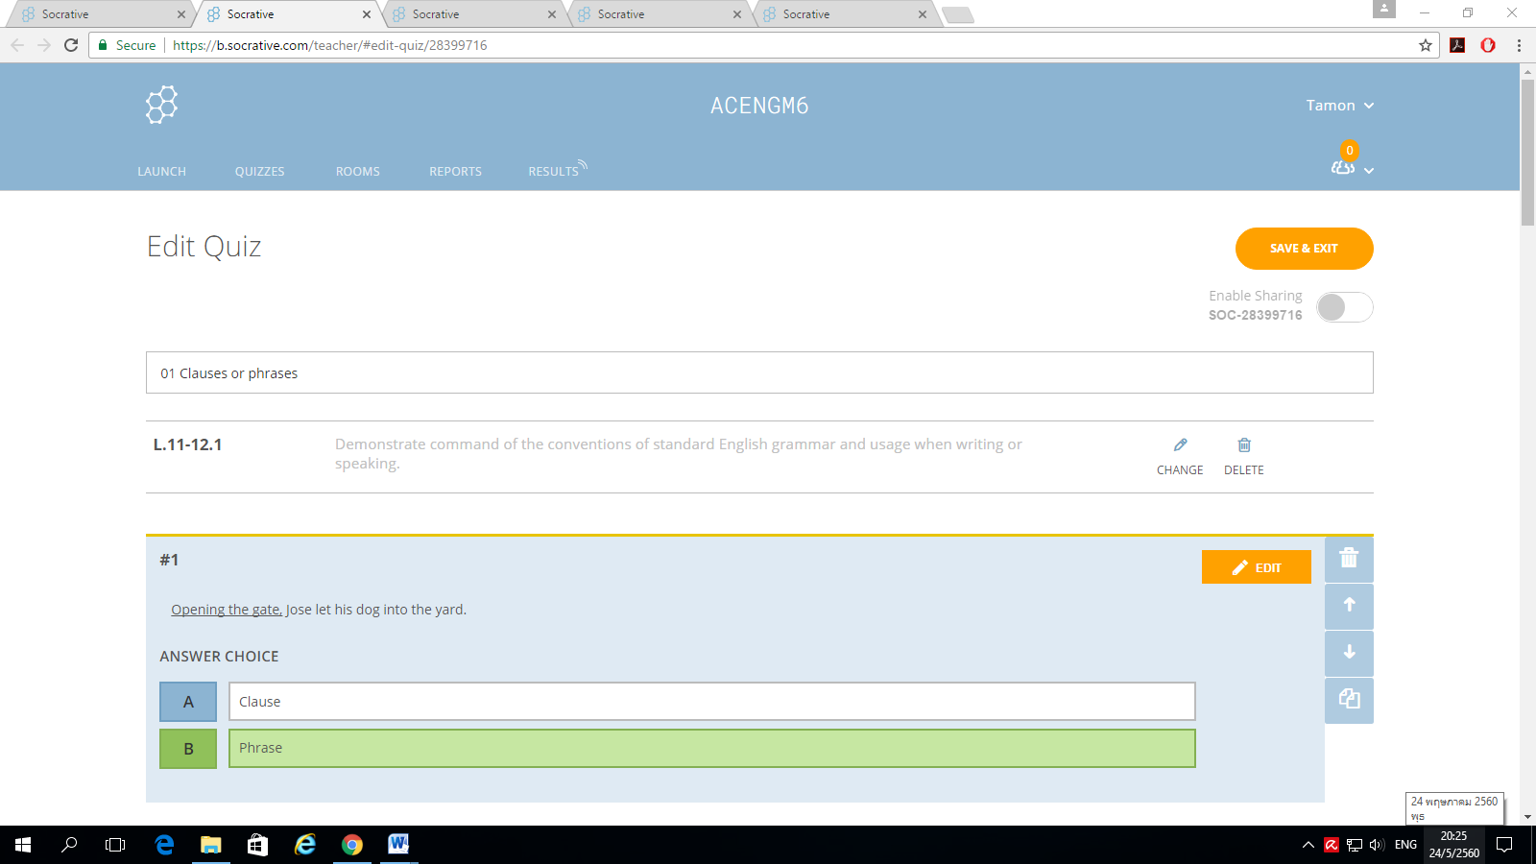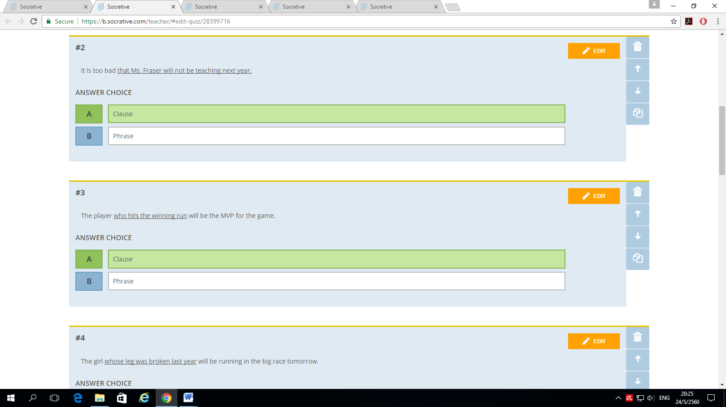

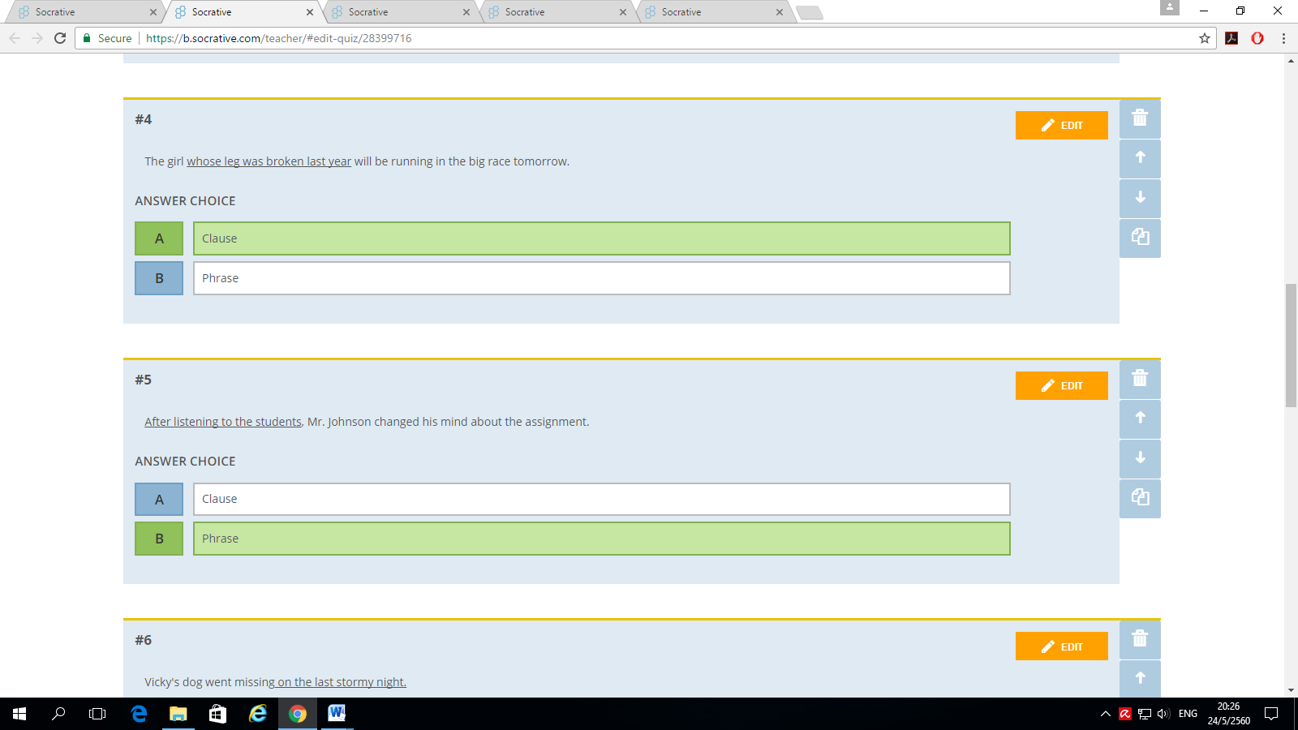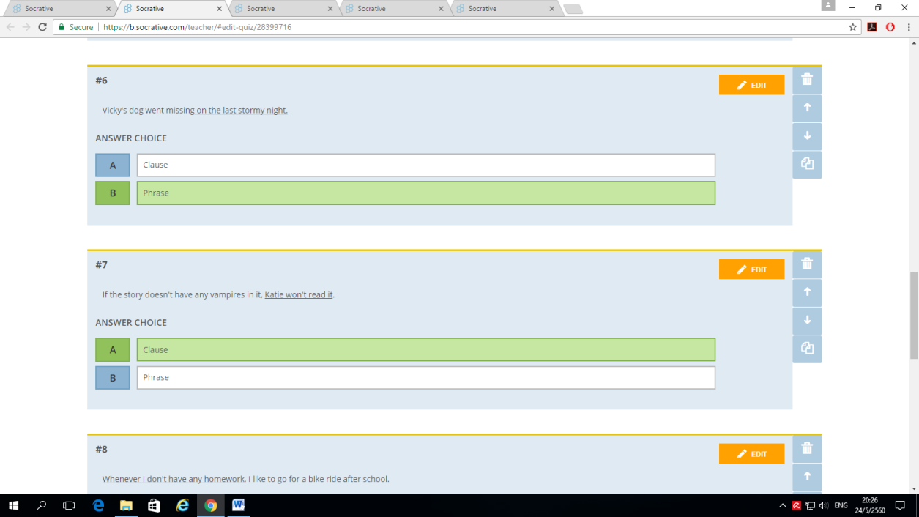

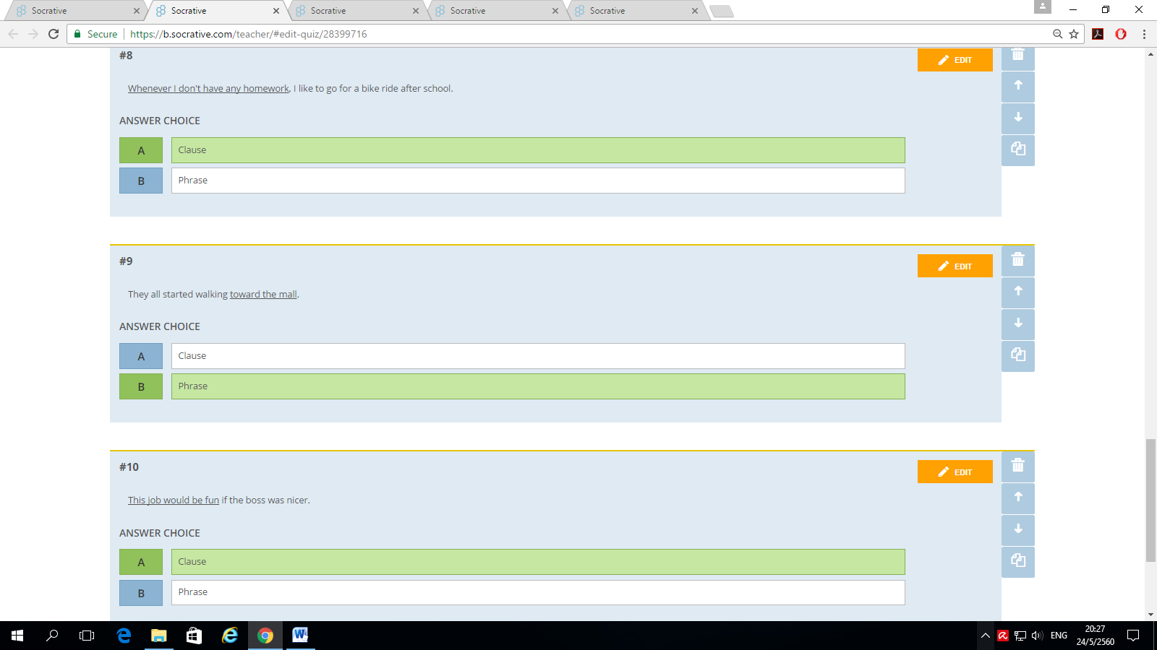

**Assumption College**

**Learning Management Plan**

**Semester: 1 Academic Year: 2021 Week: 2**

**Subject Code: EN30219 Subject: English for IELTS 1**

**Level of Students: M. 6 Learning Unit: Society and technology**

**Topic: Simple, Compound and Complex Sentences Time: 1 Period**

**Indicator M.4-6 (6):** Use a wide range of structures, comprehensive vocabulary and effective pronunciation features with full flexibility, fluency and accuracy, to clearly present arguments according to common conventions with logically organized information and ideas, in either speaking or writing to the questions asked

**Learning Objective:**

**Knowledge:** The students will be able to identify the purpose of the writer, interpret the unknown words in the passage, and summarize the whole passage

**Process/Skill:** The students will be able toanswer the question concerning the passage correctly.

**Desirable Characteristics:** Self-discipline

**Learners’ Key Competencies**

🞎 communication capability

**☑** thinking capability

🞎 problem solving capability

🞎 capability in applying life skills and

🞎 capability in technological application

**Sub Concept/ Topic: Identifying simple, compound and complex sentences**

**Activities: (PPP)**

1. Start the lesson by showing students a picture of a place. Talk about the picture using 3 sentences which are simple, compound and complex sentences, respectively. “I want to go to this place.” “I want to go there with my friends and I will take a lot of pictures there”. “I want to go there because it is very beautiful.” Show these 3 sentences using the PowerPoint Presentation. Use this link to go to the "Sentence Type" video on the **Shmoop website**: http://www.shmoop.com/video/sentence-types. Encourage them to get involved in the lesson and show interest. **(Warm Up / Lead-In)**
2. Present the aspect of language in a context that students are familiar with and explain the form of the language in a meaningful context. Contrast the **Thai and English wisdoms in terms of Languages**. Explain the differences of the three sentence structures of English and Thai languages. Tell students that the ideas about the simple sentences and compound sentences in Thai and English are not the same. Compare the similarity of the Thai and English languages in terms of complex sentences. **(Presentation)**
3. Students practice this construction through controlled activities such as worksheets or question and answer activities to check comprehension. Create a quiz in **Socrative** on simple, compound, and complex sentences. Show questions one-by-one as students answer with their mobile phones. After each question, discuss correct and incorrect answers. **(Practice)**
4. Create as many opportunities for students to produce the construction more independently. Students use the language in context in an activity set up by the teacher who will be giving minimal assistance. Instruct students to go into Google drive and create a document. Students will then write a three paragraph, 15 sentence "how to" essay. They must choose a task they want to describe in detail. In this essay, they must use all three types of sentences. When finished writing, they should highlight the simple sentences in blue, the compound sentences in yellow, and the complex sentences in orange. Show students an exemplar of what is expected in this essay. Finish the lesson by giving the students feedback on the activity, explain any mistakes and correct them. **(Production)**
5. Give students more exercises about the topic. Students must write down and be ready to present/discuss with the class about their answers. Each student will present this during the next lesson. **(Assignment)**

**Teaching Materials**

**☑** Textbook

**☑** PowerPoint Presentation

🞎 Dictionary

🞎 Websites

🞎 Google Forms, Google Slides

🞎 Kahoot!, Quizizz or Quizlet, AC Online Classroom

**☑** Socrative

**Teaching Procedures:**

**Teaching Model** □ 5E Model **☑** PPP □ Explicit Teaching Model

□ CIPPA □CALLA□ SIOP

□ Others………

**Teaching Method** □ CLT □ CBL □ TBL

□ The Direct Method □ Real-life scenarios

□ The Structural Approach □ Cooperative Learning

□Others………

**Teaching Technique** □ KWL-Plus□ CIRC □ Brainstorming

□ STAD □ Dramatization □ Group discussion

□ Pair work □ Peer Teaching □Mind Maps

□ Group work □ Others………

**Evaluation:**

|  |  |  |
| --- | --- | --- |
| **Learning Objective** | **Evaluation Method** | **Evaluation Tools** |
| Knowledge | Checking the quizzes in the textbook | Quizzes/Test |
| Process/Skill | Oral recitation of passages/answers | Oral evaluation |
| Desirable Characteristics | Observation | Observationform |

**Post-Teaching Recommendation:**

|  |  |  |  |  |  |  |  |
| --- | --- | --- | --- | --- | --- | --- | --- |
| Post Evaluation | CLASS | % of students who passed | | | % of students who didn’t pass | | |
| Indicator | | | Indicator | | |
| 1 |  |  | 1 |  |  |
| KNOWLEDGE | M.6/1 |  |  |  |  |  |  |
| M.6/2 |  |  |  |  |  |  |
| M.6/3 |  |  |  |  |  |  |
| M.6/4 |  |  |  |  |  |  |
| M.6/5 |  |  |  |  |  |  |
| M.6/6 |  |  |  |  |  |  |
| M.6/7 |  |  |  |  |  |  |
| M.6/8 |  |  |  |  |  |  |
| M.6/9 |  |  |  |  |  |  |

**How to solve the problem**: **Knowledge**

□ Review students’ prior knowledge

□ Review what students have learned again slowly.

□ Advise students to search further information on internet

□ Spare some time to teach them individually or in group

□ Give some more exercises / reports

□ Assign students to do group work or pair work

□ Let the encounter “Learning by Doing” process as much as possible.

|  |  |  |  |  |  |  |  |
| --- | --- | --- | --- | --- | --- | --- | --- |
| Post Evaluation | CLASS | % of students who passed | | | % of students who didn’t pass | | |
| Indicator | | | Indicator | | |
| 1 |  |  | 1 |  |  |
| PROCESS/SKILL | M.6/1 |  |  |  |  |  |  |
| M.6/2 |  |  |  |  |  |  |
| M.6/3 |  |  |  |  |  |  |
| M.6/4 |  |  |  |  |  |  |
| M.6/5 |  |  |  |  |  |  |
| M.6/6 |  |  |  |  |  |  |
| M.6/7 |  |  |  |  |  |  |
| M.6/8 |  |  |  |  |  |  |
| M.6/9 |  |  |  |  |  |  |

**How to solve the problem**: **Skill**

□ Encourage them to listen / speak / read / or write from other sources.

□ Practice them to listen / speak / read / or write

□ Give them more chance to use all skills in English while teaching.

□ Let them criticize themselves the weak point in studying in that period and help them solve that problem.

|  |  |  |  |  |  |  |  |
| --- | --- | --- | --- | --- | --- | --- | --- |
| Post Evaluation | CLASS | % of students who passed | | | % of students who didn’t pass | | |
| Indicator | | | Indicator | | |
| 1 |  |  | 1 |  |  |
| DESIRABLE  CHARACTERISTICS | M.6/1 |  |  |  |  |  |  |
| M.6/2 |  |  |  |  |  |  |
| M.6/3 |  |  |  |  |  |  |
| M.6/4 |  |  |  |  |  |  |
| M.6/5 |  |  |  |  |  |  |
| M.6/6 |  |  |  |  |  |  |
| M.6/7 |  |  |  |  |  |  |
| M.6/8 |  |  |  |  |  |  |
| M.6/9 |  |  |  |  |  |  |

**How to solve the problem: Desirable Characteristics**

□ Point out the importance of that qualification.

□ Give them some incentives

□ Give warning / suggestion / detention

□ Encourage them to have this desirable characteristic

**Follow-Up**………………………..………………………………………………..……………………

……..…………………………..…………………………..……………..………………………………

…………………………………..…………………………………..……………………………………

Teacher …………………………………….

Head of Foreign Languages Department …………………………………………………

|  |  |  |  |
| --- | --- | --- | --- |
| Week | Period | Topic | Website |
| 2 | 2 | Simple, Compound, Complex Sentences | https://b.socrative.com/teacher/#import-quiz/28399781 |

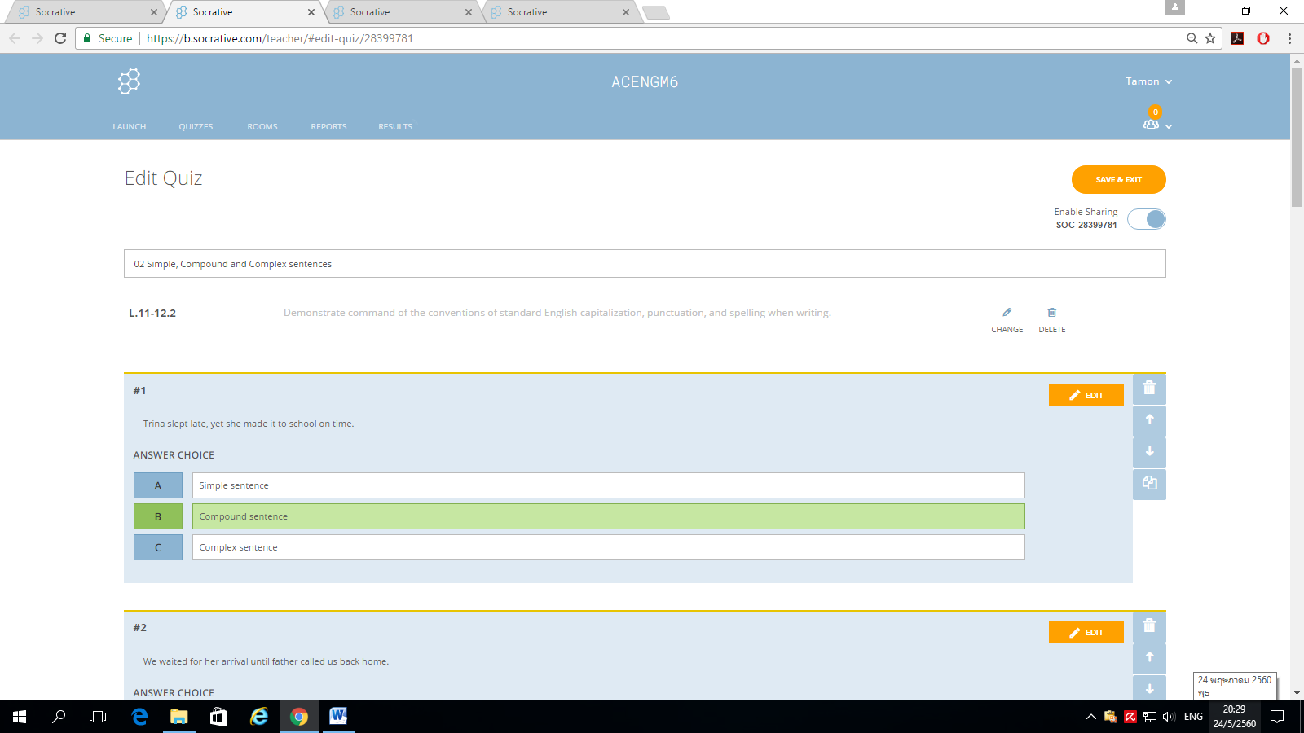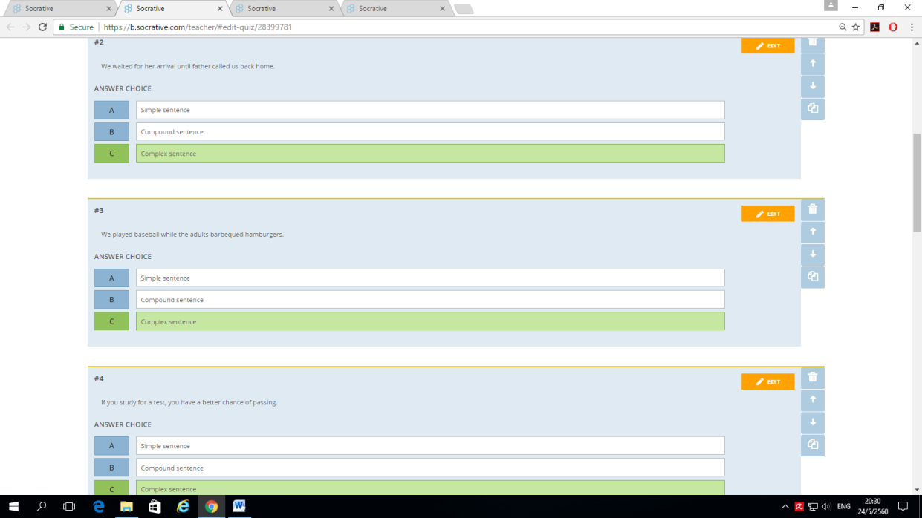

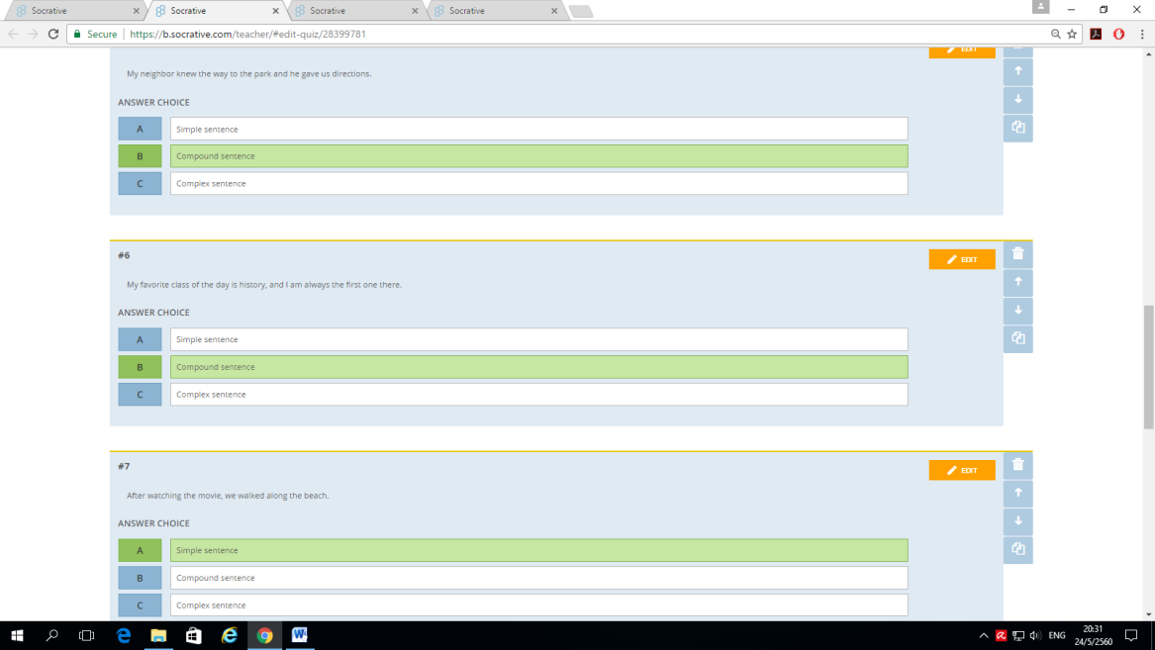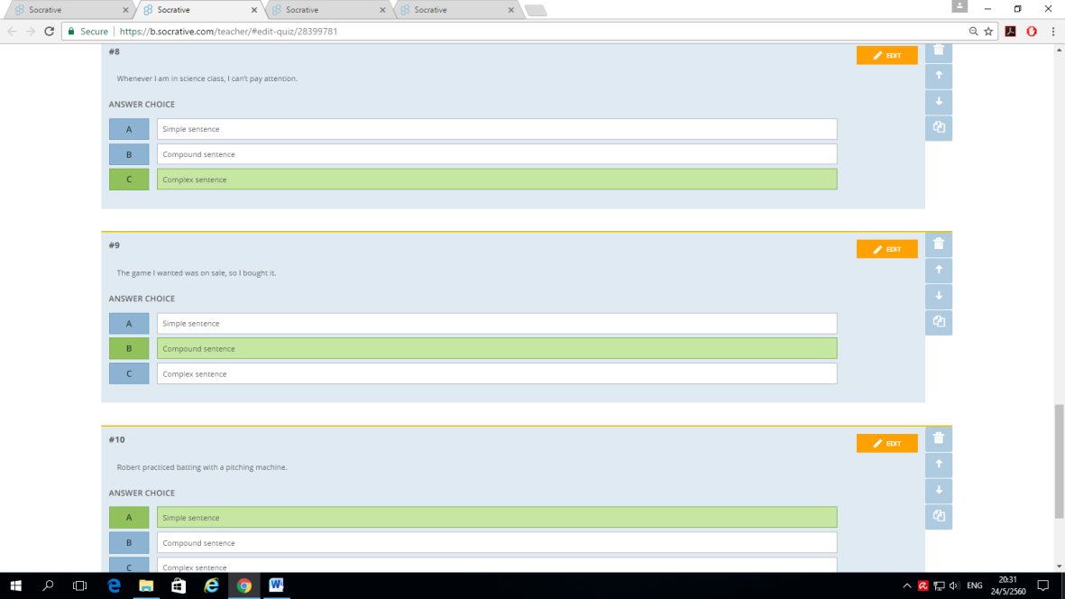

**Assumption College**

**Learning Management Plan**

**Semester: 1 Academic Year: 2021 Week: 3**

**Subject Code: EN30219 Subject: English for IELTS 1**

**Level of Students: M. 6 Learning Unit: Society and technology**

**Topic: Participle Clauses Time: 1 Period**

**Indicator M.4-6 (2):** Demonstrate comprehension of text details to perform sentence completion tasks, extract key points from academic texts, identify antonyms and synonyms in written text, employ strategies to deal with unknown vocabulary and interpret written texts to identify and match detailed information

**Learning Objective:**

**Knowledge:** The students will be able to change the given sentences into participle clauses.

**Process/Skill:** The students will be able towrite sentences using participle clauses correctly.

**Desirable Characteristics:** Dedication and commitment to work

**Learners’ Key Competencies**

🞎 communication capability

🞎 thinking capability

**☑** problem solving capability

🞎 capability in applying life skills and

🞎 capability in technological application

**Sub Concept/ Topic: Changing the given sentences into participle clauses**

**Activities: (Explicit Teaching Model)**

1. Review the lesson of last period. Then, introduce the way to change sentences into participle clauses. **(Revision)**
2. Ask some important questions such as “What are participle clauses?” then let the students answer and discuss in group. After that, explain the rules appearing in the book rule by rule with exercises to help increase their understanding. **(Teaching)**
3. Let students do the exercise after teaching rules. Then randomly choose students to answer the questions. If students can give clear explanation, continue to the next question, but if not, the teacher should explain it clearly. After that, provide time for students to do exercises by themselves. **(Practice under supervision)**
4. Random some students to answer each question and give the correction, and tell the reason why they correct each item like that with the help and suggestion of the teacher. **(Giving correction)**
5. Ask students to login to ‘Socrative’ and do the exercises provided by the teacher. **(Individual practice)**
6. Give some assignments to students to practice. **(Revision)**

**Teaching Materials**

**☑** Textbook

**☑** PowerPoint Presentation

🞎 Dictionary

🞎 Websites

🞎 Google Forms, Google Slides

🞎 Kahoot!, Quizizz or Quizlet, AC Online Classroom

**☑** Socrative

**Teaching Procedures:**

**Teaching Model** □ 5E Model □ PPP **☑** Explicit Teaching Model

□ CIPPA □CALLA□ SIOP

□ Others………

**Teaching Method** □ CLT □ CBL □ TBL

□ The Direct Method □ Real-life scenarios

□ The Structural Approach □ Cooperative Learning

□Others………

**Teaching Technique** □ KWL-Plus□ CIRC □ Brainstorming

□ STAD □ Dramatization □ Group discussion

□ Pair work □ Peer Teaching □Mind Maps

□ Group work □ Others………

**Evaluation:**

|  |  |  |
| --- | --- | --- |
| **Learning Objective** | **Evaluation Method** | **Evaluation Tools** |
| Knowledge | Checking the quizzes in the textbook | Quizzes/Test |
| Process/Skill | Oral recitation of passages/answers | Oral evaluation |
| Desirable Characteristics | Observation | Observationform |

**Post-Teaching Recommendation:**

|  |  |  |  |  |  |  |  |
| --- | --- | --- | --- | --- | --- | --- | --- |
| Post Evaluation | CLASS | % of students who passed | | | % of students who didn’t pass | | |
| Indicator | | | Indicator | | |
| 1 |  |  | 1 |  |  |
| KNOWLEDGE | M.6/1 |  |  |  |  |  |  |
| M.6/2 |  |  |  |  |  |  |
| M.6/3 |  |  |  |  |  |  |
| M.6/4 |  |  |  |  |  |  |
| M.6/5 |  |  |  |  |  |  |
| M.6/6 |  |  |  |  |  |  |
| M.6/7 |  |  |  |  |  |  |
| M.6/8 |  |  |  |  |  |  |
| M.6/9 |  |  |  |  |  |  |

**How to solve the problem**: **Knowledge**

□ Review students’ prior knowledge

□ Review what students have learned again slowly.

□ Advise students to search further information on internet

□ Spare some time to teach them individually or in group

□ Give some more exercises / reports

□ Assign students to do group work or pair work

□ Let the encounter “Learning by Doing” process as much as possible.

|  |  |  |  |  |  |  |  |
| --- | --- | --- | --- | --- | --- | --- | --- |
| Post Evaluation | CLASS | % of students who passed | | | % of students who didn’t pass | | |
| Indicator | | | Indicator | | |
| 1 |  |  | 1 |  |  |
| PROCESS/SKILL | M.6/1 |  |  |  |  |  |  |
| M.6/2 |  |  |  |  |  |  |
| M.6/3 |  |  |  |  |  |  |
| M.6/4 |  |  |  |  |  |  |
| M.6/5 |  |  |  |  |  |  |
| M.6/6 |  |  |  |  |  |  |
| M.6/7 |  |  |  |  |  |  |
| M.6/8 |  |  |  |  |  |  |
| M.6/9 |  |  |  |  |  |  |

**How to solve the problem**: **Skill**

□ Encourage them to listen / speak / read / or write from other sources.

□ Practice them to listen / speak / read / or write

□ Give them more chance to use all skills in English while teaching.

□ Let them criticize themselves the weak point in studying in that period and help them solve that problem.

|  |  |  |  |  |  |  |  |
| --- | --- | --- | --- | --- | --- | --- | --- |
| Post Evaluation | CLASS | % of students who passed | | | % of students who didn’t pass | | |
| Indicator | | | Indicator | | |
| 1 |  |  | 1 |  |  |
| DESIRABLE  CHARACTERISTICS | M.6/1 |  |  |  |  |  |  |
| M.6/2 |  |  |  |  |  |  |
| M.6/3 |  |  |  |  |  |  |
| M.6/4 |  |  |  |  |  |  |
| M.6/5 |  |  |  |  |  |  |
| M.6/6 |  |  |  |  |  |  |
| M.6/7 |  |  |  |  |  |  |
| M.6/8 |  |  |  |  |  |  |
| M.6/9 |  |  |  |  |  |  |

**How to solve the problem: Desirable Characteristics**

□ Point out the importance of that qualification.

□ Give them some incentives

□ Give warning / suggestion / detention

□ Encourage them to have this desirable characteristic

**Follow-Up**………………………..………………………………………………..……………………

……..…………………………..…………………………..……………..………………………………

…………………………………..…………………………………..……………………………………

Teacher …………………………………….

Head of Foreign Languages Department …………………………………………………

|  |  |  |  |
| --- | --- | --- | --- |
| Week | Period | Topic | Website |
| 3 | 2 | Participle clauses | https://b.socrative.com/teacher/#import-quiz/28461416 |

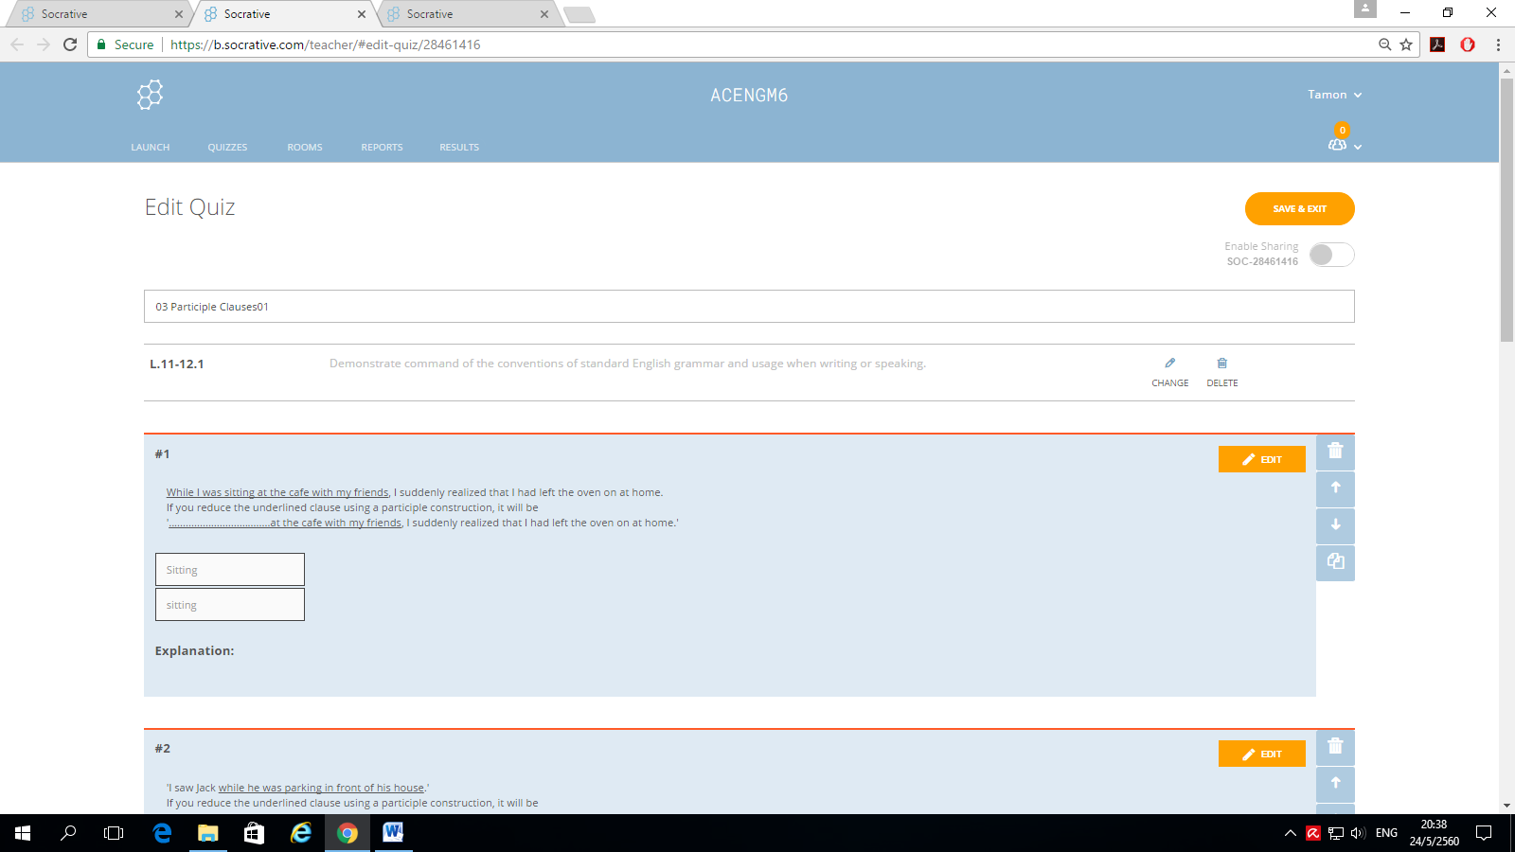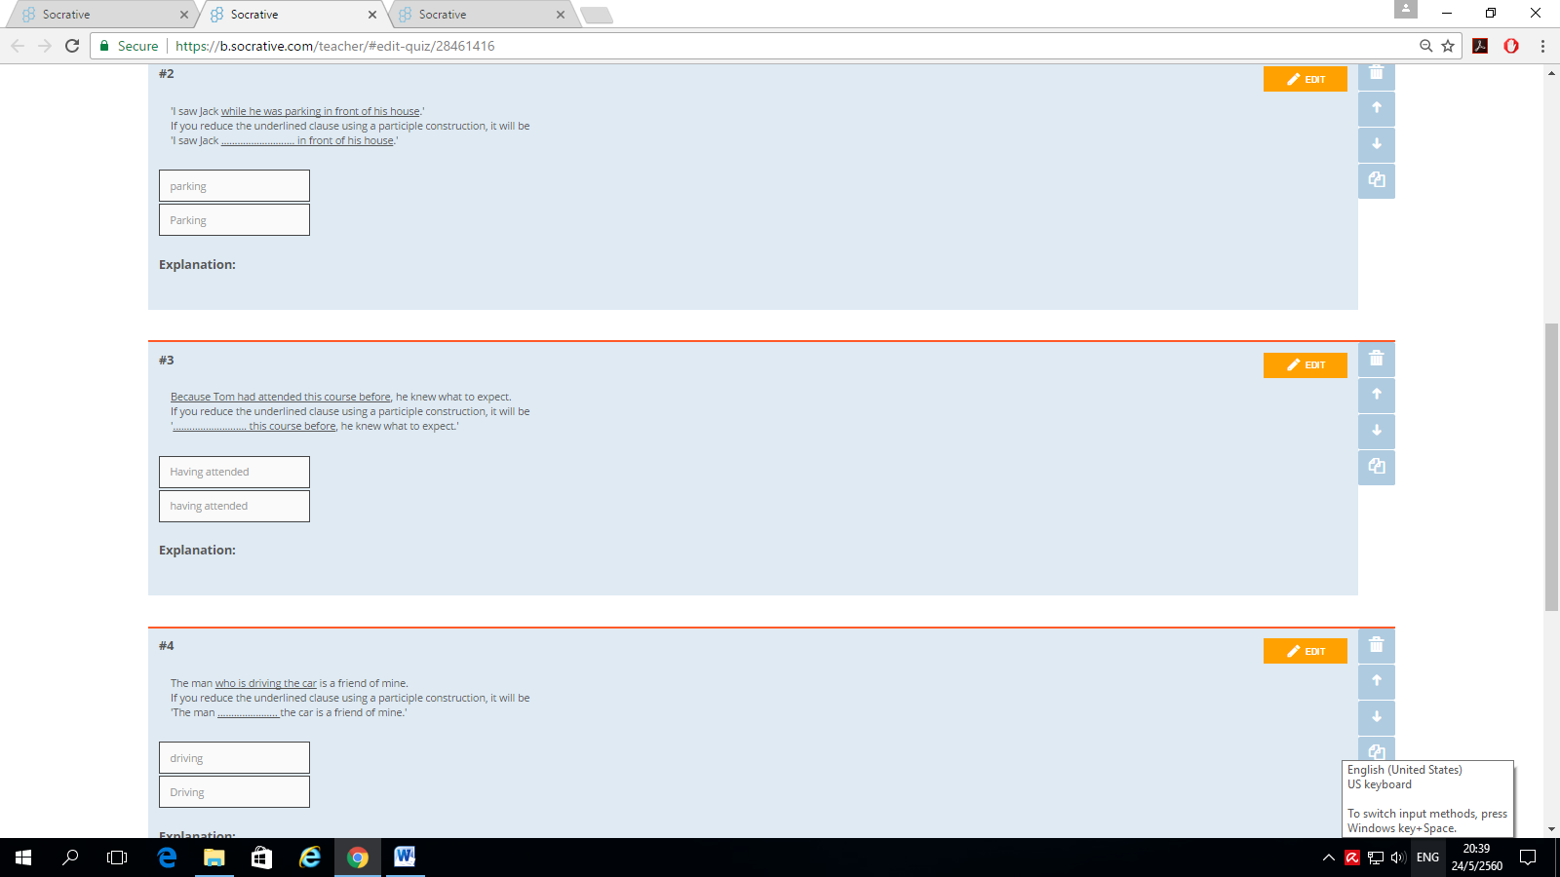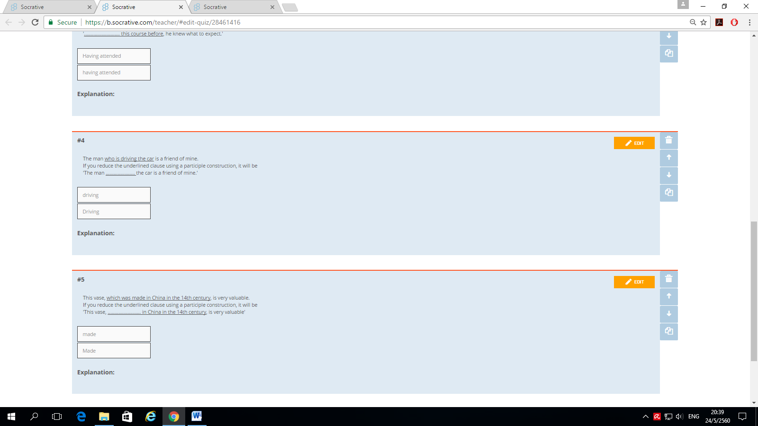

**Assumption College**

**Learning Management Plan**

**Semester: 1 Academic Year: 2021 Week: 4**

**Subject Code: EN30219 Subject: English for IELTS 1**

**Level of Students: M. 6 Learning Unit: Society and technology**

**Topic: Absolute Phrases Time: 1 Period**

**Indicator M.4-6 (2):** Demonstrate comprehension of text details to perform sentence completion tasks, extract key points from academic texts, identify antonyms and synonyms in written text, employ strategies to deal with unknown vocabulary and interpret written texts to identify and match detailed information

**Learning Objective:**

**Knowledge:** The students will be able to change the given sentences into absolute phrases.

**Process/Skill:** The students will be able towrite sentences using absolute phrases correctly.

**Desirable Characteristics:** Love of nation, religion and king

**Learners’ Key Competencies**

🞎 communication capability

🞎 thinking capability

🞎 problem solving capability

**☑** capability in applying life skills and

🞎 capability in technological application

**Sub Concept/ Topic: Changing the given sentences into absolute phrases**

**Activities: CIPPA**

1. Activate students’ prior knowledge by mentioning the last lesson about participle clauses. **(Activating prior knowledge)**
2. Encourage students to seek new knowledge by showing them 4 sentences: two containing participle clauses and two containing absolute phrases. Ask them to find and explain the similarities and differences of the two structures. Have their peers correct their thinking with the help of the teacher. **(Seeking new knowledge)**
3. Have them look at the worksheet and have them study the new knowledge. Let them integrate their new knowledge with the prior knowledge. Compare the new learning with methods that they already used and understand. **(Integrating knowledge)**
4. Have them do some more exercises by themselves. Then, have them exchange what they have learned by discussing in small groups of four. **(Sharing knowledge)**
5. Have them help one another conclude what they have learned and give the answer of the exercises in the book. **(Conclusion and knowledge organization)**
6. Have students share their answers to the class to check their understanding. **(Showing Tasks)**
7. Use the new knowledge to do more exercises in the worksheet and in the book. **(Knowledge application)**

**Teaching Materials**

**☑** Textbook

* PowerPoint Presentation

🞎 Dictionary

🞎 Websites

🞎 Google Forms, Google Slides

🞎 Kahoot!, Quizizz or Quizlet, AC Online Classroom

🞎 Socrative

**Teaching Procedures:**

**Teaching Model** □ 5E Model □ PPP □ Explicit Teaching Model

**☑** CIPPA □CALLA□ SIOP

□ Others………

**Teaching Method** □ CLT □ CBL □ TBL

□ The Direct Method □ Real-life scenarios

□ The Structural Approach □ Cooperative Learning

□Others………

**Teaching Technique** □ KWL-Plus□ CIRC □ Brainstorming

□ STAD □ Dramatization □ Group discussion

□ Pair work □ Peer Teaching □Mind Maps

□ Group work □ Others………

**Evaluation:**

|  |  |  |
| --- | --- | --- |
| **Learning Objective** | **Evaluation Method** | **Evaluation Tools** |
| Knowledge | Checking the quizzes in the textbook | Quizzes/Test |
| Process/Skill | Oral recitation of passages/answers | Oral evaluation |
| Desirable Characteristics | Observation | Observationform |

**Post-Teaching Recommendation:**

|  |  |  |  |  |  |  |  |
| --- | --- | --- | --- | --- | --- | --- | --- |
| Post Evaluation | CLASS | % of students who passed | | | % of students who didn’t pass | | |
| Indicator | | | Indicator | | |
| 1 |  |  | 1 |  |  |
| KNOWLEDGE | M.6/1 |  |  |  |  |  |  |
| M.6/2 |  |  |  |  |  |  |
| M.6/3 |  |  |  |  |  |  |
| M.6/4 |  |  |  |  |  |  |
| M.6/5 |  |  |  |  |  |  |
| M.6/6 |  |  |  |  |  |  |
| M.6/7 |  |  |  |  |  |  |
| M.6/8 |  |  |  |  |  |  |
| M.6/9 |  |  |  |  |  |  |

**How to solve the problem**: **Knowledge**

□ Review students’ prior knowledge

□ Review what students have learned again slowly.

□ Advise students to search further information on internet

□ Spare some time to teach them individually or in group

□ Give some more exercises / reports

□ Assign students to do group work or pair work

□ Let the encounter “Learning by Doing” process as much as possible.

|  |  |  |  |  |  |  |  |
| --- | --- | --- | --- | --- | --- | --- | --- |
| Post Evaluation | CLASS | % of students who passed | | | % of students who didn’t pass | | |
| Indicator | | | Indicator | | |
| 1 |  |  | 1 |  |  |
| PROCESS/SKILL | M.6/1 |  |  |  |  |  |  |
| M.6/2 |  |  |  |  |  |  |
| M.6/3 |  |  |  |  |  |  |
| M.6/4 |  |  |  |  |  |  |
| M.6/5 |  |  |  |  |  |  |
| M.6/6 |  |  |  |  |  |  |
| M.6/7 |  |  |  |  |  |  |
| M.6/8 |  |  |  |  |  |  |
| M.6/9 |  |  |  |  |  |  |

**How to solve the problem**: **Skill**

□ Encourage them to listen / speak / read / or write from other sources.

□ Practice them to listen / speak / read / or write

□ Give them more chance to use all skills in English while teaching.

□ Let them criticize themselves the weak point in studying in that period and help them solve that problem.

|  |  |  |  |  |  |  |  |
| --- | --- | --- | --- | --- | --- | --- | --- |
| Post Evaluation | CLASS | % of students who passed | | | % of students who didn’t pass | | |
| Indicator | | | Indicator | | |
| 1 |  |  | 1 |  |  |
| DESIRABLE  CHARACTERISTICS | M.6/1 |  |  |  |  |  |  |
| M.6/2 |  |  |  |  |  |  |
| M.6/3 |  |  |  |  |  |  |
| M.6/4 |  |  |  |  |  |  |
| M.6/5 |  |  |  |  |  |  |
| M.6/6 |  |  |  |  |  |  |
| M.6/7 |  |  |  |  |  |  |
| M.6/8 |  |  |  |  |  |  |
| M.6/9 |  |  |  |  |  |  |

**How to solve the problem: Desirable Characteristics**

□ Point out the importance of that qualification.

□ Give them some incentives

□ Give warning / suggestion / detention

□ Encourage them to have this desirable characteristic

**Follow-Up**………………………..………………………………………………..……………………

……..…………………………..…………………………..……………..………………………………

…………………………………..…………………………………..……………………………………

Teacher …………………………………….

Head of Foreign Languages Department …………………………………………………

|  |  |  |  |
| --- | --- | --- | --- |
| Week | Period | Topic | Website |
| 4 | 1 | Absolute Phrases | https://b.socrative.com/teacher/#import-quiz/28461476 |

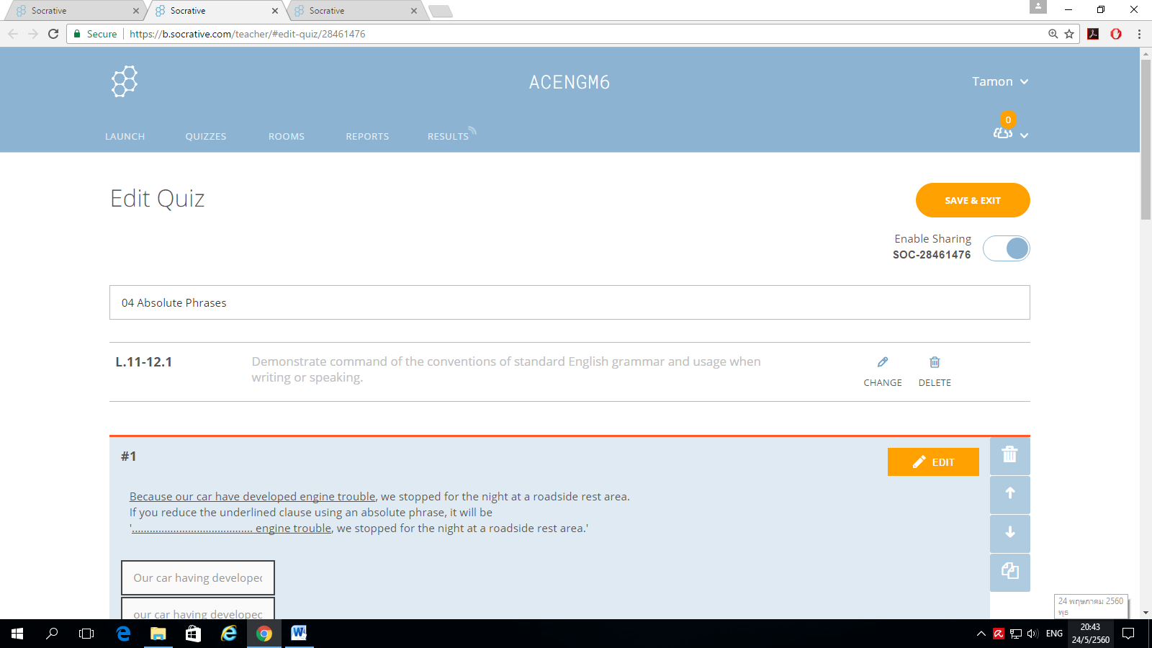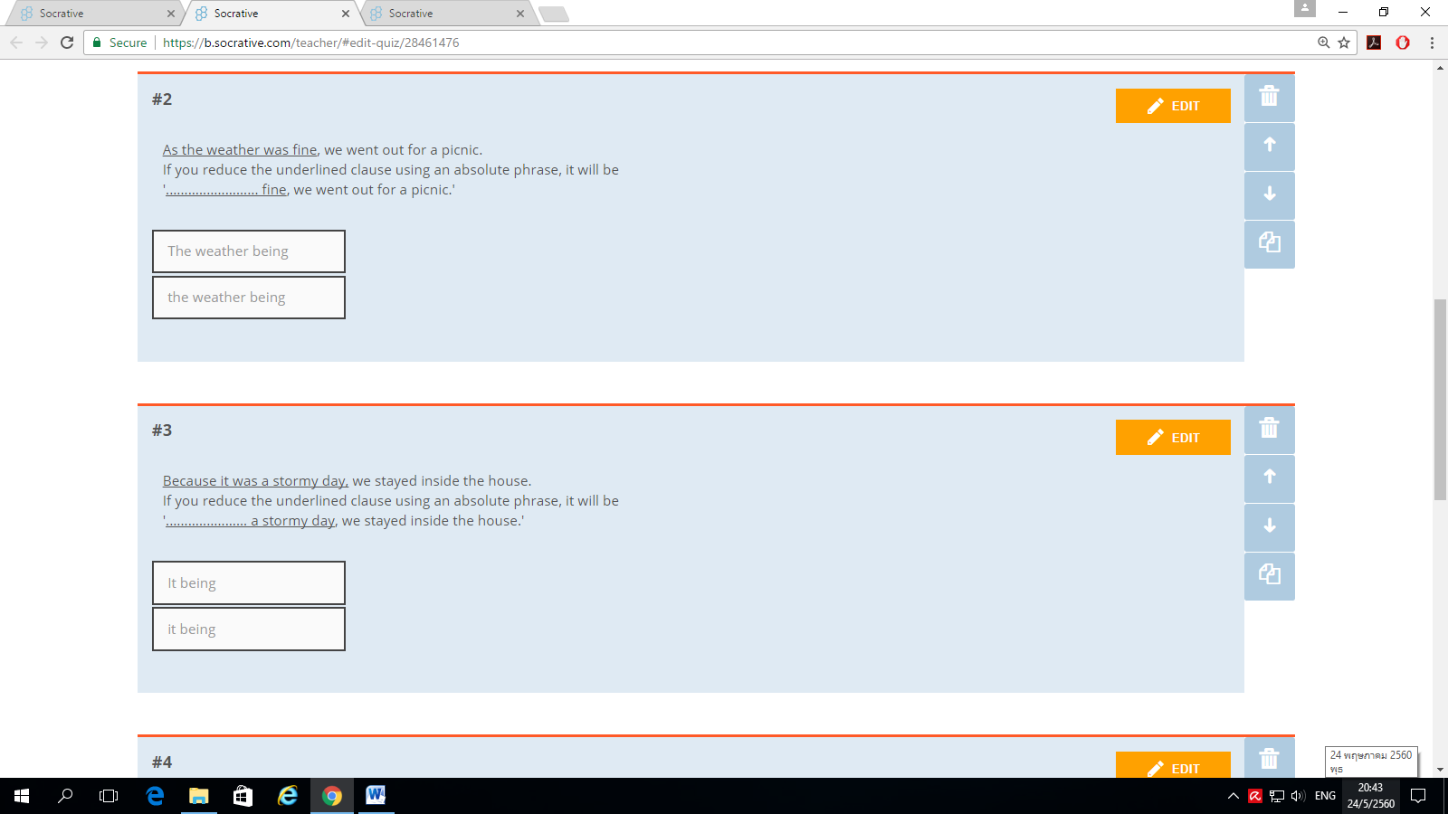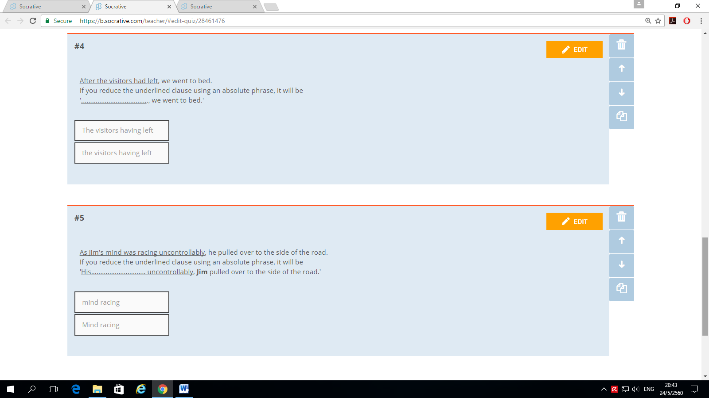

**Assumption College**

**Learning Management Plan**

**Semester: 1 Academic Year: 2021 Week: 5**

**Subject Code: EN30219 Subject: English for IELTS 1**

**Level of Students: M. 6 Learning Unit: Global Communication**

**Topic: Inversion Time: 1 Period**

**Indicator M.4-6 (7):** Explain, analyse and discuss hobbies, interests, feelings, beliefs and origins of customs and traditions of native speakers along with similarities and differences between the lifestyles, beliefs and culture of native speakers and those of Thais, and apply them appropriately

**Learning Objective:**

**Knowledge:** The students will be able to change the given sentences using the structure of inversion.

**Process/Skill:** The students will be able towrite sentences using the structure of inversion correctly.

**Desirable Characteristics:** Cherishing Thai-ness

**Learners’ Key Competencies**

🞎 communication capability

🞎 thinking capability

🞎 problem solving capability

🞎 capability in applying life skills and

**☑** capability in technological application

**Sub Concept/ Topic: The structure of inversion in English**

**Activities: KWL-Plus**

1. Discuss the topic with students. Distribute K-W-L chart to each student. **(Preparation)**
2. Based on what they have learnt about inversions last year, ask students to tell what they remember about inversions in English. Write student responses on the board, chart paper, or overhead in the first column marked What I Know. **(Pre teaching)**
3. **Promote the 21st century learning skills in terms of communication by allowing students to communicate in English and work in group** to brainstorm information they know about the topic and list it in the K column of the chart (Know) Then, help students develop questions about what they would like to know about the topic; write these questions in the W column. (Want to Know) Next, have students read the examples of sentences using the structure of inversions. After that, have students list the way to use inversions in English that they have learned in the L column. When the entire chart is complete, discuss what students have learned. Ask them to revise their charts. Ask students if they need to change any information from the first list. (Learned) **(While teaching)**
4. To continue with the KWL Plus Strategy, ask students to categorize the information in the L column. Together indicate with plus and minus signs information verified in the text (+) and incorrect information (-) (Plus) **(After teaching)**
5. Next, ask students to develop a concept map or graphic organizer integrating the information from what they learnt about inversions. The topic becomes the center of the map, and the categories represent the map concepts, with explanatory details from the L column included under each category. **(Mind-Mapping)**
6. Have students use the concept map or graphic organizer to write a summary of the way to use inversions. **(Summarizing)**
7. Ask students how this instructional activity helped them to better understand the text and have them answer more questions to check their understanding of what they have learned. **(Evaluation)**

**Teaching Materials**

**☑** Textbook

* PowerPoint Presentation

🞎 Dictionary

🞎 Websites

🞎 Google Forms, Google Slides

🞎 Kahoot!, Quizizz or Quizlet, AC Online Classroom

🞎 Socrative

**Teaching Procedures:**

**Teaching Model** □ 5E Model □ PPP □ Explicit Teaching Model

□ CIPPA □CALLA□ SIOP

□ Others………

**Teaching Method** □ CLT □ CBL □ TBL

□ The Direct Method □ Real-life scenarios

□ The Structural Approach □ Cooperative Learning

□Others………

**Teaching Technique ☑** KWL-Plus□ CIRC □ Brainstorming

□ STAD □ Dramatization □ Group discussion

□ Pair work □ Peer Teaching □Mind Maps

□ Group work □ Others………

**Evaluation:**

|  |  |  |
| --- | --- | --- |
| **Learning Objective** | **Evaluation Method** | **Evaluation Tools** |
| Knowledge | Checking the quizzes in the textbook | Quizzes/Test |
| Process/Skill | Oral recitation of passages/answers | Oral evaluation |
| Desirable Characteristics | Observation | Observationform |

**Post-Teaching Recommendation:**

|  |  |  |  |  |  |  |  |
| --- | --- | --- | --- | --- | --- | --- | --- |
| Post Evaluation | CLASS | % of students who passed | | | % of students who didn’t pass | | |
| Indicator | | | Indicator | | |
| 1 |  |  | 1 |  |  |
| KNOWLEDGE | M.6/1 |  |  |  |  |  |  |
| M.6/2 |  |  |  |  |  |  |
| M.6/3 |  |  |  |  |  |  |
| M.6/4 |  |  |  |  |  |  |
| M.6/5 |  |  |  |  |  |  |
| M.6/6 |  |  |  |  |  |  |
| M.6/7 |  |  |  |  |  |  |
| M.6/8 |  |  |  |  |  |  |
| M.6/9 |  |  |  |  |  |  |

**How to solve the problem**: **Knowledge**

□ Review students’ prior knowledge

□ Review what students have learned again slowly.

□ Advise students to search further information on internet

□ Spare some time to teach them individually or in group

□ Give some more exercises / reports

□ Assign students to do group work or pair work

□ Let the encounter “Learning by Doing” process as much as possible.

|  |  |  |  |  |  |  |  |
| --- | --- | --- | --- | --- | --- | --- | --- |
| Post Evaluation | CLASS | % of students who passed | | | % of students who didn’t pass | | |
| Indicator | | | Indicator | | |
| 1 |  |  | 1 |  |  |
| PROCESS/SKILL | M.6/1 |  |  |  |  |  |  |
| M.6/2 |  |  |  |  |  |  |
| M.6/3 |  |  |  |  |  |  |
| M.6/4 |  |  |  |  |  |  |
| M.6/5 |  |  |  |  |  |  |
| M.6/6 |  |  |  |  |  |  |
| M.6/7 |  |  |  |  |  |  |
| M.6/8 |  |  |  |  |  |  |
| M.6/9 |  |  |  |  |  |  |

**How to solve the problem**: **Skill**

□ Encourage them to listen / speak / read / or write from other sources.

□ Practice them to listen / speak / read / or write

□ Give them more chance to use all skills in English while teaching.

□ Let them criticize themselves the weak point in studying in that period and help them solve that problem.

|  |  |  |  |  |  |  |  |
| --- | --- | --- | --- | --- | --- | --- | --- |
| Post Evaluation | CLASS | % of students who passed | | | % of students who didn’t pass | | |
| Indicator | | | Indicator | | |
| 1 |  |  | 1 |  |  |
| DESIRABLE  CHARACTERISTICS | M.6/1 |  |  |  |  |  |  |
| M.6/2 |  |  |  |  |  |  |
| M.6/3 |  |  |  |  |  |  |
| M.6/4 |  |  |  |  |  |  |
| M.6/5 |  |  |  |  |  |  |
| M.6/6 |  |  |  |  |  |  |
| M.6/7 |  |  |  |  |  |  |
| M.6/8 |  |  |  |  |  |  |
| M.6/9 |  |  |  |  |  |  |

**How to solve the problem: Desirable Characteristics**

□ Point out the importance of that qualification.

□ Give them some incentives

□ Give warning / suggestion / detention

□ Encourage them to have this desirable characteristic

**Follow-Up**………………………..………………………………………………..……………………

……..…………………………..…………………………..……………..………………………………

…………………………………..…………………………………..……………………………………

Teacher …………………………………….

Head of Foreign Languages Department …………………………………………………

**Assumption College**

**Learning Management Plan**

**Semester: 1 Academic Year: 2021 Week: 6**

**Subject Code: EN30219 Subject: English for IELTS 1**

**Level of Students: M. 6 Learning Unit: Global Communication**

**Topic: Finding Main Idea Time: 1 Period**

**Indicator M.4-6 (3):** Combine and organise paragraphs to respond to an opinion essay, employ complex connectors to link cause and effect clauses, formulate a clear thesis statement, identify main features of a diagram and write a paragraph plan under time restraints by using self-assess own writing for grammatical mistakes

**Learning Objective:**

**Knowledge:** The students will be able to identify the main idea of the passage.

**Process/Skill:** The students will be able toanswer the questions concerning the passage correctly.

**Desirable Characteristics:** Honesty and integrity

**Learners’ Key Competencies**

**☑** communication capability

🞎 thinking capability

🞎 problem solving capability

🞎 capability in applying life skills and

🞎 capability in technological application

**Sub Concept/ Topic: Identifying the main idea of the passage**

**Activities: (PPP & CIRC)**

1. Explain the learning objectives. Introduce the new topic using PowerPoint Presentation and give some questions related to the topic. Have students make predictions about the topic. **(Warm Up / Lead-In)**
2. Divide students into 4-member cooperative learning teams. Students are grouped heterogeneously. Give students a hand out of narrative text and they read it silently. Then let them read the text orally with their peers. During oral reading, students take turns reading the story aloud, alternating readers after each paragraph. While their partner is reading, the listeners follow along, correcting any errors the reader may make. Ask students to mention the difficult words from the text. Use phrasal verbs or synonyms to substitute the difficult words. Students restate or explain the new word in their own words. Ask students to create a non-linguistic representation of the word (a picture, or symbolic representation). **(Presentation)**
3. Every group is given a worksheet. Have students work in teams. First, ask students to look up the meaning of difficult words on the dictionary with their groups and write the answers on the answer sheet. After that, let each group present their answers. Next, let students answer the questions based on the text with their group members. Then, let them present their answers. Then, have student answer the true-false questions based on the text with their group members. **(Practice)**
4. Have every group work together to master main ideas and other comprehension skills. They should help summarizing stories to one another and conclude or retell the content of the story. Then, students reflect what they had learned in the learning process. The whole class makes summary. **(Production)**
5. Give students assignment to write down the moral values or new ideas that they acquire after learning about the topic. **(Assignment)**

**Teaching Materials**

**☑** Textbook

* PowerPoint Presentation

🞎 Dictionary

🞎 Websites

🞎 Google Forms, Google Slides

🞎 Kahoot!, Quizizz or Quizlet, AC Online Classroom

🞎 Socrative

**Teaching Procedures:**

**Teaching Model** □ 5E Model **☑** PPP □ Explicit Teaching Model

□ CIPPA □CALLA□ SIOP

□ Others………

**Teaching Method** □ CLT □ CBL □ TBL

□ The Direct Method □ Real-life scenarios

□ The Structural Approach □ Cooperative Learning

□Others………

**Teaching Technique** □ KWL-Plus **☑** CIRC □ Brainstorming

□ STAD □ Dramatization □ Group discussion

□ Pair work □ Peer Teaching □Mind Maps

□ Group work □ Others………

**Evaluation:**

|  |  |  |
| --- | --- | --- |
| **Learning Objective** | **Evaluation Method** | **Evaluation Tools** |
| Knowledge | Checking the quizzes in the textbook | Quizzes/Test |
| Process/Skill | Oral recitation of passages/answers | Oral evaluation |
| Desirable Characteristics | Observation | Observationform |

**Post-Teaching Recommendation:**

|  |  |  |  |  |  |  |  |
| --- | --- | --- | --- | --- | --- | --- | --- |
| Post Evaluation | CLASS | % of students who passed | | | % of students who didn’t pass | | |
| Indicator | | | Indicator | | |
| 1 |  |  | 1 |  |  |
| KNOWLEDGE | M.6/1 |  |  |  |  |  |  |
| M.6/2 |  |  |  |  |  |  |
| M.6/3 |  |  |  |  |  |  |
| M.6/4 |  |  |  |  |  |  |
| M.6/5 |  |  |  |  |  |  |
| M.6/6 |  |  |  |  |  |  |
| M.6/7 |  |  |  |  |  |  |
| M.6/8 |  |  |  |  |  |  |
| M.6/9 |  |  |  |  |  |  |

**How to solve the problem**: **Knowledge**

□ Review students’ prior knowledge

□ Review what students have learned again slowly.

□ Advise students to search further information on internet

□ Spare some time to teach them individually or in group

□ Give some more exercises / reports

□ Assign students to do group work or pair work

□ Let the encounter “Learning by Doing” process as much as possible.

|  |  |  |  |  |  |  |  |
| --- | --- | --- | --- | --- | --- | --- | --- |
| Post Evaluation | CLASS | % of students who passed | | | % of students who didn’t pass | | |
| Indicator | | | Indicator | | |
| 1 |  |  | 1 |  |  |
| PROCESS/SKILL | M.6/1 |  |  |  |  |  |  |
| M.6/2 |  |  |  |  |  |  |
| M.6/3 |  |  |  |  |  |  |
| M.6/4 |  |  |  |  |  |  |
| M.6/5 |  |  |  |  |  |  |
| M.6/6 |  |  |  |  |  |  |
| M.6/7 |  |  |  |  |  |  |
| M.6/8 |  |  |  |  |  |  |
| M.6/9 |  |  |  |  |  |  |

**How to solve the problem**: **Skill**

□ Encourage them to listen / speak / read / or write from other sources.

□ Practice them to listen / speak / read / or write

□ Give them more chance to use all skills in English while teaching.

□ Let them criticize themselves the weak point in studying in that period and help them solve that problem.

|  |  |  |  |  |  |  |  |
| --- | --- | --- | --- | --- | --- | --- | --- |
| Post Evaluation | CLASS | % of students who passed | | | % of students who didn’t pass | | |
| Indicator | | | Indicator | | |
| 1 |  |  | 1 |  |  |
| DESIRABLE  CHARACTERISTICS | M.6/1 |  |  |  |  |  |  |
| M.6/2 |  |  |  |  |  |  |
| M.6/3 |  |  |  |  |  |  |
| M.6/4 |  |  |  |  |  |  |
| M.6/5 |  |  |  |  |  |  |
| M.6/6 |  |  |  |  |  |  |
| M.6/7 |  |  |  |  |  |  |
| M.6/8 |  |  |  |  |  |  |
| M.6/9 |  |  |  |  |  |  |

**How to solve the problem: Desirable Characteristics**

□ Point out the importance of that qualification.

□ Give them some incentives

□ Give warning / suggestion / detention

□ Encourage them to have this desirable characteristic

**Follow-Up**………………………..………………………………………………..……………………

……..…………………………..…………………………..……………..………………………………

…………………………………..…………………………………..……………………………………

Teacher …………………………………….

Head of Foreign Languages Department …………………………………………………

**Assumption College**

**Learning Management Plan**

**Semester: 1 Academic Year: 2021 Week: 7**

**Subject Code: EN30219 Subject: English for IELTS 1**

**Level of Students: M. 6 Learning Unit: Global Communication**

**Topic: Reading Comprehension Time: 1 Period**

**Indicator M.4-6 (1):** Identify topic sentences of paragraphs, identify main ideas and overall meaning of texts to complete diagrams, match headings with paragraphs, and differentiate paragraph headings according to content

**Learning Objective:**

**Knowledge:** The students will be able to identify the purpose of the writer, interpret the unknown words in the passage, and summarize the whole passage

**Process/Skill:** The students will be able toanswer the question concerning the passage correctly.

**Desirable Characteristics:** Observance of principles of Sufficiency Economy Philosophy in one’s way of life

**Learners’ Key Competencies**

🞎 communication capability

**☑** thinking capability

🞎 problem solving capability

🞎 capability in applying life skills and

🞎 capability in technological application

**Sub Concept/ Topic: Answering the questions in the passage correctly**

**Activities: CIRC and Cooperative Learning**

1. Show students some photos relating to the topic. Activate student’s background knowledge about the topic. Have them work in pairs and list the vocabulary they know about the topic. Then, have them make predictions about the content**. (Presentation)**
2. Form groups of 4 students heterogeneously and assign them to read the passage from the book. Have them read to one another, skim and scan the text to get the main idea, identify text structure and answer questions. Have them make presentation or read the result from group’s discussion. **(Team practice)**
3. Let students work individually to write a draft and give opinion to the topic from the result on the group discussion. **(Independent practice)**
4. Allow students to assess each other's performance. Have them revise and edit each other’s work. The better students can help the weaker ones to give correction and they can learn from their own team members. It gives students the opportunity to encounter diversity in different ways, critique and judge each other’s work**. (Peer pre-assessment)**
5. Give each student a short story and let them read individually**. (Additional practic**e)
6. **Promote the 21st century learning skills in terms of digital literacy by encouraging students to use smartphones to play interactive quizzes.** Assess them using **Kahoot!!** to check if the students understand the concepts of the lesson. In the assessment stage, each student individually takes a quiz. Then their scores are combined and compared to their own past averages and points**. (Testing)**
7. Each team will be awarded based on the degree to which students meet or exceed their own earlier performance**. (Team Recognition)**

**Teaching Materials**

**☑** Textbook

**☑** PowerPoint Presentation

🞎 Dictionary

🞎 Websites

🞎 Google Forms, Google Slides

**☑** Kahoot!, Quizizz or Quizlet, AC Online Classroom

🞎 Socrative

**Teaching Procedures:**

**Teaching Model** □ 5E Model □ PPP □ Explicit Teaching Model

□ CIPPA □CALLA□ SIOP

□ Others………

**Teaching Method** □ CLT □ CBL □ TBL

□ The Direct Method □ Real-life scenarios

□ The Structural Approach **☑** Cooperative Learning

□Others………

**Teaching Technique** □ KWL-Plus **☑** CIRC □ Brainstorming

□ STAD □ Dramatization □ Group discussion

□ Pair work □ Peer Teaching □Mind Maps

□ Group work □ Others………

**Evaluation:**

|  |  |  |
| --- | --- | --- |
| **Learning Objective** | **Evaluation Method** | **Evaluation Tools** |
| Knowledge | Checking the quizzes in the textbook | Quizzes/Test |
| Process/Skill | Oral recitation of passages/answers | Oral evaluation |
| Desirable Characteristics | Observation | Observationform |

**Post-Teaching Recommendation:**

|  |  |  |  |  |  |  |  |
| --- | --- | --- | --- | --- | --- | --- | --- |
| Post Evaluation | CLASS | % of students who passed | | | % of students who didn’t pass | | |
| Indicator | | | Indicator | | |
| 1 |  |  | 1 |  |  |
| KNOWLEDGE | M.6/1 |  |  |  |  |  |  |
| M.6/2 |  |  |  |  |  |  |
| M.6/3 |  |  |  |  |  |  |
| M.6/4 |  |  |  |  |  |  |
| M.6/5 |  |  |  |  |  |  |
| M.6/6 |  |  |  |  |  |  |
| M.6/7 |  |  |  |  |  |  |
| M.6/8 |  |  |  |  |  |  |
| M.6/9 |  |  |  |  |  |  |

**How to solve the problem**: **Knowledge**

□ Review students’ prior knowledge

□ Review what students have learned again slowly.

□ Advise students to search further information on internet

□ Spare some time to teach them individually or in group

□ Give some more exercises / reports

□ Assign students to do group work or pair work

□ Let the encounter “Learning by Doing” process as much as possible.

|  |  |  |  |  |  |  |  |
| --- | --- | --- | --- | --- | --- | --- | --- |
| Post Evaluation | CLASS | % of students who passed | | | % of students who didn’t pass | | |
| Indicator | | | Indicator | | |
| 1 |  |  | 1 |  |  |
| PROCESS/SKILL | M.6/1 |  |  |  |  |  |  |
| M.6/2 |  |  |  |  |  |  |
| M.6/3 |  |  |  |  |  |  |
| M.6/4 |  |  |  |  |  |  |
| M.6/5 |  |  |  |  |  |  |
| M.6/6 |  |  |  |  |  |  |
| M.6/7 |  |  |  |  |  |  |
| M.6/8 |  |  |  |  |  |  |
| M.6/9 |  |  |  |  |  |  |

**How to solve the problem**: **Skill**

□ Encourage them to listen / speak / read / or write from other sources.

□ Practice them to listen / speak / read / or write

□ Give them more chance to use all skills in English while teaching.

□ Let them criticize themselves the weak point in studying in that period and help them solve that problem.

|  |  |  |  |  |  |  |  |
| --- | --- | --- | --- | --- | --- | --- | --- |
| Post Evaluation | CLASS | % of students who passed | | | % of students who didn’t pass | | |
| Indicator | | | Indicator | | |
| 1 |  |  | 1 |  |  |
| DESIRABLE  CHARACTERISTICS | M.6/1 |  |  |  |  |  |  |
| M.6/2 |  |  |  |  |  |  |
| M.6/3 |  |  |  |  |  |  |
| M.6/4 |  |  |  |  |  |  |
| M.6/5 |  |  |  |  |  |  |
| M.6/6 |  |  |  |  |  |  |
| M.6/7 |  |  |  |  |  |  |
| M.6/8 |  |  |  |  |  |  |
| M.6/9 |  |  |  |  |  |  |

**How to solve the problem: Desirable Characteristics**

□ Point out the importance of that qualification.

□ Give them some incentives

□ Give warning / suggestion / detention

□ Encourage them to have this desirable characteristic

**Follow-Up**………………………..………………………………………………..……………………

……..…………………………..…………………………..……………..………………………………

…………………………………..…………………………………..……………………………………

Teacher …………………………………….

Head of Foreign Languages Department …………………………………………………

**Assumption College**

**Learning Management Plan**

**Semester: 1 Academic Year: 2021 Week: 8**

**Subject Code: EN30219 Subject: English for IELTS 1**

**Level of Students: M. 6 Learning Unit: Global Communication**

**Topic: Word Formation Time: 1 Period**

**Indicator M.4-6 (5**): Identify key information to complete notes or to complete gaps in sentences from a listening or a lecture, identify correct word forms in a listening task, identify relevant details in a listening to discern correct answer among multiple choices, listen to identify specific information needed to complete a flow chart and discern key points in a lecture to chronologically arrange stages in a process

**Learning Objective:**

**Knowledge:** The students will be able to choose the correct formation of words.

**Process/Skill:** The students will be able toselect the formation of words correctly.

**Desirable Characteristics:** Gentlemen of Assumption College

**Learners’ Key Competencies**

🞎 communication capability

🞎 thinking capability

**☑** problem solving capability

🞎 capability in applying life skills and

🞎 capability in technological application

**Sub Concept/ Topic: Choosing the correct formation of words**

**Activities: (SIOP + Cooperative Learning + STAD)**

1. Students are shown clearly defined content objectives on the board. Ask them what are the noun, verb, and adverb of the word ‘broad’. Tell them that they will be discussing how to make new words from root words. **(Preparation)**  
2.Concepts should be directly linked to students’ background experience. Ask students to work in **groups of 4** **with different levels of ability**. Ask them about the suffixes they have known. Write those examples on the board. Have students write as many words ending with suffixes as possible. Then discuss the pattern. (**Building Background**)

3.Use speech that is appropriate for students' language proficiency to talk about root words and suffixes. Have the students watch the videos in YouTube, and list suffixes they have heard. (**Comprehensible Input** )

4.Use of a variety of question types, including those that promote higher level thinking skills. Give some more root words for them to fill in with the most suitable suffixes. Provide ample opportunities for students to use learning strategies. (**Student Strategies for Success**)

5. Have them work in group again and let them write the suffixes of the words prepared by the teacher. Ample wait time for student-student interactions. Students share the answers. The class talks about whether the word formation is correct. (**Interactions**)

6.Accommodate students and keep them engaged for at least 90% of the lesson. (**Lesson Delivery**)

7.Ask each team what is the rule of putting suffixes after the words from their notice and the strategies learnt. Give hands-on materials or manipulatives for students to practice and give them more examples of words with suffixes. **Provide activities for each team to apply content and language knowledge in the classroom and work cooperatively with teacher-provided worksheets and answer sheets**. **Have the STAD teams play games concerning** word formation using **Kahoot!!** (**Practice / Application**)

8.Handout assignment and explain. Students will have an activity that will require them to further practice the formation of words. Review material and ask students if they have any questions. Assess them using **Kahoot!!** to check if the students understand the concepts of the lesson. **In the assessment stage, each student individually takes a quiz.** **Then their scores are combined and compared to their own past averages and points. Each team will be awarded on the basis of the degree to which students meet or exceed their own earlier performance**. (**Review and Assessment**)

**Teaching Materials**

**☑** Textbook

**☑** PowerPoint Presentation

🞎 Dictionary

🞎 Websites

🞎 Google Forms, Google Slides

**☑** Kahoot!, Quizizz or Quizlet, AC Online Classroom

🞎 Socrative

**Teaching Procedures:**

**Teaching Model** □ 5E Model □ PPP □ Explicit Teaching Model

□ CIPPA □CALLA **☑** SIOP

□ Others………

**Teaching Method** □ CLT □ CBL □ TBL

□ The Direct Method □ Real-life scenarios

□ The Structural Approach **☑** Cooperative Learning

□Others………

**Teaching Technique** □ KWL-Plus□ CIRC □ Brainstorming

**☑** STAD □ Dramatization □ Group discussion

□ Pair work □ Peer Teaching □Mind Maps

□ Group work □ Others………

**Evaluation:**

|  |  |  |
| --- | --- | --- |
| **Learning Objective** | **Evaluation Method** | **Evaluation Tools** |
| Knowledge | Checking the quizzes in the textbook | Quizzes/Test |
| Process/Skill | Oral recitation of passages/answers | Oral evaluation |
| Desirable Characteristics | Observation | Observationform |

**Post-Teaching Recommendation:**

|  |  |  |  |  |  |  |  |
| --- | --- | --- | --- | --- | --- | --- | --- |
| Post Evaluation | CLASS | % of students who passed | | | % of students who didn’t pass | | |
| Indicator | | | Indicator | | |
| 1 |  |  | 1 |  |  |
| KNOWLEDGE | M.6/1 |  |  |  |  |  |  |
| M.6/2 |  |  |  |  |  |  |
| M.6/3 |  |  |  |  |  |  |
| M.6/4 |  |  |  |  |  |  |
| M.6/5 |  |  |  |  |  |  |
| M.6/6 |  |  |  |  |  |  |
| M.6/7 |  |  |  |  |  |  |
| M.6/8 |  |  |  |  |  |  |
| M.6/9 |  |  |  |  |  |  |

**How to solve the problem**: **Knowledge**

□ Review students’ prior knowledge

□ Review what students have learned again slowly.

□ Advise students to search further information on internet

□ Spare some time to teach them individually or in group

□ Give some more exercises / reports

□ Assign students to do group work or pair work

□ Let the encounter “Learning by Doing” process as much as possible.

|  |  |  |  |  |  |  |  |
| --- | --- | --- | --- | --- | --- | --- | --- |
| Post Evaluation | CLASS | % of students who passed | | | % of students who didn’t pass | | |
| Indicator | | | Indicator | | |
| 1 |  |  | 1 |  |  |
| PROCESS/SKILL | M.6/1 |  |  |  |  |  |  |
| M.6/2 |  |  |  |  |  |  |
| M.6/3 |  |  |  |  |  |  |
| M.6/4 |  |  |  |  |  |  |
| M.6/5 |  |  |  |  |  |  |
| M.6/6 |  |  |  |  |  |  |
| M.6/7 |  |  |  |  |  |  |
| M.6/8 |  |  |  |  |  |  |
| M.6/9 |  |  |  |  |  |  |

**How to solve the problem**: **Skill**

□ Encourage them to listen / speak / read / or write from other sources.

□ Practice them to listen / speak / read / or write

□ Give them more chance to use all skills in English while teaching.

□ Let them criticize themselves the weak point in studying in that period and help them solve that problem.

|  |  |  |  |  |  |  |  |
| --- | --- | --- | --- | --- | --- | --- | --- |
| Post Evaluation | CLASS | % of students who passed | | | % of students who didn’t pass | | |
| Indicator | | | Indicator | | |
| 1 |  |  | 1 |  |  |
| DESIRABLE  CHARACTERISTICS | M.6/1 |  |  |  |  |  |  |
| M.6/2 |  |  |  |  |  |  |
| M.6/3 |  |  |  |  |  |  |
| M.6/4 |  |  |  |  |  |  |
| M.6/5 |  |  |  |  |  |  |
| M.6/6 |  |  |  |  |  |  |
| M.6/7 |  |  |  |  |  |  |
| M.6/8 |  |  |  |  |  |  |
| M.6/9 |  |  |  |  |  |  |

**How to solve the problem: Desirable Characteristics**

□ Point out the importance of that qualification.

□ Give them some incentives

□ Give warning / suggestion / detention

□ Encourage them to have this desirable characteristic

**Follow-Up**………………………..………………………………………………..……………………

……..…………………………..…………………………..……………..………………………………

…………………………………..…………………………………..……………………………………

Teacher …………………………………….

Head of Foreign Languages Department …………………………………………………

**Assumption College**

**Learning Management Plan**

**Semester: 1 Academic Year: 2021 Week: 9**

**Subject Code: EN30219 Subject: English for IELTS 1**

**Level of Students: M. 6 Learning Unit: A way of life**

**Topic: Word Choice Time: 1 Period**

**Indicator M.4-6 (5):** Identify key information to complete notes or to complete gaps in sentences from a listening or a lecture, identify correct word forms in a listening task, identify relevant details in a listening to discern correct answer among multiple choices, listen to identify specific information needed to complete a flow chart and discern key points in a lecture to chronologically arrange stages in a process

**Learning Objective:**

**Knowledge:** The students will be able to choose the correct words.

**Process/Skill:** The students will be able to fill in the sentences given with the most suitable words.

**Desirable Characteristics:** Public-mindedness

**Learners’ Key Competencies**

🞎 communication capability

🞎 thinking capability

🞎 problem solving capability

🞎 capability in applying life skills and

🞎 capability in technological application

**Sub Concept/ Topic: Choosing the correct words**

**Activities: (CALLA)**

1. Engage students in the topic and identify objectives for the lesson. Find out what students already know about it and motivate them to learn more. Tell students that in this lesson, they are going to learn to choose the words to complete sentences. **(Preparation)**
2. Present new information. Have students work in pairs. Let them listen to some sentences with word riddles.

The pairs of students will try to guess the riddle by writing their answer on a sheet of paper. Encourage students to discuss the words they heard in the riddle. Call on one or more students to share their answers. Answers should focus on the fact that the more precise or descriptive the word choice was in the riddle, the easier it was to figure out the riddle. Monitor student understanding of the concept of using precise words as well as the discussions that ensued while students were trying to determine what word should be written on the whiteboard. Discuss connections to students' prior knowledge. Now show them the word ‘rise and raise’. Explain the target learning strategy for the lesson. Teach them about rise and raise. Have them practice using these two words. Model what the students are asked to do. **(Presentation)**

1. Have students form groups of four. Have them complete the text with the correct words ‘rise or raise’. Remind students to use the learning strategy**. (Practice)**
2. Question students so they will reflect on their own learning. Ask students to their own learning rather than wait for the teacher to assess them. Ask them if they use the words ‘rise and raise’ correctly. **(Self-Evaluation)**
3. Make connections between content and language or to the student's first language. Tell them the meaning of the two words in Thai. Therefore, students will have to practice to use these words more often and realize the differences of their meanings. Guide students on how to apply what they learned to their own lives. Point out other contexts where the learning strategy may help. **(Expansion)**

**Teaching Materials**

**☑** Textbook

**☑** PowerPoint Presentation

🞎 Dictionary

🞎 Websites

🞎 Google Forms, Google Slides

🞎 Kahoot!, Quizizz or Quizlet, AC Online Classroom

🞎 Socrative

**Teaching Procedures:**

**Teaching Model** □ 5E Model □ PPP □ Explicit Teaching Model

□ CIPPA **☑** CALLA□ SIOP

□ Others………

**Teaching Method** □ CLT □ CBL □ TBL

□ The Direct Method □ Real-life scenarios

□ The Structural Approach □ Cooperative Learning

□Others………

**Teaching Technique** □ KWL-Plus□ CIRC □ Brainstorming

□ STAD □ Dramatization □ Group discussion

□ Pair work □ Peer Teaching □Mind Maps

□ Group work □ Others………

**Evaluation:**

|  |  |  |
| --- | --- | --- |
| **Learning Objective** | **Evaluation Method** | **Evaluation Tools** |
| Knowledge | Checking the quizzes in the textbook | Quizzes/Test |
| Process/Skill | Oral recitation of passages/answers | Oral evaluation |
| Desirable Characteristics | Observation | Observationform |

**Post-Teaching Recommendation:**

|  |  |  |  |  |  |  |  |
| --- | --- | --- | --- | --- | --- | --- | --- |
| Post Evaluation | CLASS | % of students who passed | | | % of students who didn’t pass | | |
| Indicator | | | Indicator | | |
| 1 |  |  | 1 |  |  |
| KNOWLEDGE | M.6/1 |  |  |  |  |  |  |
| M.6/2 |  |  |  |  |  |  |
| M.6/3 |  |  |  |  |  |  |
| M.6/4 |  |  |  |  |  |  |
| M.6/5 |  |  |  |  |  |  |
| M.6/6 |  |  |  |  |  |  |
| M.6/7 |  |  |  |  |  |  |
| M.6/8 |  |  |  |  |  |  |
| M.6/9 |  |  |  |  |  |  |

**How to solve the problem**: **Knowledge**

□ Review students’ prior knowledge

□ Review what students have learned again slowly.

□ Advise students to search further information on internet

□ Spare some time to teach them individually or in group

□ Give some more exercises / reports

□ Assign students to do group work or pair work

□ Let the encounter “Learning by Doing” process as much as possible.

|  |  |  |  |  |  |  |  |
| --- | --- | --- | --- | --- | --- | --- | --- |
| Post Evaluation | CLASS | % of students who passed | | | % of students who didn’t pass | | |
| Indicator | | | Indicator | | |
| 1 |  |  | 1 |  |  |
| PROCESS/SKILL | M.6/1 |  |  |  |  |  |  |
| M.6/2 |  |  |  |  |  |  |
| M.6/3 |  |  |  |  |  |  |
| M.6/4 |  |  |  |  |  |  |
| M.6/5 |  |  |  |  |  |  |
| M.6/6 |  |  |  |  |  |  |
| M.6/7 |  |  |  |  |  |  |
| M.6/8 |  |  |  |  |  |  |
| M.6/9 |  |  |  |  |  |  |

**How to solve the problem**: **Skill**

□ Encourage them to listen / speak / read / or write from other sources.

□ Practice them to listen / speak / read / or write

□ Give them more chance to use all skills in English while teaching.

□ Let them criticize themselves the weak point in studying in that period and help them solve that problem.

|  |  |  |  |  |  |  |  |
| --- | --- | --- | --- | --- | --- | --- | --- |
| Post Evaluation | CLASS | % of students who passed | | | % of students who didn’t pass | | |
| Indicator | | | Indicator | | |
| 1 |  |  | 1 |  |  |
| DESIRABLE  CHARACTERISTICS | M.6/1 |  |  |  |  |  |  |
| M.6/2 |  |  |  |  |  |  |
| M.6/3 |  |  |  |  |  |  |
| M.6/4 |  |  |  |  |  |  |
| M.6/5 |  |  |  |  |  |  |
| M.6/6 |  |  |  |  |  |  |
| M.6/7 |  |  |  |  |  |  |
| M.6/8 |  |  |  |  |  |  |
| M.6/9 |  |  |  |  |  |  |

**How to solve the problem: Desirable Characteristics**

□ Point out the importance of that qualification.

□ Give them some incentives

□ Give warning / suggestion / detention

□ Encourage them to have this desirable characteristic

**Follow-Up**………………………..………………………………………………..……………………

……..…………………………..…………………………..……………..………………………………

…………………………………..…………………………………..……………………………………

Teacher …………………………………….

Head of Foreign Languages Department …………………………………………………

**Assumption College**

**Learning Management Plan**

**Semester: 1 Academic Year: 2021 Week: 10**

**Subject Code: EN30219 Subject: English for IELTS 1**

**Level of Students: M. 6 Learning Unit: A way of life**

**Topic: Summative Test Time: 1 Period**

**Summative Examination**

**Assumption College**

**Learning Management Plan**

**Semester: 1 Academic Year: 2021 Week: 11**

**Subject Code: EN30219 Subject: English for IELTS 1**

**Level of Students: M. 6 Learning Unit: A way of life**

**Topic: Phrasal Verbs Time: 1 Period**

**Indicator M.4-6 (5):** Identify key information to complete notes or to complete gaps in sentences from a listening or a lecture, identify correct word forms in a listening task, identify relevant details in a listening to discern correct answer among multiple choices, listen to identify specific information needed to complete a flow chart and discern key points in a lecture to chronologically arrange stages in a process

**Learning Objective:**

**Knowledge:** The students will be able to identify and cite examples of phrasal verbs in songs.

**Process/Skill:** The students will be able tomatch phrasal verbs with their meanings.

**Desirable Characteristics:** Avidity for learning

**Learners’ Key Competencies**

🞎 communication capability

🞎 thinking capability

🞎 problem solving capability

**☑** capability in applying life skills and

🞎 capability in technological application

**Sub Concept/ Topic: Identifying and matching phrasal verbs with their meanings**

**Activities: (5 E Learning Cycle Model)**

1. Let students listen to a song and underline the phrasal verbs appearing in the song. Once the students have found these phrasal verbs, ask the students to provide synonyms for the phrasal verbs. **(Engagement)**
2. Student-to-student interaction is encouraged by having them work in pairs. Observe and listen to the students as they interact.Tell the students a little bit about what you have done that teaching day:

**Example:** *I got up at seven this morning. After I had breakfast, I put together tonight's*[*lesson plan*](https://www.thoughtco.com/lesson-plan-format-1210494)*and came to school. I got into the bus at X square and got off at Y square....*

Ask students which of the verbs you used were phrasal verbs and ask them to repeat those verbs. At this point, ask them if they have taken a look under the heading 'get' in a dictionary. Ask them what they discovered. **(Exploration)**

1. Students are encouraged to use their common experiences and data from the Engage and Explore lessons to develop explanations. Explain that phrasal verbs are very important in English - especially for [native speakers](https://www.thoughtco.com/native-speaker-linguistics-1691421) of the language. Point out that it might not be important for them to be able to use a lot of phrasal verbs if they use their English with other non-native speakers. However, it is important that they have a passive knowledge of phrasal verbs, as they will need to understand more and more phrasal verbs as they become used to reading, listening, seeing and exploring authentic materials in English. **(Explanation)**
2. Students' attention on conceptual connections between new and former experiences is focused. Students are asked what they have learned. Write a list of common verbs that combine with prepositions to make [phrasal verbs](https://www.thoughtco.com/vocabulary-phrasal-verbs-1210338) such as take, get, make, put, bring, turn, be, and carry. Divide students into small groups of 3-4 each, ask students to choose three of the verbs from the list and then brainstorm to come up with as many phrasal verbs using each of the three verbs that they can. They should also write example sentences for each of the phrasal verbs. **(Elaboration)**
3. Students will create a multimedia presentation on **Google Slides** showing their examples of phrasal verbs and their example sentences. Observe and record as students demonstrate their understanding of the concepts and performance of skills. Provide time for students to compare their ideas with those of others and perhaps to revise their thinking. Assess their understanding by interviewing them. Encourage students to assess their own progress. **(Evaluation)**

**Teaching Materials**

**☑** Textbook

**☑** PowerPoint Presentation

🞎 Dictionary

🞎 Websites

**☑** Google Forms, Google Slides

🞎 Kahoot!, Quizizz or Quizlet, AC Online Classroom

🞎 Socrative

**Teaching Procedures:**

**Teaching Model ☑** 5E Model □ PPP □ Explicit Teaching Model

□ CIPPA □CALLA□ SIOP

□ Others………

**Teaching Method** □ CLT □ CBL □ TBL

□ The Direct Method □ Real-life scenarios

□ The Structural Approach □ Cooperative Learning

□Others………

**Teaching Technique** □ KWL-Plus□ CIRC □ Brainstorming

□ STAD □ Dramatization □ Group discussion

□ Pair work □ Peer Teaching □Mind Maps

□ Group work □ Others………

**Evaluation:**

|  |  |  |
| --- | --- | --- |
| **Learning Objective** | **Evaluation Method** | **Evaluation Tools** |
| Knowledge | Checking the quizzes in the textbook | Quizzes/Test |
| Process/Skill | Oral recitation of passages/answers | Oral evaluation |
| Desirable Characteristics | Observation | Observationform |

**Post-Teaching Recommendation:**

|  |  |  |  |  |  |  |  |
| --- | --- | --- | --- | --- | --- | --- | --- |
| Post Evaluation | CLASS | % of students who passed | | | % of students who didn’t pass | | |
| Indicator | | | Indicator | | |
| 1 |  |  | 1 |  |  |
| KNOWLEDGE | M.6/1 |  |  |  |  |  |  |
| M.6/2 |  |  |  |  |  |  |
| M.6/3 |  |  |  |  |  |  |
| M.6/4 |  |  |  |  |  |  |
| M.6/5 |  |  |  |  |  |  |
| M.6/6 |  |  |  |  |  |  |
| M.6/7 |  |  |  |  |  |  |
| M.6/8 |  |  |  |  |  |  |
| M.6/9 |  |  |  |  |  |  |

**How to solve the problem**: **Knowledge**

□ Review students’ prior knowledge

□ Review what students have learned again slowly.

□ Advise students to search further information on internet

□ Spare some time to teach them individually or in group

□ Give some more exercises / reports

□ Assign students to do group work or pair work

□ Let the encounter “Learning by Doing” process as much as possible.

|  |  |  |  |  |  |  |  |
| --- | --- | --- | --- | --- | --- | --- | --- |
| Post Evaluation | CLASS | % of students who passed | | | % of students who didn’t pass | | |
| Indicator | | | Indicator | | |
| 1 |  |  | 1 |  |  |
| PROCESS/SKILL | M.6/1 |  |  |  |  |  |  |
| M.6/2 |  |  |  |  |  |  |
| M.6/3 |  |  |  |  |  |  |
| M.6/4 |  |  |  |  |  |  |
| M.6/5 |  |  |  |  |  |  |
| M.6/6 |  |  |  |  |  |  |
| M.6/7 |  |  |  |  |  |  |
| M.6/8 |  |  |  |  |  |  |
| M.6/9 |  |  |  |  |  |  |

**How to solve the problem**: **Skill**

□ Encourage them to listen / speak / read / or write from other sources.

□ Practice them to listen / speak / read / or write

□ Give them more chance to use all skills in English while teaching.

□ Let them criticize themselves the weak point in studying in that period and help them solve that problem.

|  |  |  |  |  |  |  |  |
| --- | --- | --- | --- | --- | --- | --- | --- |
| Post Evaluation | CLASS | % of students who passed | | | % of students who didn’t pass | | |
| Indicator | | | Indicator | | |
| 1 |  |  | 1 |  |  |
| DESIRABLE  CHARACTERISTICS | M.6/1 |  |  |  |  |  |  |
| M.6/2 |  |  |  |  |  |  |
| M.6/3 |  |  |  |  |  |  |
| M.6/4 |  |  |  |  |  |  |
| M.6/5 |  |  |  |  |  |  |
| M.6/6 |  |  |  |  |  |  |
| M.6/7 |  |  |  |  |  |  |
| M.6/8 |  |  |  |  |  |  |
| M.6/9 |  |  |  |  |  |  |

**How to solve the problem: Desirable Characteristics**

□ Point out the importance of that qualification.

□ Give them some incentives

□ Give warning / suggestion / detention

□ Encourage them to have this desirable characteristic

**Follow-Up**………………………..………………………………………………..……………………

……..…………………………..…………………………..……………..………………………………

…………………………………..…………………………………..……………………………………

Teacher …………………………………….

Head of Foreign Languages Department …………………………………………………

**Assumption College**

**Learning Management Plan**

**Semester: 1 Academic Year: 2021 Week: 12**

**Subject Code: EN30219 Subject: English for IELTS 1**

**Level of Students: M. 6 Learning Unit: A way of life**

**Topic: Word Parts Time: 1 Period**

**Indicator M.4-6 (4):** Write to describe non-text media such as graphs and charts, argue a position in an essay and apply the conventions of academic writing in English

**Learning Objective:**

**Knowledge:** The students will be able to identify root words.

**Process/Skill:** The students will be able togive the meaning of the root words.

**Desirable Characteristics:** Self-discipline

**Learners’ Key Competencies**

🞎 communication capability

🞎 thinking capability

🞎 problem solving capability

🞎 capability in applying life skills and

**☑** capability in technological application

**Sub Concept/ Topic: Identifying and giving the definition of the root words given**

**Activities: (Explicit Teaching Model)**

1. Review the lesson of last period. Then, write the following word on the board: ANTIDISESTABLISHMENTARIANISM

Ask students if they recognize any word or word parts. Have them share the word parts that they see, and as they share, underline or circle those word parts. Example: Anti-dis-establish-ment-arian-ism

Explain that when you know what each of the word parts means, you can use those meanings as clues to figure out the meaning of the whole word.

Ask students if they have heard of any other words that use any of these word parts (prefixes or suffixes). Example: Anti → Antiperspirant. Explain that to perspire is to sweat so what might ANTIperspirant be used for? **(Revision)**

1. Have students study the lesson in the book. Introduce the root word column, the meaning column, and the example column. Students are encouraged to use their common experiences to compare and contrast the Thai and English wisdoms in terms of Languages. Have students work in small groups for 20 minutes to see how many additional examples they can generate using the roots provided. After 20 minutes, share examples. After that, explain the rules appearing in the book rule by rule with exercises to help increase their understanding. **(Teaching)**
2. Let students do exercises after teaching rules. Then, randomly choose students to answer questions. If students can give clear explanation, continue next question, but if not, the teacher should explain it clearly. After that, provide time for students to do exercises by themselves. **(Practice under supervision)**
3. Random some students to answer each question with the correction, and tell the reason why they correct it like that with the help and suggestion of the teacher. **(Giving correction)**
4. **Promote the 21st century learning skills in terms of digital literacy by encouraging students to use smartphones to play interactive quizzes.** Ask students to login in **‘Socrative’** and do the exercises provided by the teacher. **(Individual practice)**
5. Give some assignments to students to practice. **(Revision)**

**Teaching Materials**

**☑** Textbook

**☑** PowerPoint Presentation

🞎 Dictionary

🞎 Websites

🞎 Google Forms, Google Slides

🞎 Kahoot!, Quizizz or Quizlet, AC Online Classroom

**☑** Socrative

**Teaching Procedures:**

**Teaching Model** □ 5E Model □ PPP **☑** Explicit Teaching Model

□ CIPPA □CALLA□ SIOP

□ Others………

**Teaching Method** □ CLT □ CBL □ TBL

□ The Direct Method □ Real-life scenarios

□ The Structural Approach □ Cooperative Learning

□Others………

**Teaching Technique** □ KWL-Plus□ CIRC □ Brainstorming

□ STAD □ Dramatization □ Group discussion

□ Pair work □ Peer Teaching □Mind Maps

□ Group work □ Others………

**Evaluation:**

|  |  |  |
| --- | --- | --- |
| **Learning Objective** | **Evaluation Method** | **Evaluation Tools** |
| Knowledge | Checking the quizzes in the textbook | Quizzes/Test |
| Process/Skill | Oral recitation of passages/answers | Oral evaluation |
| Desirable Characteristics | Observation | Observationform |

**Post-Teaching Recommendation:**

|  |  |  |  |  |  |  |  |
| --- | --- | --- | --- | --- | --- | --- | --- |
| Post Evaluation | CLASS | % of students who passed | | | % of students who didn’t pass | | |
| Indicator | | | Indicator | | |
| 1 |  |  | 1 |  |  |
| KNOWLEDGE | M.6/1 |  |  |  |  |  |  |
| M.6/2 |  |  |  |  |  |  |
| M.6/3 |  |  |  |  |  |  |
| M.6/4 |  |  |  |  |  |  |
| M.6/5 |  |  |  |  |  |  |
| M.6/6 |  |  |  |  |  |  |
| M.6/7 |  |  |  |  |  |  |
| M.6/8 |  |  |  |  |  |  |
| M.6/9 |  |  |  |  |  |  |

**How to solve the problem**: **Knowledge**

□ Review students’ prior knowledge

□ Review what students have learned again slowly.

□ Advise students to search further information on internet

□ Spare some time to teach them individually or in group

□ Give some more exercises / reports

□ Assign students to do group work or pair work

□ Let the encounter “Learning by Doing” process as much as possible.

|  |  |  |  |  |  |  |  |
| --- | --- | --- | --- | --- | --- | --- | --- |
| Post Evaluation | CLASS | % of students who passed | | | % of students who didn’t pass | | |
| Indicator | | | Indicator | | |
| 1 |  |  | 1 |  |  |
| PROCESS/SKILL | M.6/1 |  |  |  |  |  |  |
| M.6/2 |  |  |  |  |  |  |
| M.6/3 |  |  |  |  |  |  |
| M.6/4 |  |  |  |  |  |  |
| M.6/5 |  |  |  |  |  |  |
| M.6/6 |  |  |  |  |  |  |
| M.6/7 |  |  |  |  |  |  |
| M.6/8 |  |  |  |  |  |  |
| M.6/9 |  |  |  |  |  |  |

**How to solve the problem**: **Skill**

□ Encourage them to listen / speak / read / or write from other sources.

□ Practice them to listen / speak / read / or write

□ Give them more chance to use all skills in English while teaching.

□ Let them criticize themselves the weak point in studying in that period and help them solve that problem.

|  |  |  |  |  |  |  |  |
| --- | --- | --- | --- | --- | --- | --- | --- |
| Post Evaluation | CLASS | % of students who passed | | | % of students who didn’t pass | | |
| Indicator | | | Indicator | | |
| 1 |  |  | 1 |  |  |
| DESIRABLE  CHARACTERISTICS | M.6/1 |  |  |  |  |  |  |
| M.6/2 |  |  |  |  |  |  |
| M.6/3 |  |  |  |  |  |  |
| M.6/4 |  |  |  |  |  |  |
| M.6/5 |  |  |  |  |  |  |
| M.6/6 |  |  |  |  |  |  |
| M.6/7 |  |  |  |  |  |  |
| M.6/8 |  |  |  |  |  |  |
| M.6/9 |  |  |  |  |  |  |

**How to solve the problem: Desirable Characteristics**

□ Point out the importance of that qualification.

□ Give them some incentives

□ Give warning / suggestion / detention

□ Encourage them to have this desirable characteristic

**Follow-Up**………………………..………………………………………………..……………………

……..…………………………..…………………………..……………..………………………………

…………………………………..…………………………………..……………………………………

Teacher …………………………………….

Head of Foreign Languages Department …………………………………………………

**Assumption College**

**Learning Management Plan**

**Semester: 1 Academic Year: 2021 Week: 13**

**Subject Code: EN30219 Subject: English for IELTS 1**

**Level of Students: M. 6 Learning Unit: Pictures of the world**

**Topic: Prefixes & Suffixes Time: 1 Period**

**Indicator M.4-6 (4):** Write to describe non-text media such as graphs and charts, argue a position in an essay and apply the conventions of academic writing in English

**Learning Objective:**

**Knowledge:** The students will be able to identify the prefixes and suffixes in the words.

**Process/Skill:** The students will be able tochoose the correct prefixes and suffixes.

**Desirable Characteristics:** Dedication and commitment to work

**Learners’ Key Competencies**

**☑** communication capability

🞎 thinking capability

🞎 problem solving capability

🞎 capability in applying life skills and

🞎 capability in technological application

**Sub Concept/ Topic:** Identifying and choosing the correct prefixes and suffixes

**Activities: (Explicit Teaching Model)**

1. Have students recall previous knowledge about root words. Tell students that today, they will learn about prefixes and suffixes. Have students listen to the song ‘Prefixes and Suffixes’ and list the words with prefixes and suffixes appearing in the song. **(Revision)**
2. Explain to students the meaning of prefixes and suffixes. Have students study the lesson in the book. Introduce the prefix column, the suffix column, the meaning column, and the example column. Have students work in small groups for 20 minutes to see how many additional examples they can generate using the prefixes and suffixes provided. After 20 minutes, share examples. After that, explain the rules appearing in the book rule by rule with exercises to help increase their understanding. **(Teaching)**
3. Let students do exercises after teaching rules. Then, randomly choose students to answer questions. If students can give clear explanation, continue next question, but if not, the teacher should explain it clearly. After that, provide time for students to do exercises by themselves. **(Practice under supervision)**
4. Random some students to answer each question with the correction, and tell the reason why they correct it like that with the help and suggestion of the teacher. **(Giving correction)**
5. Ask students to login in **‘Socrative’** and do the exercises provided by the teacher. **(Individual practice)**
6. Give some assignments to students to practice. **(Revision)**

**Teaching Materials**

**☑** Textbook

**☑** PowerPoint Presentation

🞎 Dictionary

🞎 Websites

🞎 Google Forms, Google Slides

🞎 Kahoot!, Quizizz or Quizlet, AC Online Classroom

**☑** Socrative

**Teaching Procedures:**

**Teaching Model** □ 5E Model □ PPP **☑** Explicit Teaching Model

□ CIPPA □CALLA□ SIOP

□ Others………

**Teaching Method** □ CLT □ CBL □ TBL

□ The Direct Method □ Real-life scenarios

□ The Structural Approach □ Cooperative Learning

□Others………

**Teaching Technique** □ KWL-Plus□ CIRC □ Brainstorming

□ STAD □ Dramatization □ Group discussion

□ Pair work □ Peer Teaching □Mind Maps

□ Group work □ Others………

**Evaluation:**

|  |  |  |
| --- | --- | --- |
| **Learning Objective** | **Evaluation Method** | **Evaluation Tools** |
| Knowledge | Checking the quizzes in the textbook | Quizzes/Test |
| Process/Skill | Oral recitation of passages/answers | Oral evaluation |
| Desirable Characteristics | Observation | Observationform |

**Post-Teaching Recommendation:**

|  |  |  |  |  |  |  |  |
| --- | --- | --- | --- | --- | --- | --- | --- |
| Post Evaluation | CLASS | % of students who passed | | | % of students who didn’t pass | | |
| Indicator | | | Indicator | | |
| 1 |  |  | 1 |  |  |
| KNOWLEDGE | M.6/1 |  |  |  |  |  |  |
| M.6/2 |  |  |  |  |  |  |
| M.6/3 |  |  |  |  |  |  |
| M.6/4 |  |  |  |  |  |  |
| M.6/5 |  |  |  |  |  |  |
| M.6/6 |  |  |  |  |  |  |
| M.6/7 |  |  |  |  |  |  |
| M.6/8 |  |  |  |  |  |  |
| M.6/9 |  |  |  |  |  |  |

**How to solve the problem**: **Knowledge**

□ Review students’ prior knowledge

□ Review what students have learned again slowly.

□ Advise students to search further information on internet

□ Spare some time to teach them individually or in group

□ Give some more exercises / reports

□ Assign students to do group work or pair work

□ Let the encounter “Learning by Doing” process as much as possible.

|  |  |  |  |  |  |  |  |
| --- | --- | --- | --- | --- | --- | --- | --- |
| Post Evaluation | CLASS | % of students who passed | | | % of students who didn’t pass | | |
| Indicator | | | Indicator | | |
| 1 |  |  | 1 |  |  |
| PROCESS/SKILL | M.6/1 |  |  |  |  |  |  |
| M.6/2 |  |  |  |  |  |  |
| M.6/3 |  |  |  |  |  |  |
| M.6/4 |  |  |  |  |  |  |
| M.6/5 |  |  |  |  |  |  |
| M.6/6 |  |  |  |  |  |  |
| M.6/7 |  |  |  |  |  |  |
| M.6/8 |  |  |  |  |  |  |
| M.6/9 |  |  |  |  |  |  |

**How to solve the problem**: **Skill**

□ Encourage them to listen / speak / read / or write from other sources.

□ Practice them to listen / speak / read / or write

□ Give them more chance to use all skills in English while teaching.

□ Let them criticize themselves the weak point in studying in that period and help them solve that problem.

|  |  |  |  |  |  |  |  |
| --- | --- | --- | --- | --- | --- | --- | --- |
| Post Evaluation | CLASS | % of students who passed | | | % of students who didn’t pass | | |
| Indicator | | | Indicator | | |
| 1 |  |  | 1 |  |  |
| DESIRABLE  CHARACTERISTICS | M.6/1 |  |  |  |  |  |  |
| M.6/2 |  |  |  |  |  |  |
| M.6/3 |  |  |  |  |  |  |
| M.6/4 |  |  |  |  |  |  |
| M.6/5 |  |  |  |  |  |  |
| M.6/6 |  |  |  |  |  |  |
| M.6/7 |  |  |  |  |  |  |
| M.6/8 |  |  |  |  |  |  |
| M.6/9 |  |  |  |  |  |  |

**How to solve the problem: Desirable Characteristics**

□ Point out the importance of that qualification.

□ Give them some incentives

□ Give warning / suggestion / detention

□ Encourage them to have this desirable characteristic

**Follow-Up**………………………..………………………………………………..……………………

……..…………………………..…………………………..……………..………………………………

…………………………………..…………………………………..……………………………………

Teacher …………………………………….

Head of Foreign Languages Department …………………………………………………

**Assumption College**

**Learning Management Plan**

**Semester: 1 Academic Year: 2021 Week: 14**

**Subject Code: EN30219 Subject: English for IELTS 1**

**Level of Students: M. 6 Learning Unit: Pictures of the world**

**Topic: Contextual Analysis Time: 1 Period**

**Indicator M.4-6 (7):** Explain, analyse and discuss hobbies, interests, feelings, beliefs and origins of customs and traditions of native speakers along with similarities and differences between the lifestyles, beliefs and culture of native speakers and those of Thais, and apply them appropriately

**Learning Objective:**

**Knowledge:** The students will be able to identify the context clues.

**Process/Skill:** The students will be able touse context clues to define words’ definition.

**Desirable Characteristics:** Love of nation, religion and king

**Learners’ Key Competencies**

🞎 communication capability

**☑** thinking capability

🞎 problem solving capability

🞎 capability in applying life skills and

🞎 capability in technological application

**Sub Concept/ Topic: Identifying and using context clues to guess the meaning of the words**

**Activities: (CALLA)**

1. Engage students in the topic and identify objectives for the lesson. Find out what students already know about it and motivate them to learn more. Tell students that in this lesson, they are going to learn to guess the meaning of the words from context clues. **(Preparation)**
2. Present new information. **Promote the 21st century learning skills in terms of communication by allowing students to communicate in English and work in pair.** Have students work in pairs and study the different types of context clues in the book. Explain the way use the different types of context clues to guess the meaning. Show them some examples. Discuss how the addition of information helped define the unknown word even though there was no definition. **(Presentation)**
3. Have students form groups of four. Distribute short stories. Direct students to highlight unknown words, and then use context clues to determine meaning. Have students underline or circle parts of text that helped them define the word. Circulate the room to assist and clarify. Pull small groups of students who need extra help. Review and share answers as a class. **(Practice)**
4. Question students so they will reflect on their own learning. Ask students to their own learning rather than wait for the teacher to assess them. Ask them if they can find the context clues and define the meaning of the words correctly. **(Self-Evaluation)**
5. Make connections between content and their ways of living. Ask students to find the lyrics to a favorite song and bring to class. Use context clues to infer meanings of unfamiliar words. Practice using context clues on sentences or short text used on standardized testing. **(Expansion)**

**Teaching Materials**

**☑** Textbook

**☑** PowerPoint Presentation

🞎 Dictionary

🞎 Websites

🞎 Google Forms, Google Slides

🞎 Kahoot!, Quizizz or Quizlet, AC Online Classroom

🞎 Socrative

**Teaching Procedures:**

**Teaching Model** □ 5E Model □ PPP □ Explicit Teaching Model

□ CIPPA **☑** CALLA□ SIOP

□ Others………

**Teaching Method** □ CLT □ CBL □ TBL

□ The Direct Method □ Real-life scenarios

□ The Structural Approach □ Cooperative Learning

□Others………

**Teaching Technique** □ KWL-Plus□ CIRC □ Brainstorming

□ STAD □ Dramatization □ Group discussion

□ Pair work □ Peer Teaching □Mind Maps

□ Group work □ Others………

**Evaluation:**

|  |  |  |
| --- | --- | --- |
| **Learning Objective** | **Evaluation Method** | **Evaluation Tools** |
| Knowledge | Checking the quizzes in the textbook | Quizzes/Test |
| Process/Skill | Oral recitation of passages/answers | Oral evaluation |
| Desirable Characteristics | Observation | Observationform |

**Post-Teaching Recommendation:**

|  |  |  |  |  |  |  |  |
| --- | --- | --- | --- | --- | --- | --- | --- |
| Post Evaluation | CLASS | % of students who passed | | | % of students who didn’t pass | | |
| Indicator | | | Indicator | | |
| 1 |  |  | 1 |  |  |
| KNOWLEDGE | M.6/1 |  |  |  |  |  |  |
| M.6/2 |  |  |  |  |  |  |
| M.6/3 |  |  |  |  |  |  |
| M.6/4 |  |  |  |  |  |  |
| M.6/5 |  |  |  |  |  |  |
| M.6/6 |  |  |  |  |  |  |
| M.6/7 |  |  |  |  |  |  |
| M.6/8 |  |  |  |  |  |  |
| M.6/9 |  |  |  |  |  |  |

**How to solve the problem**: **Knowledge**

□ Review students’ prior knowledge

□ Review what students have learned again slowly.

□ Advise students to search further information on internet

□ Spare some time to teach them individually or in group

□ Give some more exercises / reports

□ Assign students to do group work or pair work

□ Let the encounter “Learning by Doing” process as much as possible.

|  |  |  |  |  |  |  |  |
| --- | --- | --- | --- | --- | --- | --- | --- |
| Post Evaluation | CLASS | % of students who passed | | | % of students who didn’t pass | | |
| Indicator | | | Indicator | | |
| 1 |  |  | 1 |  |  |
| PROCESS/SKILL | M.6/1 |  |  |  |  |  |  |
| M.6/2 |  |  |  |  |  |  |
| M.6/3 |  |  |  |  |  |  |
| M.6/4 |  |  |  |  |  |  |
| M.6/5 |  |  |  |  |  |  |
| M.6/6 |  |  |  |  |  |  |
| M.6/7 |  |  |  |  |  |  |
| M.6/8 |  |  |  |  |  |  |
| M.6/9 |  |  |  |  |  |  |

**How to solve the problem**: **Skill**

□ Encourage them to listen / speak / read / or write from other sources.

□ Practice them to listen / speak / read / or write

□ Give them more chance to use all skills in English while teaching.

□ Let them criticize themselves the weak point in studying in that period and help them solve that problem.

|  |  |  |  |  |  |  |  |
| --- | --- | --- | --- | --- | --- | --- | --- |
| Post Evaluation | CLASS | % of students who passed | | | % of students who didn’t pass | | |
| Indicator | | | Indicator | | |
| 1 |  |  | 1 |  |  |
| DESIRABLE  CHARACTERISTICS | M.6/1 |  |  |  |  |  |  |
| M.6/2 |  |  |  |  |  |  |
| M.6/3 |  |  |  |  |  |  |
| M.6/4 |  |  |  |  |  |  |
| M.6/5 |  |  |  |  |  |  |
| M.6/6 |  |  |  |  |  |  |
| M.6/7 |  |  |  |  |  |  |
| M.6/8 |  |  |  |  |  |  |
| M.6/9 |  |  |  |  |  |  |

**How to solve the problem: Desirable Characteristics**

□ Point out the importance of that qualification.

□ Give them some incentives

□ Give warning / suggestion / detention

□ Encourage them to have this desirable characteristic

**Follow-Up**………………………..………………………………………………..……………………

……..…………………………..…………………………..……………..………………………………

…………………………………..…………………………………..……………………………………

Teacher …………………………………….

Head of Foreign Languages Department …………………………………………………

**Assumption College**

**Learning Management Plan**

**Semester: 1 Academic Year: 2021 Week: 15**

**Subject Code: EN30219 Subject: English for IELTS 1**

**Level of Students: M. 6 Learning Unit: Pictures of the world**

**Topic: General Knowledge Time: 1 Period**

**Indicator M.4-6 (3):** Combine and organise paragraphs to respond to an opinion essay, employ complex connectors to link cause and effect clauses, formulate a clear thesis statement, identify main features of a diagram and write a paragraph plan under time restraints by using self-assess own writing for grammatical mistakes

**Learning Objective:**

**Knowledge:** The students are able to understand various grammar points necessary for all examinations.

**Process/Skill:** The students are able tofind false with the mistake in the sentence.

**Desirable Characteristics:** Cherishing Thai-ness

**Learners’ Key Competencies**

🞎 communication capability

🞎 thinking capability

**☑** problem solving capability

🞎 capability in applying life skills and

🞎 capability in technological application

**Sub Concept/ Topic: Identifying the main idea of the passage**

**Activities: (PPP)**

1. Start the lesson by showing students some sentences with a blank to fill in with the most appropriate grammatical point. Encourage them to get involved in the lesson and show interest. **(Warm Up / Lead-In)**
2. Give them some more examples from the book. Present the aspect of language in a context that students are familiar with and explain the form of the language in a meaningful context. Point out and explain why each grammatical point is needed in each item. **(Presentation)**
3. **Promote the 21st century learning skills in terms of communication by allowing students to communicate in English and work in pair to** practice doing more items through controlled activities to check comprehension.

Ample wait time for student-student interactions. Students share the answers. The class talks about whether the answers are correct. Have them play a game using **Kahoot!!** Show questions one-by-one as students answer with their mobile phones. After each question, discuss correct and incorrect answers. **(Practice)**

1. Create as many opportunities for students to produce the construction more independently. Instruct students to go into **Google Forms** and create a test with 5 questions. All questions must consist of the answers with various grammatical points. Show students an exemplar of what they are going to do. Finish the lesson by giving the students feedback on the activity, explain any mistakes and correct them. **(Production)**
2. Give students more exercises about the topic. Have them do the exercise from **Socrative** provided by the teacher. **(Assignment)**

**Teaching Materials**

**☑** Textbook

**☑** PowerPoint Presentation

🞎 Dictionary

🞎 Websites

**☑** Google Forms, Google Slides

🞎 Kahoot!, Quizizz or Quizlet, AC Online Classroom

**☑** Socrative

**Teaching Procedures:**

**Teaching Model** □ 5E Model **☑** PPP □ Explicit Teaching Model

□ CIPPA □CALLA□ SIOP

□ Others………

**Teaching Method** □ CLT □ CBL □ TBL

□ The Direct Method □ Real-life scenarios

□ The Structural Approach □ Cooperative Learning

□Others………

**Teaching Technique** □ KWL-Plus□ CIRC □ Brainstorming

□ STAD □ Dramatization □ Group discussion

□ Pair work □ Peer Teaching □Mind Maps

□ Group work □ Others………

**Evaluation:**

|  |  |  |
| --- | --- | --- |
| **Learning Objective** | **Evaluation Method** | **Evaluation Tools** |
| Knowledge | Checking the quizzes in the textbook | Quizzes/Test |
| Process/Skill | Oral recitation of passages/answers | Oral evaluation |
| Desirable Characteristics | Observation | Observationform |

**Post-Teaching Recommendation:**

|  |  |  |  |  |  |  |  |
| --- | --- | --- | --- | --- | --- | --- | --- |
| Post Evaluation | CLASS | % of students who passed | | | % of students who didn’t pass | | |
| Indicator | | | Indicator | | |
| 1 |  |  | 1 |  |  |
| KNOWLEDGE | M.6/1 |  |  |  |  |  |  |
| M.6/2 |  |  |  |  |  |  |
| M.6/3 |  |  |  |  |  |  |
| M.6/4 |  |  |  |  |  |  |
| M.6/5 |  |  |  |  |  |  |
| M.6/6 |  |  |  |  |  |  |
| M.6/7 |  |  |  |  |  |  |
| M.6/8 |  |  |  |  |  |  |
| M.6/9 |  |  |  |  |  |  |

**How to solve the problem**: **Knowledge**

□ Review students’ prior knowledge

□ Review what students have learned again slowly.

□ Advise students to search further information on internet

□ Spare some time to teach them individually or in group

□ Give some more exercises / reports

□ Assign students to do group work or pair work

□ Let the encounter “Learning by Doing” process as much as possible.

|  |  |  |  |  |  |  |  |
| --- | --- | --- | --- | --- | --- | --- | --- |
| Post Evaluation | CLASS | % of students who passed | | | % of students who didn’t pass | | |
| Indicator | | | Indicator | | |
| 1 |  |  | 1 |  |  |
| PROCESS/SKILL | M.6/1 |  |  |  |  |  |  |
| M.6/2 |  |  |  |  |  |  |
| M.6/3 |  |  |  |  |  |  |
| M.6/4 |  |  |  |  |  |  |
| M.6/5 |  |  |  |  |  |  |
| M.6/6 |  |  |  |  |  |  |
| M.6/7 |  |  |  |  |  |  |
| M.6/8 |  |  |  |  |  |  |
| M.6/9 |  |  |  |  |  |  |

**How to solve the problem**: **Skill**

□ Encourage them to listen / speak / read / or write from other sources.

□ Practice them to listen / speak / read / or write

□ Give them more chance to use all skills in English while teaching.

□ Let them criticize themselves the weak point in studying in that period and help them solve that problem.

|  |  |  |  |  |  |  |  |
| --- | --- | --- | --- | --- | --- | --- | --- |
| Post Evaluation | CLASS | % of students who passed | | | % of students who didn’t pass | | |
| Indicator | | | Indicator | | |
| 1 |  |  | 1 |  |  |
| DESIRABLE  CHARACTERISTICS | M.6/1 |  |  |  |  |  |  |
| M.6/2 |  |  |  |  |  |  |
| M.6/3 |  |  |  |  |  |  |
| M.6/4 |  |  |  |  |  |  |
| M.6/5 |  |  |  |  |  |  |
| M.6/6 |  |  |  |  |  |  |
| M.6/7 |  |  |  |  |  |  |
| M.6/8 |  |  |  |  |  |  |
| M.6/9 |  |  |  |  |  |  |

**How to solve the problem: Desirable Characteristics**

□ Point out the importance of that qualification.

□ Give them some incentives

□ Give warning / suggestion / detention

□ Encourage them to have this desirable characteristic

**Follow-Up**………………………..………………………………………………..……………………

……..…………………………..…………………………..……………..………………………………

…………………………………..…………………………………..……………………………………

Teacher …………………………………….

Head of Foreign Languages Department …………………………………………………

**Assumption College**

**Learning Management Plan**

**Semester: 1 Academic Year: 2021 Week: 16**

**Subject Code: EN30219 Subject: English for IELTS 1**

**Level of Students: M. 6 Learning Unit: Pictures of the world**

**Topic: Sentence Completion Time: 1 Period**

**Indicator M.4-6 (4):** Write to describe non-text media such as graphs and charts, argue a position in an essay and apply the conventions of academic writing in English

**Learning Objective:**

**Knowledge:** The students will be able to identify the sentence structure used in each sentence.

**Process/Skill:** The students will be able tochoose the most appropriate structure to fill in the sentences.

**Desirable Characteristics:** Honesty and integrity

**Learners’ Key Competencies**

🞎 communication capability

🞎 thinking capability

🞎 problem solving capability

**☑** capability in applying life skills and

🞎 capability in technological application

**Sub Concept/ Topic: Identifying the sentence structure**

**Activities: CIPPA**

1. Activate students’ prior knowledge by mentioning the lesson about phrases and clauses. Compare the structure of phrases and clauses of English and Thai languages. Show students what sentence structure in English is. **(Activating prior knowledge)**
2. Encourage students to seek new knowledge by showing them 10 sentences with different sentence structures. Use different colors to differentiate the distinct structures. Ask them to find and explain the differences of each structure. Have their peers correct their thinking with the help of the teacher. **(Seeking new knowledge)**
3. Have them look at the worksheet and have them study the new knowledge. Explain rules to fill the sentences with the sentence structure using colors. Let them integrate their new knowledge with the prior knowledge. Compare the new learning with methods that they already used and understand. **(Integrating knowledge)**
4. Have them do some more exercises in the book by themselves. Walk around and give support. Then, have them exchange what they have learned by discussing in small groups of four. **(Sharing knowledge)**
5. Have them help one another conclude what they have learned and give the answer of the exercises in the book. **(Conclusion and knowledge organization)**
6. Have students share their answers to the class to check their understanding. **(Showing Tasks)**
7. Form groups of 4 students heterogeneously. Use **Kahoot!!** to check if the students understand the lesson. **(Knowledge application)**

**Teaching Materials**

**☑** Textbook

**☑** PowerPoint Presentation

🞎 Dictionary

🞎 Websites

🞎 Google Forms, Google Slides

**☑** Kahoot!, Quizizz or Quizlet, AC Online Classroom

🞎 Socrative

**Teaching Procedures:**

**Teaching Model** □ 5E Model □ PPP □ Explicit Teaching Model

**☑** CIPPA □CALLA□ SIOP

□ Others………

**Teaching Method** □ CLT □ CBL □ TBL

□ The Direct Method □ Real-life scenarios

□ The Structural Approach □ Cooperative Learning

□Others………

**Teaching Technique** □ KWL-Plus□ CIRC □ Brainstorming

□ STAD □ Dramatization □ Group discussion

□ Pair work □ Peer Teaching □Mind Maps

□ Group work □ Others………

**Evaluation:**

|  |  |  |
| --- | --- | --- |
| **Learning Objective** | **Evaluation Method** | **Evaluation Tools** |
| Knowledge | Checking the quizzes in the textbook | Quizzes/Test |
| Process/Skill | Oral recitation of passages/answers | Oral evaluation |
| Desirable Characteristics | Observation | Observationform |

**Post-Teaching Recommendation:**

|  |  |  |  |  |  |  |  |
| --- | --- | --- | --- | --- | --- | --- | --- |
| Post Evaluation | CLASS | % of students who passed | | | % of students who didn’t pass | | |
| Indicator | | | Indicator | | |
| 1 |  |  | 1 |  |  |
| KNOWLEDGE | M.6/1 |  |  |  |  |  |  |
| M.6/2 |  |  |  |  |  |  |
| M.6/3 |  |  |  |  |  |  |
| M.6/4 |  |  |  |  |  |  |
| M.6/5 |  |  |  |  |  |  |
| M.6/6 |  |  |  |  |  |  |
| M.6/7 |  |  |  |  |  |  |
| M.6/8 |  |  |  |  |  |  |
| M.6/9 |  |  |  |  |  |  |

**How to solve the problem**: **Knowledge**

□ Review students’ prior knowledge

□ Review what students have learned again slowly.

□ Advise students to search further information on internet

□ Spare some time to teach them individually or in group

□ Give some more exercises / reports

□ Assign students to do group work or pair work

□ Let the encounter “Learning by Doing” process as much as possible.

|  |  |  |  |  |  |  |  |
| --- | --- | --- | --- | --- | --- | --- | --- |
| Post Evaluation | CLASS | % of students who passed | | | % of students who didn’t pass | | |
| Indicator | | | Indicator | | |
| 1 |  |  | 1 |  |  |
| PROCESS/SKILL | M.6/1 |  |  |  |  |  |  |
| M.6/2 |  |  |  |  |  |  |
| M.6/3 |  |  |  |  |  |  |
| M.6/4 |  |  |  |  |  |  |
| M.6/5 |  |  |  |  |  |  |
| M.6/6 |  |  |  |  |  |  |
| M.6/7 |  |  |  |  |  |  |
| M.6/8 |  |  |  |  |  |  |
| M.6/9 |  |  |  |  |  |  |

**How to solve the problem**: **Skill**

□ Encourage them to listen / speak / read / or write from other sources.

□ Practice them to listen / speak / read / or write

□ Give them more chance to use all skills in English while teaching.

□ Let them criticize themselves the weak point in studying in that period and help them solve that problem.

|  |  |  |  |  |  |  |  |
| --- | --- | --- | --- | --- | --- | --- | --- |
| Post Evaluation | CLASS | % of students who passed | | | % of students who didn’t pass | | |
| Indicator | | | Indicator | | |
| 1 |  |  | 1 |  |  |
| DESIRABLE  CHARACTERISTICS | M.6/1 |  |  |  |  |  |  |
| M.6/2 |  |  |  |  |  |  |
| M.6/3 |  |  |  |  |  |  |
| M.6/4 |  |  |  |  |  |  |
| M.6/5 |  |  |  |  |  |  |
| M.6/6 |  |  |  |  |  |  |
| M.6/7 |  |  |  |  |  |  |
| M.6/8 |  |  |  |  |  |  |
| M.6/9 |  |  |  |  |  |  |

**How to solve the problem: Desirable Characteristics**

□ Point out the importance of that qualification.

□ Give them some incentives

□ Give warning / suggestion / detention

□ Encourage them to have this desirable characteristic

**Follow-Up**………………………..………………………………………………..……………………

……..…………………………..…………………………..……………..………………………………

…………………………………..…………………………………..……………………………………

Teacher …………………………………….

Head of Foreign Languages Department …………………………………………………

**Assumption College**

**Learning Management Plan**

**Semester: 1 Academic Year: 2021 Week: 17**

**Subject Code: EN30219 Subject: English for IELTS 1**

**Level of Students: M. 6 Learning Unit: Mapping of the world**

**Topic: Sentence Completion Time: 1 Period**

**Indicator M.4-6 (4):** Write to describe non-text media such as graphs and charts, argue a position in an essay and apply the conventions of academic writing in English

**Learning Objective:**

**Knowledge:** The students will be able to identify the sentence structure used in each sentence.

**Process/Skill:** The students will be able tochoose the most appropriate structure to fill in the sentences.

**Desirable Characteristics:** Observance of principles of Sufficiency Economy Philosophy in one’s way of life

**Learners’ Key Competencies**

🞎 communication capability

🞎 thinking capability

🞎 problem solving capability

🞎 capability in applying life skills and

**☑** capability in technological application

**Sub Concept/ Topic: Identifying the main idea of the passage**

**Activities: CIPPA**

1. Activate students’ prior knowledge by mentioning the lesson about phrases and clauses. Compare the structure of phrases and clauses of English and Thai languages. Show students what sentence structure in English is. **(Activating prior knowledge)**
2. Encourage students to seek new knowledge by showing them 10 sentences with different sentence structures. Use different colors to differentiate the distinct structures. Ask them to find and explain the differences of each structure. Have their peers correct their thinking with the help of the teacher. **(Seeking new knowledge)**
3. Have them look at the worksheet and have them study the new knowledge. Explain rules to fill the sentences with the sentence structure using colors. Let them integrate their new knowledge with the prior knowledge. Compare the new learning with methods that they already used and understand. **(Integrating knowledge)**
4. Have them do some more exercises in the book by themselves. Walk around and give support. Then, have them exchange what they have learned by discussing in small groups of four. **(Sharing knowledge)**
5. Have them help one another conclude what they have learned and give the answer of the exercises in the book. **(Conclusion and knowledge organization)**
6. Have students share their answers to the class to check their understanding. **(Showing Tasks)**
7. Form groups of 4 students heterogeneously. Use Kahoot!! to check if the students understand the lesson. **(Knowledge application)**

**Teaching Materials**

**☑** Textbook

**☑** PowerPoint Presentation

🞎 Dictionary

🞎 Websites

🞎 Google Forms, Google Slides

**☑** Kahoot!, Quizizz or Quizlet, AC Online Classroom

🞎 Socrative

**Teaching Procedures:**

**Teaching Model** □ 5E Model □ PPP □ Explicit Teaching Model

**☑** CIPPA □CALLA□ SIOP

□ Others………

**Teaching Method** □ CLT □ CBL □ TBL

□ The Direct Method □ Real-life scenarios

□ The Structural Approach □ Cooperative Learning

□Others………

**Teaching Technique** □ KWL-Plus□ CIRC □ Brainstorming

□ STAD □ Dramatization □ Group discussion

□ Pair work □ Peer Teaching □Mind Maps

□ Group work □ Others………

**Evaluation:**

|  |  |  |
| --- | --- | --- |
| **Learning Objective** | **Evaluation Method** | **Evaluation Tools** |
| Knowledge | Checking the quizzes in the textbook | Quizzes/Test |
| Process/Skill | Oral recitation of passages/answers | Oral evaluation |
| Desirable Characteristics | Observation | Observationform |

**Post-Teaching Recommendation:**

|  |  |  |  |  |  |  |  |
| --- | --- | --- | --- | --- | --- | --- | --- |
| Post Evaluation | CLASS | % of students who passed | | | % of students who didn’t pass | | |
| Indicator | | | Indicator | | |
| 1 |  |  | 1 |  |  |
| KNOWLEDGE | M.6/1 |  |  |  |  |  |  |
| M.6/2 |  |  |  |  |  |  |
| M.6/3 |  |  |  |  |  |  |
| M.6/4 |  |  |  |  |  |  |
| M.6/5 |  |  |  |  |  |  |
| M.6/6 |  |  |  |  |  |  |
| M.6/7 |  |  |  |  |  |  |
| M.6/8 |  |  |  |  |  |  |
| M.6/9 |  |  |  |  |  |  |

**How to solve the problem**: **Knowledge**

□ Review students’ prior knowledge

□ Review what students have learned again slowly.

□ Advise students to search further information on internet

□ Spare some time to teach them individually or in group

□ Give some more exercises / reports

□ Assign students to do group work or pair work

□ Let the encounter “Learning by Doing” process as much as possible.

|  |  |  |  |  |  |  |  |
| --- | --- | --- | --- | --- | --- | --- | --- |
| Post Evaluation | CLASS | % of students who passed | | | % of students who didn’t pass | | |
| Indicator | | | Indicator | | |
| 1 |  |  | 1 |  |  |
| PROCESS/SKILL | M.6/1 |  |  |  |  |  |  |
| M.6/2 |  |  |  |  |  |  |
| M.6/3 |  |  |  |  |  |  |
| M.6/4 |  |  |  |  |  |  |
| M.6/5 |  |  |  |  |  |  |
| M.6/6 |  |  |  |  |  |  |
| M.6/7 |  |  |  |  |  |  |
| M.6/8 |  |  |  |  |  |  |
| M.6/9 |  |  |  |  |  |  |

**How to solve the problem**: **Skill**

□ Encourage them to listen / speak / read / or write from other sources.

□ Practice them to listen / speak / read / or write

□ Give them more chance to use all skills in English while teaching.

□ Let them criticize themselves the weak point in studying in that period and help them solve that problem.

|  |  |  |  |  |  |  |  |
| --- | --- | --- | --- | --- | --- | --- | --- |
| Post Evaluation | CLASS | % of students who passed | | | % of students who didn’t pass | | |
| Indicator | | | Indicator | | |
| 1 |  |  | 1 |  |  |
| DESIRABLE  CHARACTERISTICS | M.6/1 |  |  |  |  |  |  |
| M.6/2 |  |  |  |  |  |  |
| M.6/3 |  |  |  |  |  |  |
| M.6/4 |  |  |  |  |  |  |
| M.6/5 |  |  |  |  |  |  |
| M.6/6 |  |  |  |  |  |  |
| M.6/7 |  |  |  |  |  |  |
| M.6/8 |  |  |  |  |  |  |
| M.6/9 |  |  |  |  |  |  |

**How to solve the problem: Desirable Characteristics**

□ Point out the importance of that qualification.

□ Give them some incentives

□ Give warning / suggestion / detention

□ Encourage them to have this desirable characteristic

**Follow-Up**………………………..………………………………………………..……………………

……..…………………………..…………………………..……………..………………………………

…………………………………..…………………………………..……………………………………

Teacher …………………………………….

Head of Foreign Languages Department …………………………………………………

**Assumption College**

**Learning Management Plan**

**Semester: 1 Academic Year: 2021 Week: 18**

**Subject Code: EN30219 Subject: English for IELTS 1**

**Level of Students: M. 6 Learning Unit: Mapping of the world**

**Topic: Error Identification Time: 1 Period**

**Indicator M.4-6 (1):** Identify topic sentences of paragraphs, identify main ideas and overall meaning of texts to complete diagrams, match headings with paragraphs, and differentiate paragraph headings according to content

**Learning Objective:**

**Knowledge:** The students will be able to identify the mistakes in sentences.

**Process/Skill:** The students will be able tocorrect the ungrammatical points in the sentences.

**Desirable Characteristics:** Gentlemen of Assumption College

**Learners’ Key Competencies**

**☑** communication capability

🞎 thinking capability

🞎 problem solving capability

🞎 capability in applying life skills and

🞎 capability in technological application

**Sub Concept/ Topic: Identifying the grammatical mistakes and correct them**

**Activities: (SIOP + Cooperative Learning + STAD)**

1. Students are shown clearly defined content objectives on the board. Tell them that they will be discussing how to identify the mistakes in sentences and correct them. Discuss the importance of correcting mistakes with students. Point out that information arrived out inductively is more likely to be retained over the long term.  **(Preparation)**  
2.Concepts should be directly linked to students’ background experience. Ask students to work in **groups of 4** **with different levels of ability**. Ask students to first find mistakes in the sample sentences containing the grammatical points that have been learnt from previous lessons. (**Building Background**)

3.Use speech that is appropriate for students' language proficiency to talk about the correction key. Ask students to first find mistakes in the short biography on the board using PowerPoint Presentation. Have them list as many mistakes as possible using the correction key. (**Comprehensible Input** )

4.Use of a variety of question types, including those that promote higher level thinking skills. Ask them what are the strategies used to find those mistakes. Provide ample opportunities for students to use learning strategies. (**Student Strategies for Success**)

5. **Promote the 21st century learning skills in terms of communication by allowing students to communicate in English and work in group** to find more mistakes from the items prepared by the teacher. Ample wait time for student-student interactions. Students share the answers. The class talks about whether answers are correct. (**Interactions**)

6.Accommodate students and keep them engaged for at least 90% of the lesson. (**Lesson Delivery**)

7.Ask each group to study the lesson in the book. Have them do the exercises and help one another find the mistakes in each sentence. **Have the STAD groups play games concerning** error identification using Kahoot!! (**Practice / Application**)

8.Require students to further practice to find mistakes in the sentences. Assess them using ‘Socrative’ to check if the students understand the lesson. **In the assessment stage, each student individually takes a quiz.** **Then their scores are combined and compared to their own past averages and points. Each team will be awarded on the basis of the degree to which students meet or exceed their own earlier performance**. (**Review and Assessment**)

**Teaching Materials**

**☑** Textbook

**☑** PowerPoint Presentation

🞎 Dictionary

🞎 Websites

🞎 Google Forms, Google Slides

**☑** Kahoot!, Quizizz or Quizlet, AC Online Classroom

**☑** Socrative

**Teaching Procedures:**

**Teaching Model** □ 5E Model □ PPP □ Explicit Teaching Model

□ CIPPA □CALLA **☑** SIOP

□ Others………

**Teaching Method** □ CLT □ CBL □ TBL

□ The Direct Method □ Real-life scenarios

□ The Structural Approach **☑** Cooperative Learning

□Others………

**Teaching Technique** □ KWL-Plus□ CIRC □ Brainstorming

**☑** STAD □ Dramatization □ Group discussion

□ Pair work □ Peer Teaching □Mind Maps

□ Group work □ Others………

**Evaluation:**

|  |  |  |
| --- | --- | --- |
| **Learning Objective** | **Evaluation Method** | **Evaluation Tools** |
| Knowledge | Checking the quizzes in the textbook | Quizzes/Test |
| Process/Skill | Oral recitation of passages/answers | Oral evaluation |
| Desirable Characteristics | Observation | Observationform |

**Post-Teaching Recommendation:**

|  |  |  |  |  |  |  |  |
| --- | --- | --- | --- | --- | --- | --- | --- |
| Post Evaluation | CLASS | % of students who passed | | | % of students who didn’t pass | | |
| Indicator | | | Indicator | | |
| 1 |  |  | 1 |  |  |
| KNOWLEDGE | M.6/1 |  |  |  |  |  |  |
| M.6/2 |  |  |  |  |  |  |
| M.6/3 |  |  |  |  |  |  |
| M.6/4 |  |  |  |  |  |  |
| M.6/5 |  |  |  |  |  |  |
| M.6/6 |  |  |  |  |  |  |
| M.6/7 |  |  |  |  |  |  |
| M.6/8 |  |  |  |  |  |  |
| M.6/9 |  |  |  |  |  |  |

**How to solve the problem**: **Knowledge**

□ Review students’ prior knowledge

□ Review what students have learned again slowly.

□ Advise students to search further information on internet

□ Spare some time to teach them individually or in group

□ Give some more exercises / reports

□ Assign students to do group work or pair work

□ Let the encounter “Learning by Doing” process as much as possible.

|  |  |  |  |  |  |  |  |
| --- | --- | --- | --- | --- | --- | --- | --- |
| Post Evaluation | CLASS | % of students who passed | | | % of students who didn’t pass | | |
| Indicator | | | Indicator | | |
| 1 |  |  | 1 |  |  |
| PROCESS/SKILL | M.6/1 |  |  |  |  |  |  |
| M.6/2 |  |  |  |  |  |  |
| M.6/3 |  |  |  |  |  |  |
| M.6/4 |  |  |  |  |  |  |
| M.6/5 |  |  |  |  |  |  |
| M.6/6 |  |  |  |  |  |  |
| M.6/7 |  |  |  |  |  |  |
| M.6/8 |  |  |  |  |  |  |
| M.6/9 |  |  |  |  |  |  |

**How to solve the problem**: **Skill**

□ Encourage them to listen / speak / read / or write from other sources.

□ Practice them to listen / speak / read / or write

□ Give them more chance to use all skills in English while teaching.

□ Let them criticize themselves the weak point in studying in that period and help them solve that problem.

|  |  |  |  |  |  |  |  |
| --- | --- | --- | --- | --- | --- | --- | --- |
| Post Evaluation | CLASS | % of students who passed | | | % of students who didn’t pass | | |
| Indicator | | | Indicator | | |
| 1 |  |  | 1 |  |  |
| DESIRABLE  CHARACTERISTICS | M.6/1 |  |  |  |  |  |  |
| M.6/2 |  |  |  |  |  |  |
| M.6/3 |  |  |  |  |  |  |
| M.6/4 |  |  |  |  |  |  |
| M.6/5 |  |  |  |  |  |  |
| M.6/6 |  |  |  |  |  |  |
| M.6/7 |  |  |  |  |  |  |
| M.6/8 |  |  |  |  |  |  |
| M.6/9 |  |  |  |  |  |  |

**How to solve the problem: Desirable Characteristics**

□ Point out the importance of that qualification.

□ Give them some incentives

□ Give warning / suggestion / detention

□ Encourage them to have this desirable characteristic

**Follow-Up**………………………..………………………………………………..……………………

……..…………………………..…………………………..……………..………………………………

…………………………………..…………………………………..……………………………………

Teacher …………………………………….

Head of Foreign Languages Department …………………………………………………

**Assumption College**

**Learning Management Plan**

**Semester: 1 Academic Year: 2021 Week: 19**

**Subject Code: EN30219 Subject: English for IELTS 1**

**Level of Students: M. 6 Learning Unit: Mapping of the world**

**Topic: Final Examination Time: 1 Period**

**Final Examination**

**Assumption College**

**Learning Management Plan**

**Semester: 1 Academic Year: 2021 Week: 20**

**Subject Code: EN30219 Subject: English for IELTS 1**

**Level of Students: M. 6 Learning Unit: Mapping of the world**

**Topic: Final Examination Time: 1 Period**

**Final Examination**